**DATE: EXERCISE : 01**

**INSTALL THE DATA ANALYSIS AND VISUALIZATION TOOL: R/ PYTHON /TABLEAU PUBLIC/ POWER BI**

**AIM:**

To install the data analysis and visualization tool: R/ Python /Tableau Public/ Power BI.

**PROCEDURE:**

1. Go to the Anaconda Website and choose a Python 3.x graphical installer

(A) or a Python 2.x graphical installer (B).

a. If you aren't sure which Python version you want to install, choose

Python 3. Do not choose both.

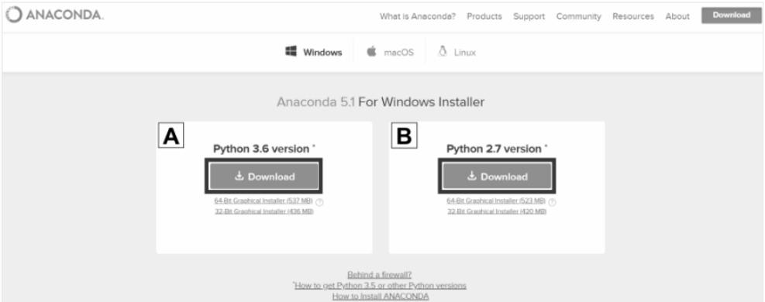

2. Choose your Version and Download it

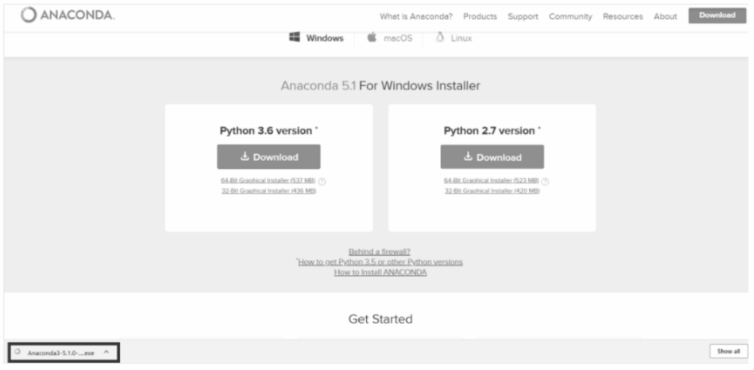

3. Run through the installation setup and wait until it’s installed.

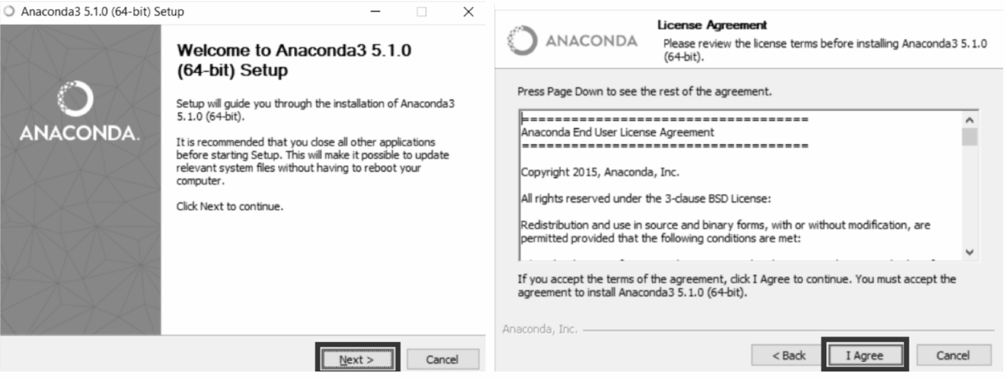

4. Set the type of user whether it’s you or all users. 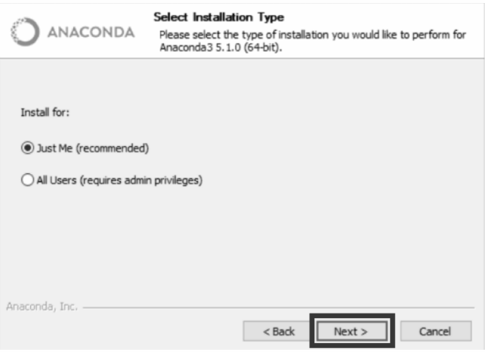

5. Set the path for the Anaconda Application and install it

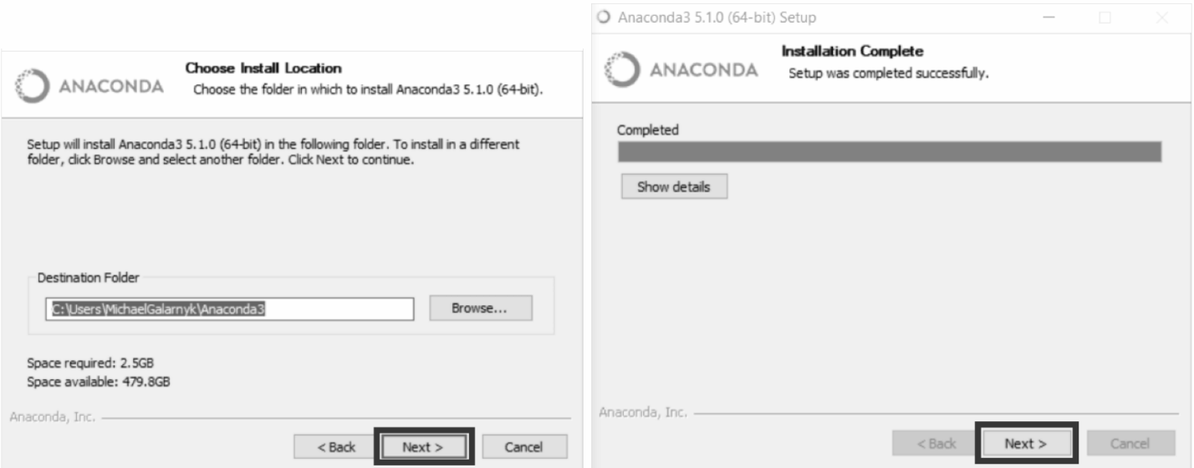

6. Finish the App installation.

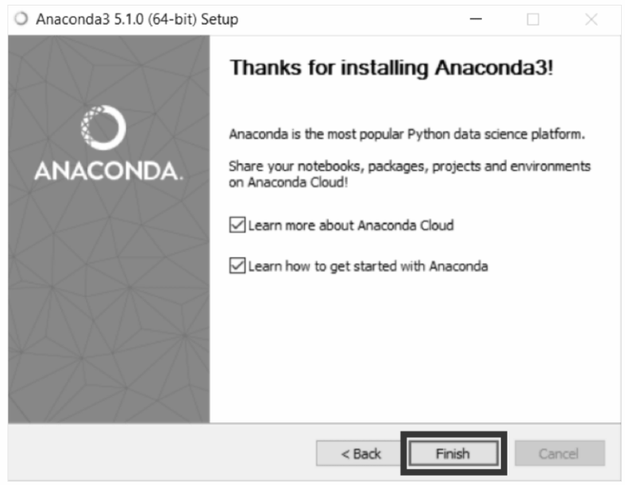

7. Open the Anaconda Navigator Application.

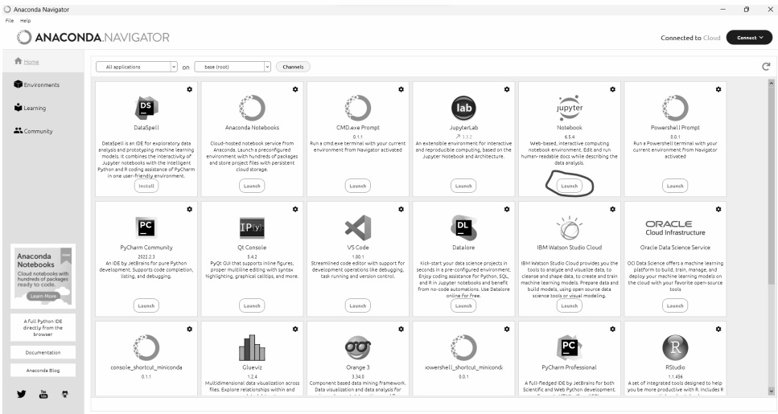

8. Open the Jupyter Notebook in the Application and Start Typing your code by creating a new File.

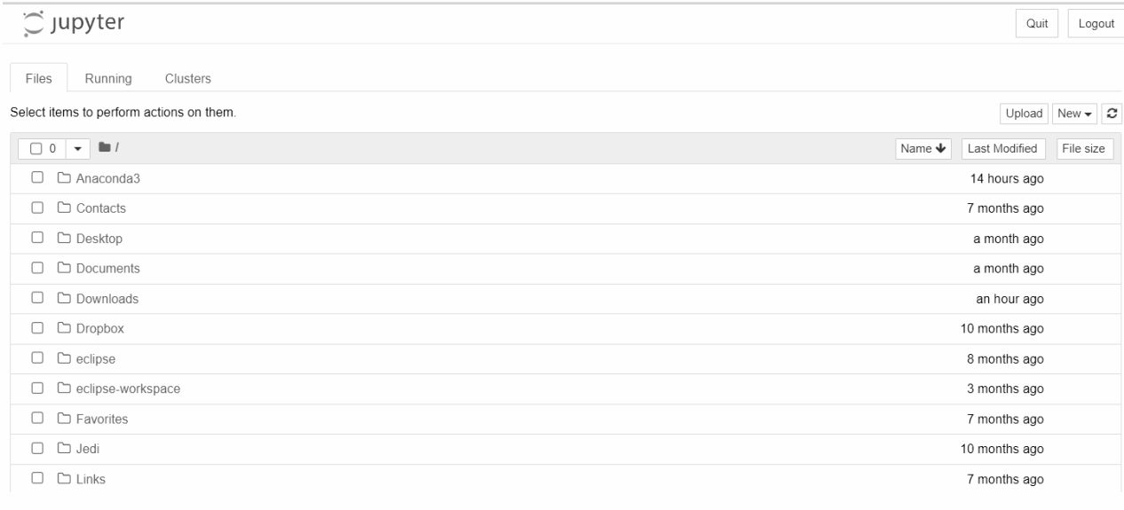

**II) Procedure to install R:**

Step – 1: Go to CRAN R project website.

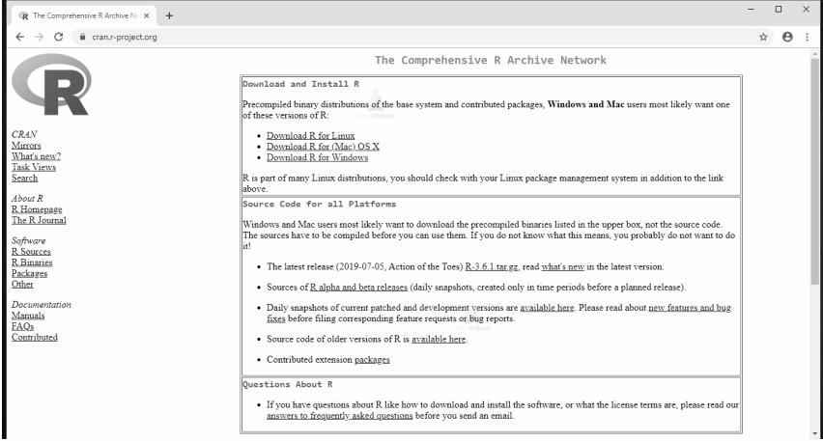

Step – 2: Click on the Download R for Windows link.

Step – 3: Click on the base subdirectory link or install R for the first time link.

Step – 4: Download the version for Windows and save the executable .exe file.

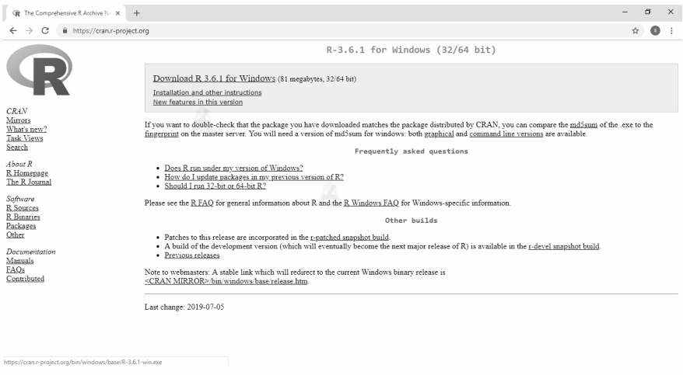

Step – 5: Run the .exe file and follow the installation instructions.

5.a. Select the desired language and then click Next.

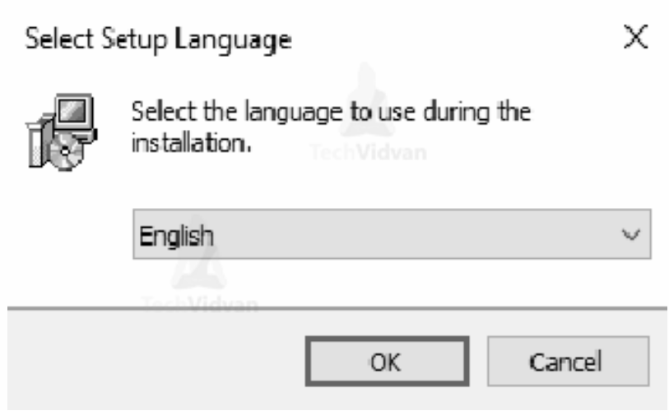

5.b. Read the license agreement and click Next.

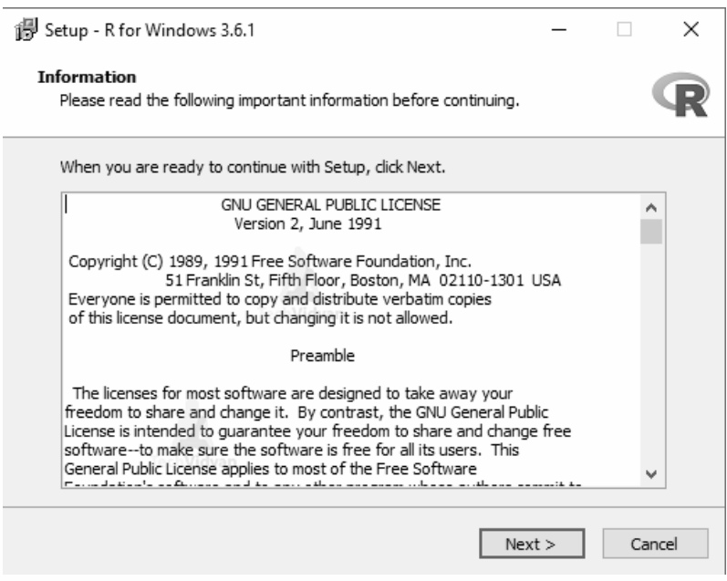

5.c. Select the components you wish to install (it is recommended to install all the components). Click Next.

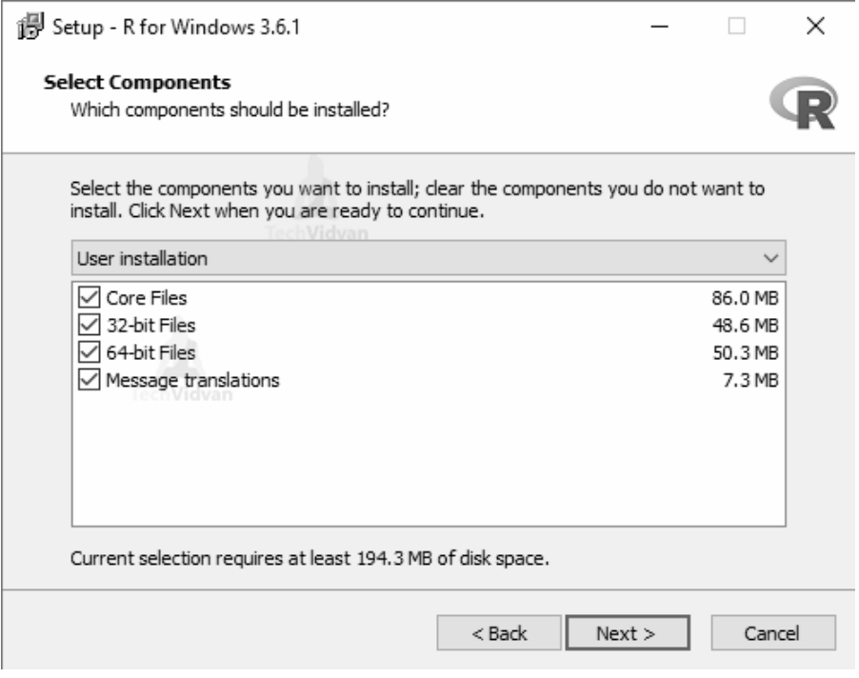

5.d. Enter/browse the folder/path you wish to install R into and then confirm by clicking Next.

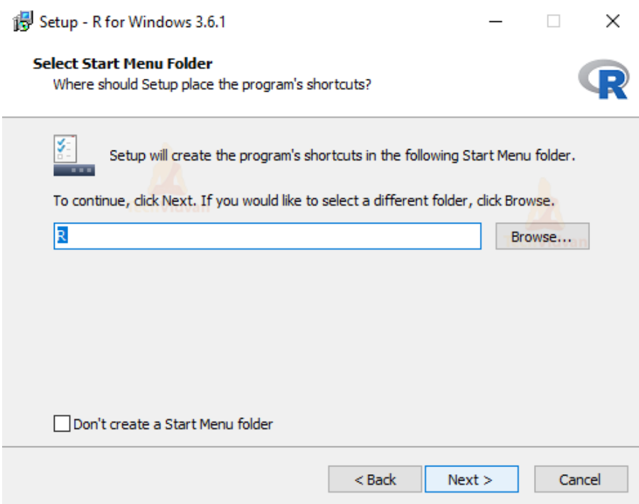

5.e. Select additional tasks like creating desktop shortcuts etc. then click Next.

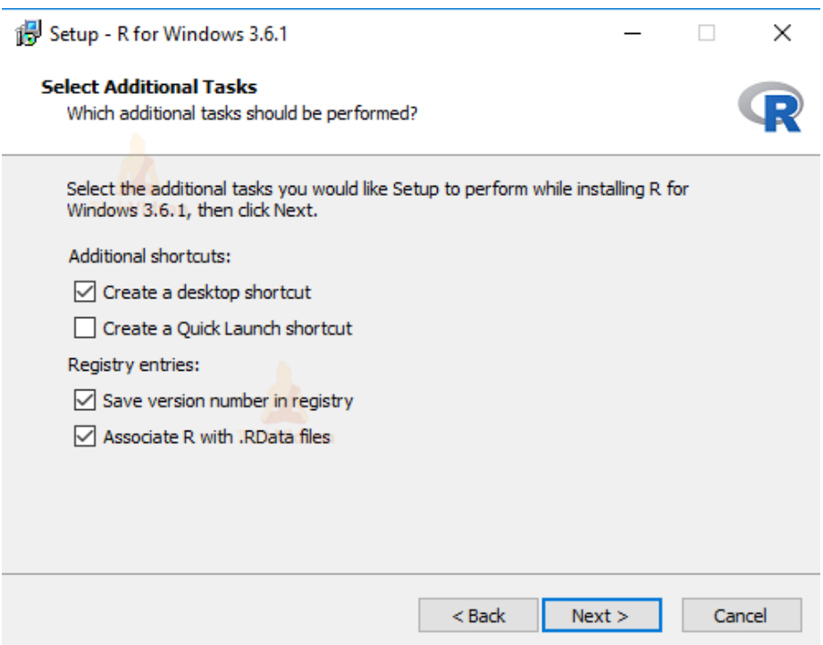

5.f. Wait for the installation process to complete.

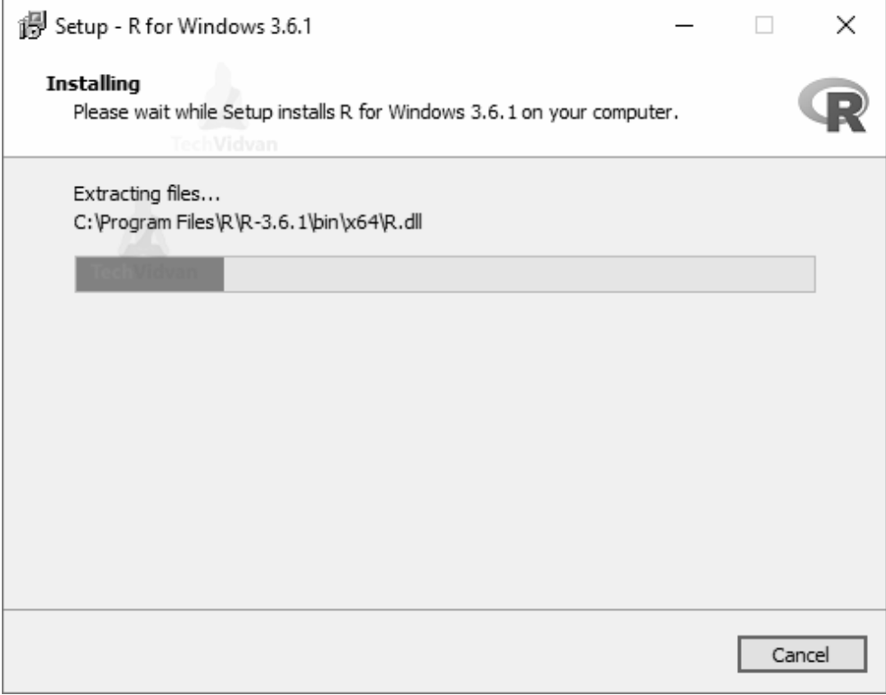

5.g. Click on Finish to complete the installation.

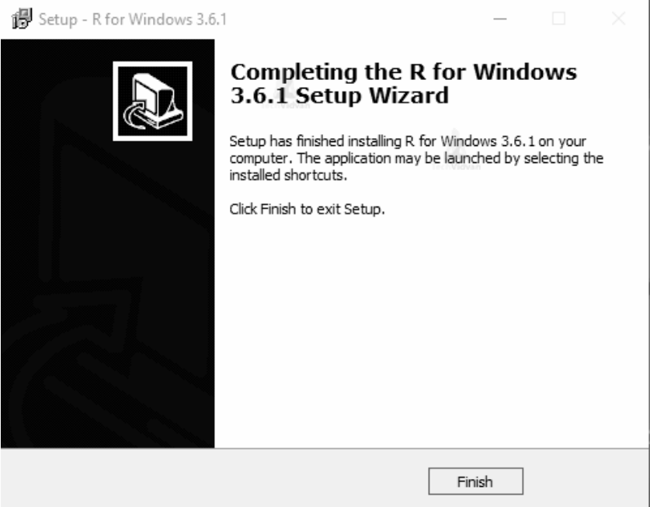

**III) Procedure to install Tableau:**

Step 1: To download Tableau Desktop, first we need to open our browser and go to <https://www.tableau.com/>



Once the website opens, click on the TRY NOW button to initiate the download process.

Step 2: This will take us to the download page for Tableau Desktop.

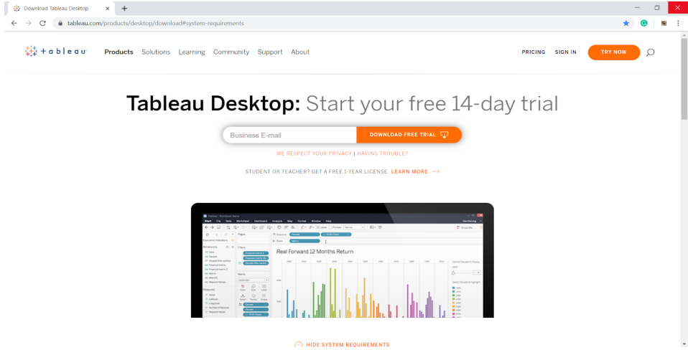

When we scroll down on this page, we will get a list of system requirements to download Tableau Desktop. Here, they have provided platform wise requirements, that is, for Windows, Mac, etc. Make sure to check the requirements for your platform before starting the download.

Step 3: At the top of this page, it will ask you to enter a business E-mail. Please note that you must not enter your personal E-mail ID here. Enter the appropriate E-mail address and click on DOWNLOAD FREE TRIAL.

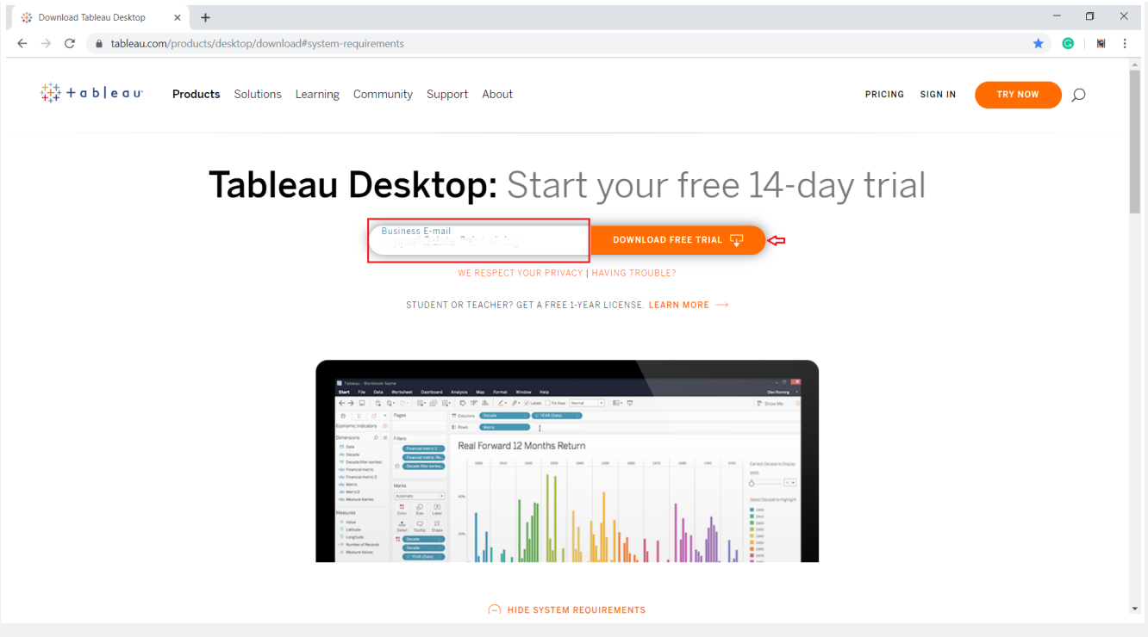

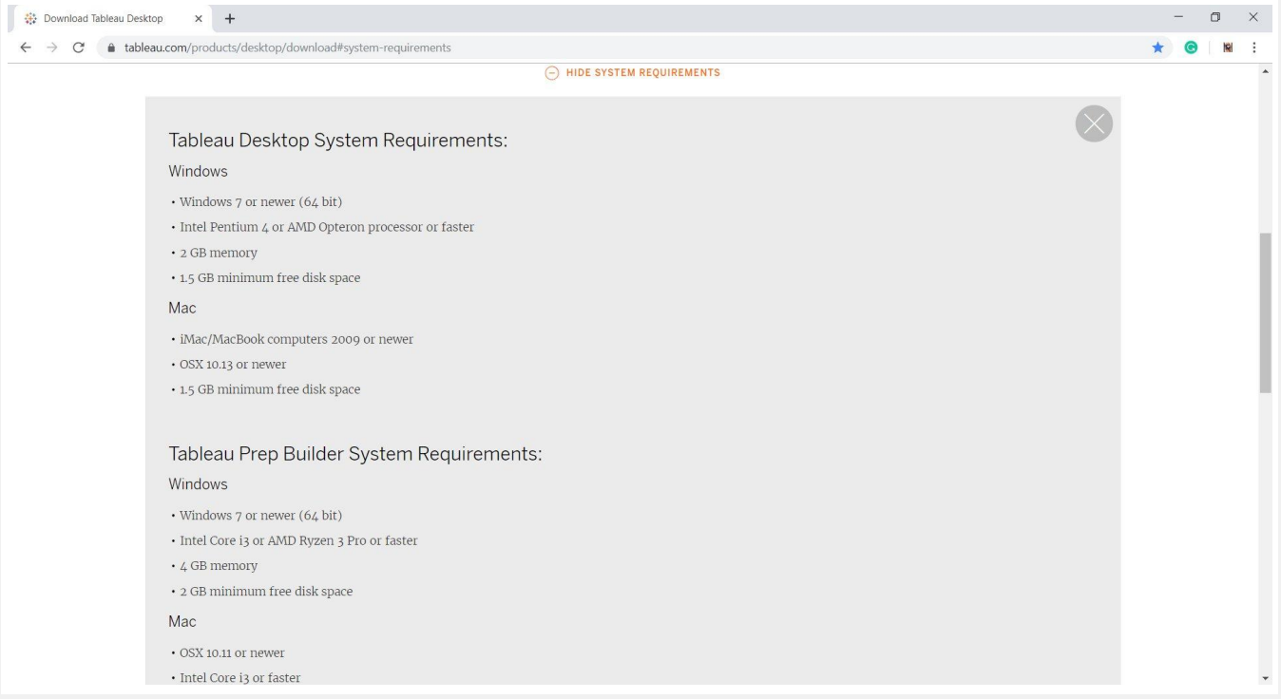

Step 4: As soon as you will click on the download button, a .exe file will start downloading automatically. You will find a file download icon at the left-most bottom of your screen. It will take around 4 to 5 minutes until the download completes.



Once the download gets completed, open the exe file.

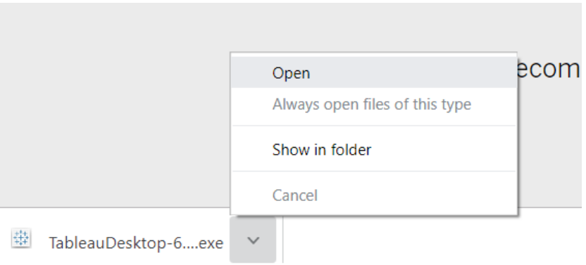

In this way, our Tableau Desktop download is complete. Next, we will move on to installing Tableau Desktop in our system.

Installing Tableau on desktop

In this section, we will see how to install Tableau Desktop through the installation wizard.

1. As soon as you open the downloaded exe file, the install wizard will launch. Click on Run to start the installation process.

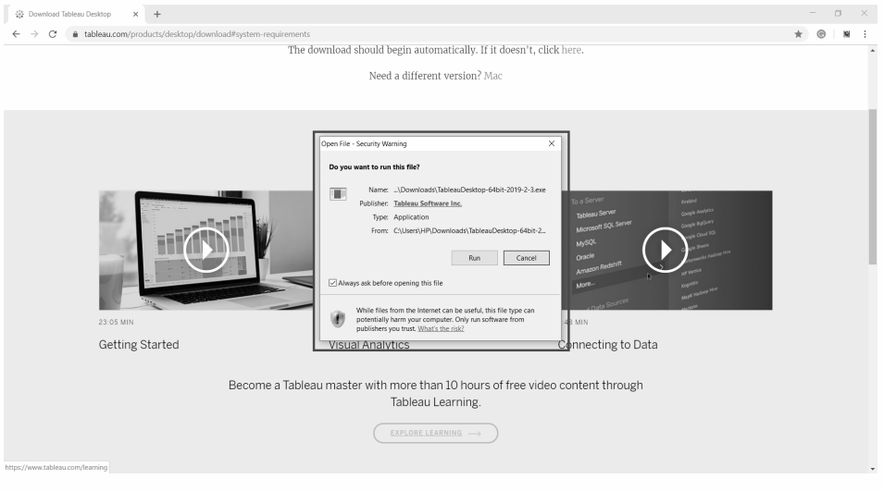

2. You will get the first window as the welcome window. Check the box for license terms agreement and click on Install. This will start the install process.

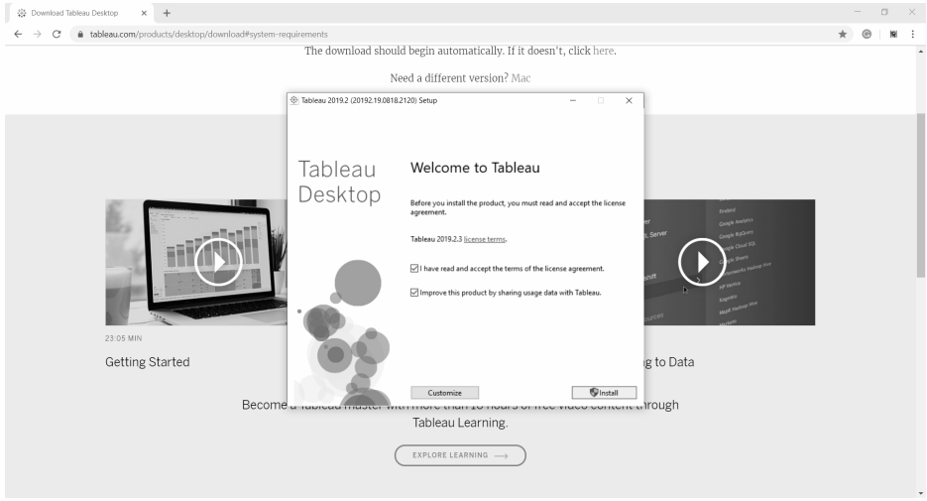

3. The next step will take a few minutes to install important files. The progress bar will indicate the progress in green.



4. The next three steps are regarding the activation process. In this window, you have to choose from two options; Start trial now and Activate. The Start trial now option is the free 14-day trial option whereas, the Activate option is for installing the paid version in which you need to enter a product key.

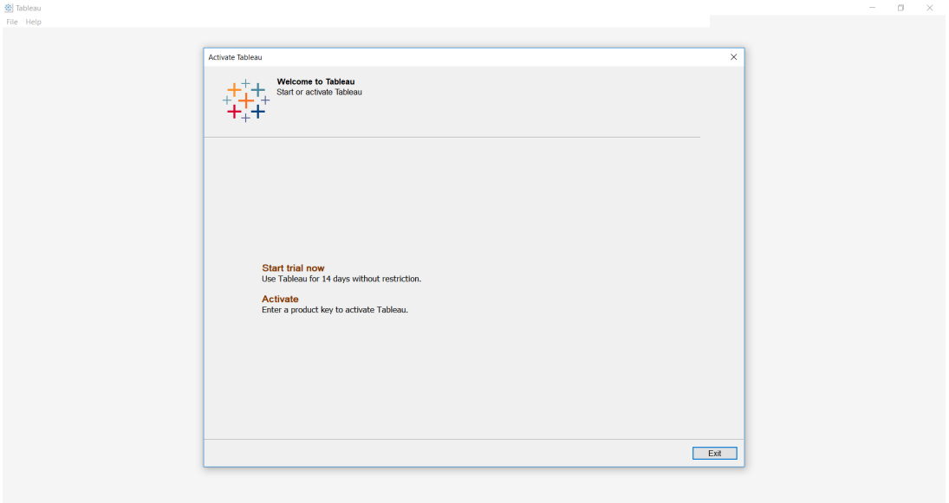

5. We went for the free trial version as our purpose of the use is learning.

6. Moving forward, it will ask you to fill up a registration form. It contains fields like Name, E-mail, Organization, Job title, etc. Fill the right details and click on Register.

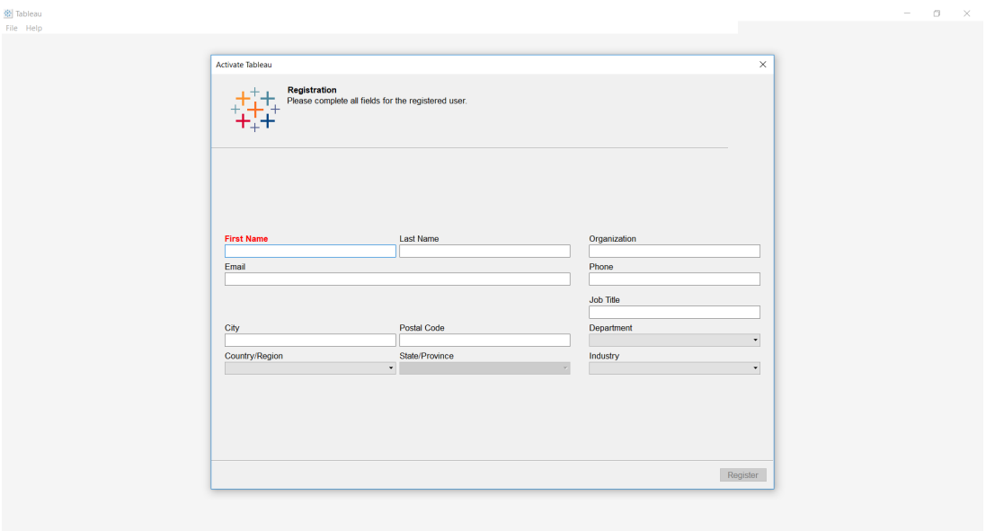

7. The next window will confirm successful registration.

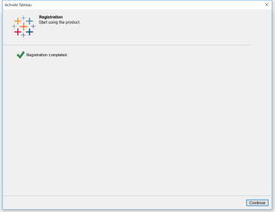

8. Once the activation is complete, go to your desktop and click on the Tableau icon to open Tableau.

9. Tableau Desktop welcome page will open. On its left, you can find a range of data source options you can connect to. And on its right panel, you can explore the training and resources option. To open a new workbook, click on the Tableau star-like icon given on the upper left corner

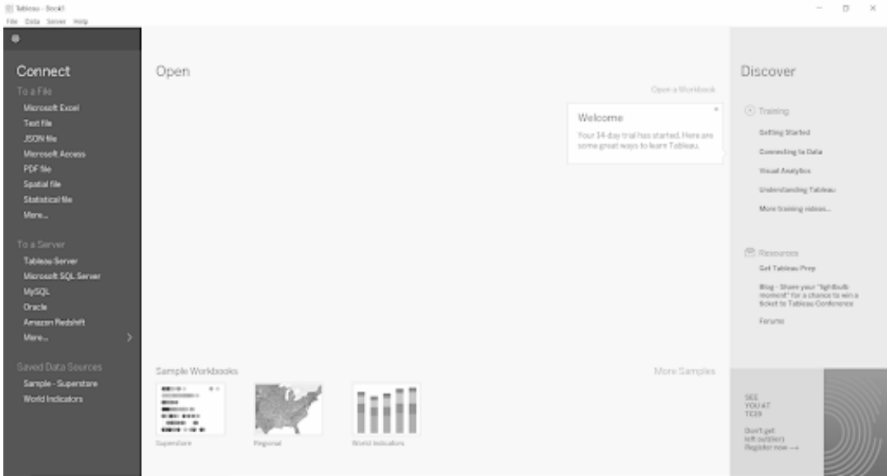

10. Thus the Installation of Tableau is done.

**IV) Procedure of Installing Microsoft Power BI**:

To install Power BI Desktop first, we need to download the desktop version software from the Microsoft website.

1. Search “Power BI Desktop Install” on the internet.

2. Click on the first link or simply click the below URL to go to the download page directly. https://powerbi.microsoft.com/en-us/desktop/ This link will take you to the below page. (Make sure you have an active internet connection in your PC or Laptop).

3. Click on the “Download Free” option to install Power BI.

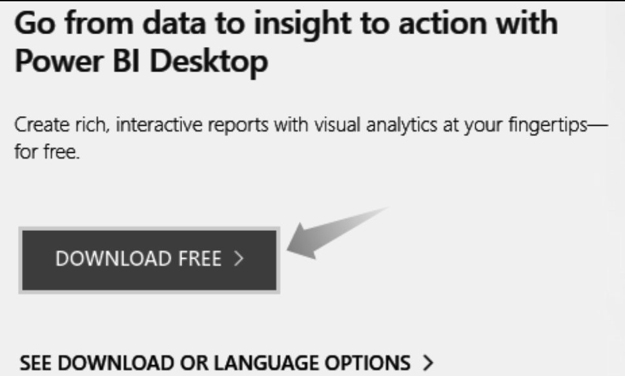

This will take you to the below page.

4. Click on the “Get” option, and the Power BI Desktop setup will get downloaded on your computer.



It would help if you were careful here to make sure what your computer’s platform is, whether it is a “32-bit version or 64-bit version”. Accordingly, you need to download the Power BI version.

5. Once the Power BI Desktop is downloaded, click on the “Install” option. You will see the following window.



Click on the “Next” option to complete the installation.

6. Once the installation is completed, it will take us to the default page of Power BI.

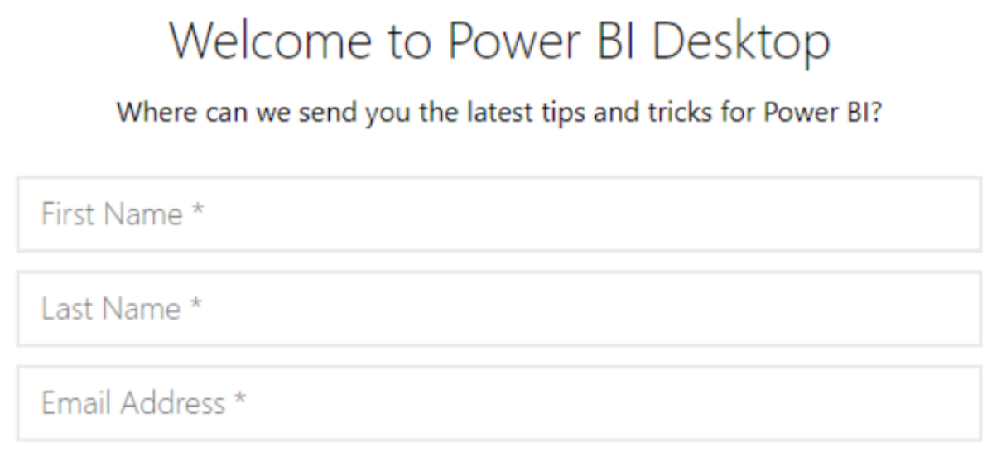

It will ask for your name, the company you are working for, email address, job title, and many other things. However, these are irrelevant at this point, so cancel this window.

7. Again, it will ask you to sign in to the Power BI Desktop account.

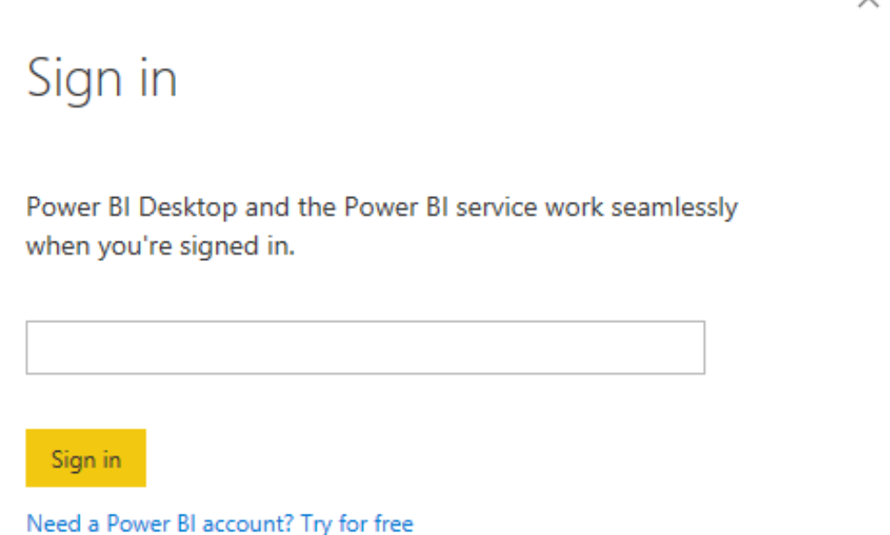

One thing is you have to use only the official company email ID. Here, you cannot use your email ID. Anyways skip this option as well.

8. We will see the following window now.

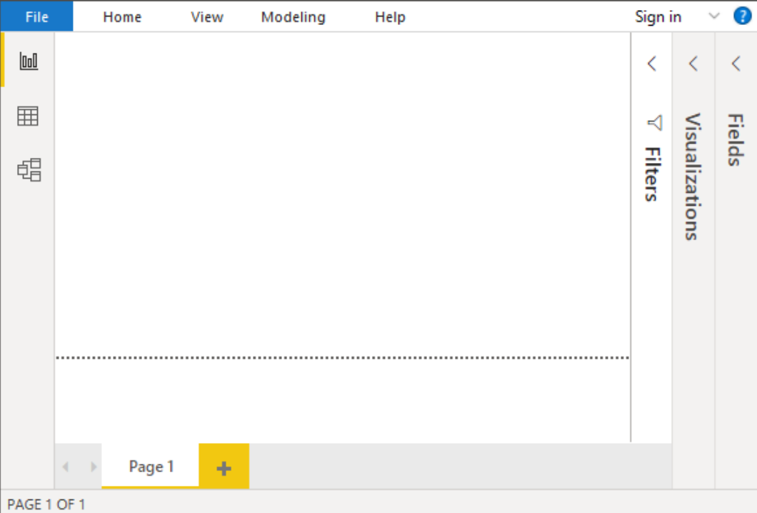

We have to work and build our reports and dashboards in this window.

Write and build the reports using Microsoft Power BI.

**RESULT**

Thus, the installation of the data Analysis and Visualization tool: R/ Python /Tableau Public/ Power BI has been performed successfully.

**DATE: EXERCISE : 02**

**PERFORM EXPLORATORY DATA ANALYSIS (EDA) WITH DATASETS LIKE EMAIL DATA SET. EXPORT ALL YOUR EMAILS AS A DATASET, IMPORT THEM INSIDE A PANDAS DATA FRAME, VISUALIZE THEM AND GET DIFFERENT INSIGHTS FROM THE DATA.**

**AIM**

To perform exploratory data analysis (EDA) with datasets like email data set. Export all your emails as a dataset, import them inside a pandas data frame, visualize them and get different insights from the data.

**PROCEDURE**

1. **Start**
2. **To extract Email Dataset:**
3. Access Google Takeout: Visit the Google Takeout website:<https://takeout.google.com/>.
4. Select Data to Include:
   * Click on "Deselect All" to unselect all services.
   * Scroll down and find "Mail."
   * Click on the checkbox next to "Mail" to select it.
5. Choose Label:
   * Click on "All Mail data included."
   * In the pop-up window, uncheck "Select All."
   * Scroll down and find "Starred" or "Starred and Important."
   * Check the checkbox next to "Starred" or "Starred and Important."
6. Configure Mail Format and Size:
   * Click on the "All mail data included" link again.
   * In the pop-up, you can customize your export settings.
   * Under "All Mail data included," select "Include all messages in Mail."
   * Set the desired file format (e.g., ZIP).
   * Set the maximum size per archive. Since you want to limit it to 1 GB, choose an appropriate size from the drop-down menu.
7. Next:
   * Scroll to the bottom of the page and click on the "Next" button.
8. Customize Archive Format:
   * Choose the delivery method (e.g., send download link via email).
   * Select the frequency (once, every 2 months, etc.) if you want to export data regularly.
   * Click on the "Create export" button.
9. Wait for Processing:
   * Google will begin creating your export. This may take some time, depending on the size of your data.
10. Download the Archive:
    * Once the export is ready, you'll receive an email with a link to download your data.
    * Click on the provided link to download the ZIP file containing your starred emails.

**3) To Convert MBOX to CSV:**

1. Import Required Libraries:
   * Import the necessary libraries, mailbox and csv.
2. Define Input and Output Paths:
   * Specify the path to the input .mbox file (input_mbox_file) and the output CSV file (output_csv_file).
3. Create CSV File and Write Headers:
   * Open the output CSV file in write mode and create a CSV writer.
   * Write the headers (['From', 'To', 'Date', 'Subject', 'Body']) to the CSV file.
4. Iterate Through Messages:
   * Create an mbox object using mailbox.mbox(input_mbox_file).
   * Iterate through each message in the .mbox file.
5. Extract Message Data:
   * Extract relevant data from each message, such as 'from' address, 'to' address, date, subject, and body.
6. Write Data to CSV File:
   * Write the extracted message data (from, to, date, subject, body) to the CSV file.
7. Close CSV File:
   * Close the CSV file to ensure that all changes are saved.

**4)Using the dataset:**

1. Start
2. Import Libraries:
   1. Import the required libraries, such as pandas and matplotlib.pyplot.
3. Read Data:
   1. Use the appropriate method to read the data into a DataFrame (e.g., pd.read_csv() for CSV files).
4. Explore Data:
   1. Display the initial rows of the DataFrame (data.head()).
   2. Display the last rows of the DataFrame (data.tail()).
   3. Use descriptive statistics (data.describe()) to understand the data.
   4. Check for data types and missing values using data.info() and data.isnull().sum().
5. Data Visualization:
   1. Perform any desired data visualizations using libraries like matplotlib.pyplot.
   2. Create plots or charts to represent insights from the data (e.g., bar chart, scatter plot).
6. Show or Save Visualization:
   1. Use plt.show() to display the visualization.
   2. Optionally, save the visualization using plt.savefig().

**5) Stop**

**PROGRAM**

import mailbox

import csv

# Path to the input .mbox file

input_mbox_file = "All mail Including Spam and Trash-003.mbox"

# Path to the output CSV file

output_csv_file = "output.csv"

# Create a CSV file and write headers

with open(output_csv_file, 'w', newline='', encoding='utf-8') as csv_file:

csv_writer = csv.writer(csv_file)

csv_writer.writerow(['From', 'To', 'Date', 'Subject', 'Body'])

# Iterate through messages in the .mbox file

mbox = mailbox.mbox(input_mbox_file)

for message in mbox:

from_address = message['from']

to_address = message['to']

date = message['date']

subject = message['subject']

body = message.get_payload()

# Write message data to CSV file

csv_writer.writerow([from_address, to_address, date, subject, body])

import numpy as np

import pandas as pd

import matplotlib.pyplot as plt

import seaborn as sns

import re

import pandas as pd

# Specify the correct encoding (e.g., 'latin-1', 'ISO-8859-1', etc.)

encoding = 'latin-1'

# Read the CSV file

df = pd.read_csv("output.csv")

# Display the DataFrame

df

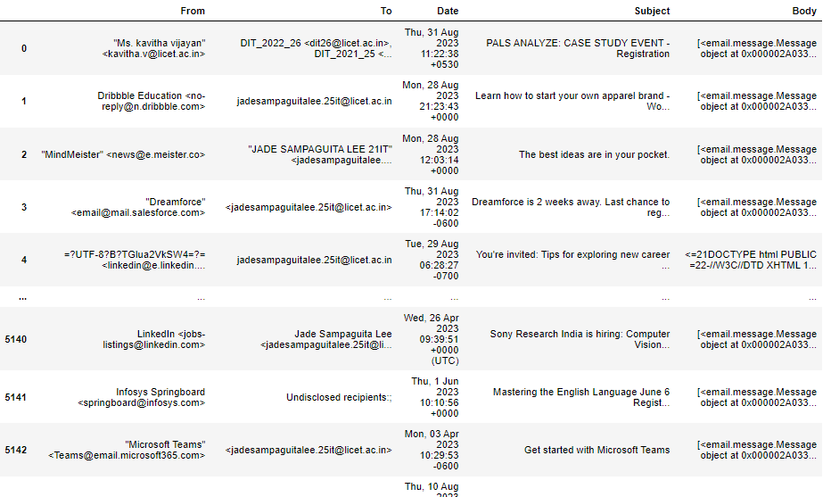

# Display the first few rows of the DataFrame

print(df.head())

# Get the summary statistics of the DataFrame

print(df.describe())

# Get information about the DataFrame, such as data types and non-null co

print(df.info())

# Check for missing values

print(df.isnull().sum())

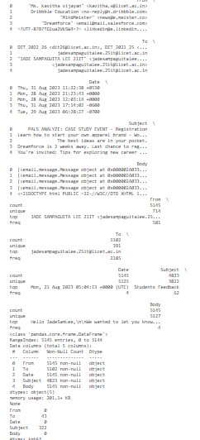

df.isnull().sum()

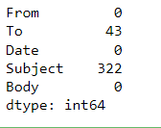

df.drop("Body",axis=1,inplace=True)

df

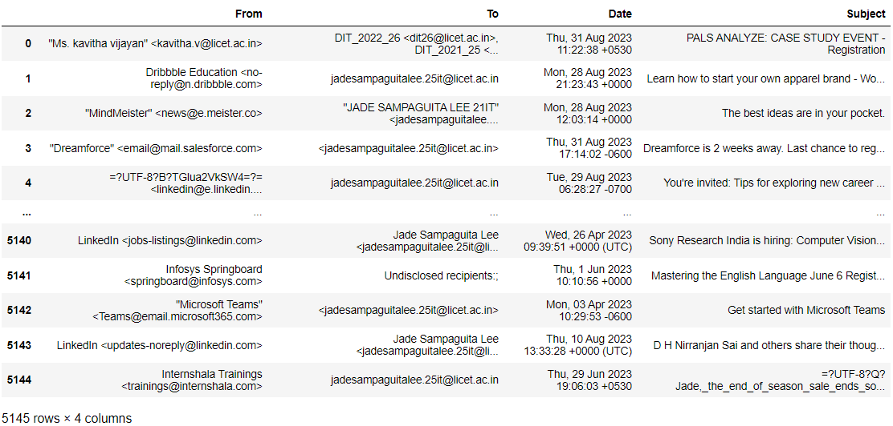

# Count of emails sent by each sender

sns.countplot(x='From', data=df)

plt.xticks(rotation=90)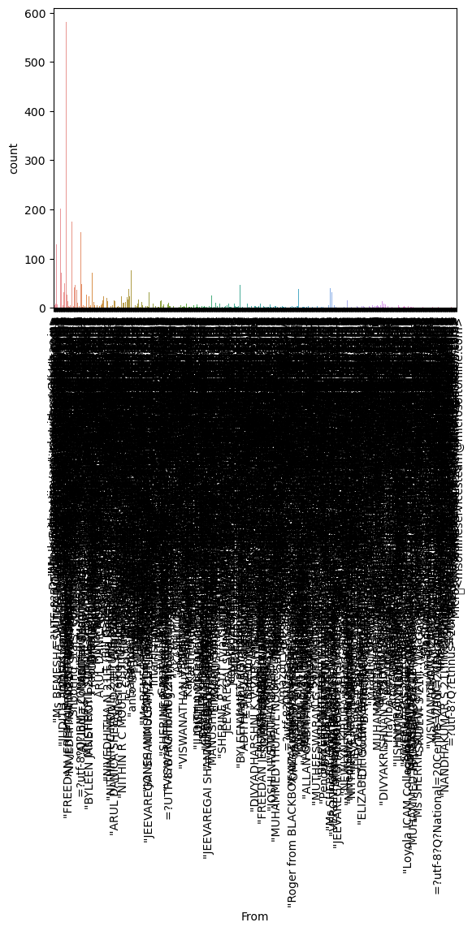

plt.show()

# Distribution of email dates

df['Date'] = pd.to_datetime(df['Date'])

df['year'] = df['Date'].dt.year

sns.countplot(x='year', data=df)

plt.show()

# Replace this with the actual file path

file_path = "output.csv"

# Read the CSV file

df = pd.read_csv(file_path, encoding='latin-1')

# Assuming the date column is named "Date", replace it with the actual co

sns.countplot(x="Date", data=df)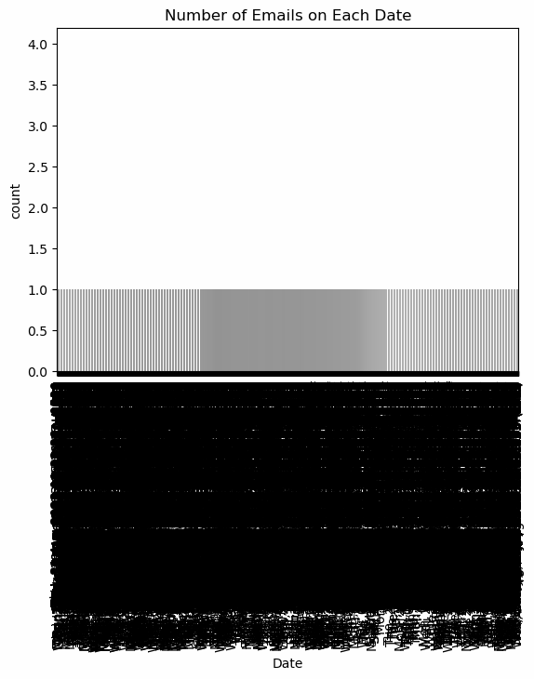

plt.xticks(rotation=90)

plt.title("Number of Emails on Each Date")

plt.show()

plt.figure(figsize=(10, 6))

top_10_subjects = df['Subject'].value_counts().head(10)

sns.barplot(x=top_10_subjects.index, y=top_10_subjects.values)

plt.xticks(rotation=90)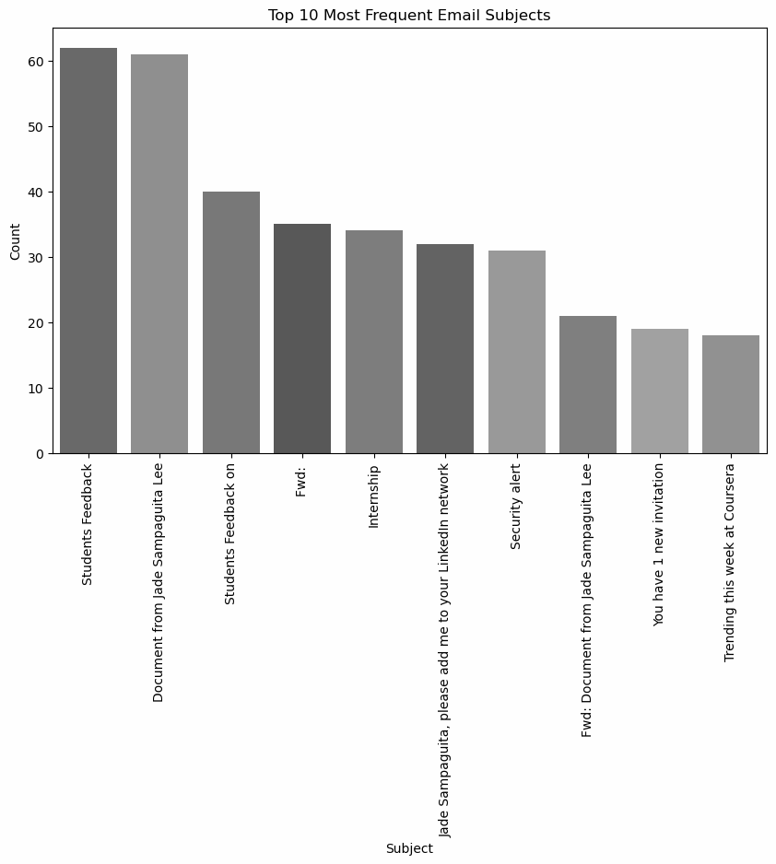

plt.title("Top 10 Most Frequent Email Subjects")

plt.xlabel("Subject")

plt.ylabel("Count")

plt.show()

from wordcloud import WordCloud

import matplotlib.pyplot as plt

# Ensure the 'Subject' column is of string type

df['Subject'] = df['Subject'].astype(str)

# Join all subjects into a single string

all_subjects = " ".join(df['Subject'])

# Create the WordCloud

wordcloud = WordCloud(width=800, height=400, background_color="white").generate(all_subjects)

# Display the WordCloud

plt.figure(figsize=(10, 5))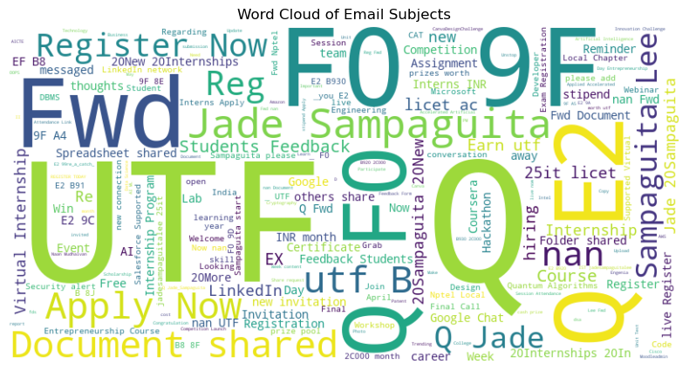

plt.imshow(wordcloud, interpolation="bilinear")

plt.axis("off")

plt.title("Word Cloud of Email Subjects")

plt.show()

df['Date'] = pd.to_datetime(df['Date'], errors='coerce')

df = df.dropna(subset=['Date'])

df['Month'] = df['Date'].dt.to_period('M')

monthly_email_count = df['Month'].value_counts().sort_index()

plt.figure(figsize=(10, 6))

sns.barplot(x=monthly_email_count.index, y=monthly_email_count.values)

plt.xticks(rotation=45, ha='right')

plt.title("Monthly Email Count")

plt.xlabel("Month")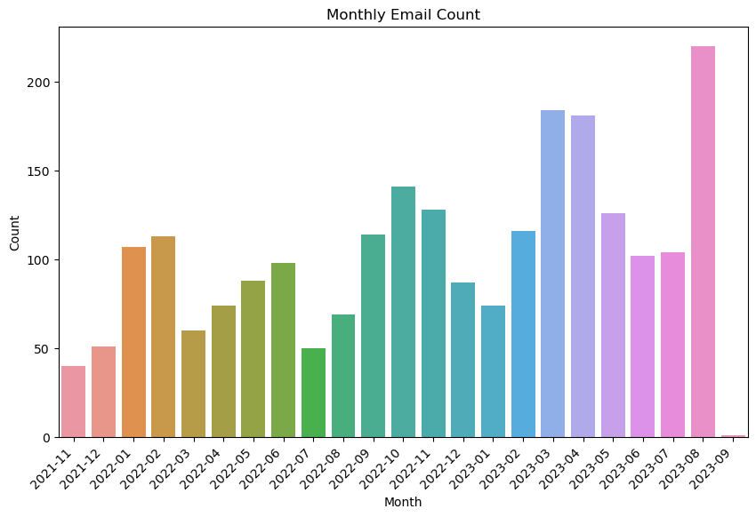

plt.ylabel("Count")

plt.show()

df['Time'] = df['Date'].dt.time

plt.figure(figsize=(12, 6))

sns.countplot(x='Time', data=df)

plt.xticks(rotation=45, ha='right')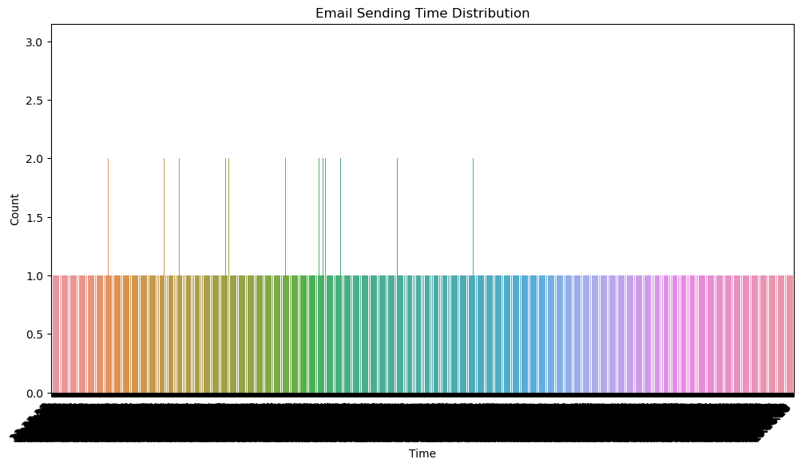

plt.title("Email Sending Time Distribution")

plt.xlabel("Time")

plt.ylabel("Count")

plt.show()

sender_counts = df['From'].value_counts()

plt.figure(figsize=(10, 6))

plt.pie(sender_counts, labels=sender_counts.index, autopct='%1.1f%%')

plt.title("Emails by Sender")

plt.axis('equal') # Equal aspect ratio ensures that pie is drawn as a ci

plt.show()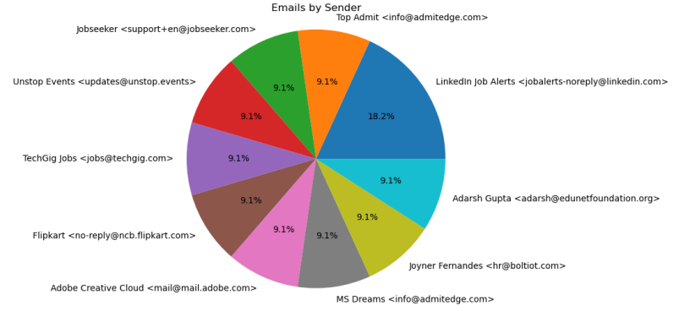

sender_counts = df['From'].value_counts()

# Plotting the bar chart

plt.figure(figsize=(12, 6))

sender_counts[:10].plot(kind='bar')

plt.xlabel("Sender")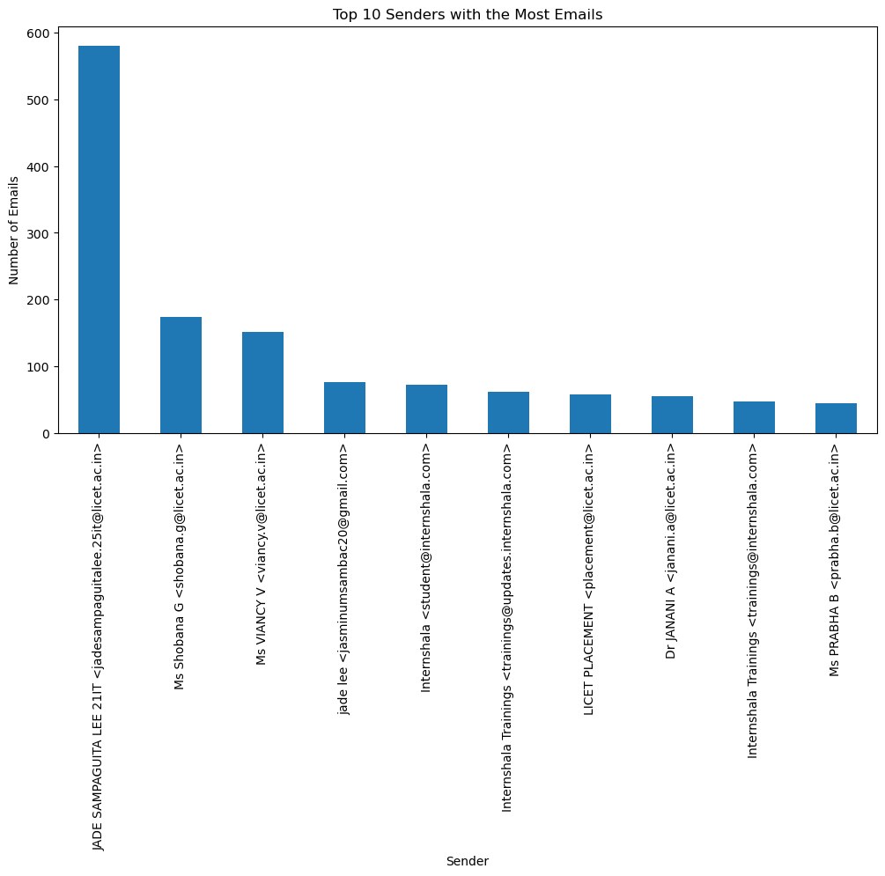

plt.ylabel("Number of Emails")

plt.title("Top 10 Senders with the Most Emails")

plt.show()

# Assuming the date column is named "Date" (replace with actual column na

df['Date'] = pd.to_datetime(df['Date'])

emails_by_date = df.resample('D', on='Date').size()

# Plotting the line chart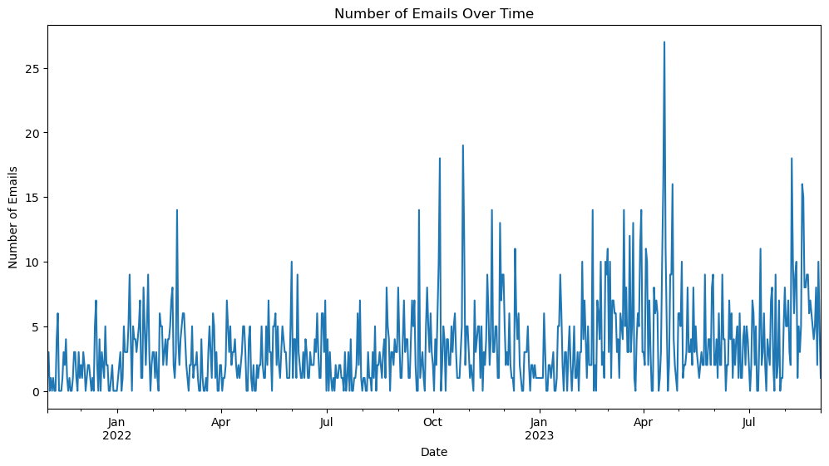

plt.figure(figsize=(12, 6))

emails_by_date.plot()

plt.xlabel("Date")

plt.ylabel("Number of Emails")

plt.title("Number of Emails Over Time")

plt.show()

# Combine all email subjects into a single string

all_subjects = ' '.join(df['Subject'])

# Create a WordCloud object and generate the word cloud

wordcloud = WordCloud(width=800, height=400, background_color='white').generate(all_subjects)

# Plot the word cloud

plt.figure(figsize=(10, 6))

plt.imshow(wordcloud, interpolation='bilinear')

plt.axis('off')

plt.title("Frequent Words in Email Subjects")

plt.show()

**RESULT**

Thus, the performance of exploratory data analysis (EDA) with datasets like email data set where we export all your emails as a dataset, import them inside a pandas data frame, visualize them and get different insights from the data has been executed successfully.

**DATE: EXERCISE : 03**

**WORKING WITH NUMPY ARRAYS, PANDAS DATA FRAMES , BASIC PLOTS USING MATPLOTLIB.**

**AIM**

Towork with Numpy arrays, Pandas data frames , Basic plots using Matplotlib.

**PROCEDURE**

1. Import Libraries:

- Import necessary libraries, including `datetime`, `math`, `pandas`, `random`, `radar`, `Faker`, `numpy`, `calendar`, `matplotlib`, `seaborn`.

2. Define Function `generateData`:

1. Set up an empty list `listdata`.

2. Define a start date, end date, and delta for date range.

3. Use a loop to generate random dates, prices, and append them to `listdata`.

4. Create a Pandas DataFrame (`df`) from the generated data, converting the 'Date' column to datetime format and grouping by date while taking the mean of prices.

5. Return the DataFrame.

3. Generate Data and Save to CSV:

1. Call `generateData` function with an argument (e.g., 50) to generate synthetic data.

2. Display the first 10 rows of the DataFrame.

3. Save the DataFrame to a CSV file named 'stock.csv'.

4. Plot Time Series Data:

1. Import `matplotlib.pyplot` as `plt`.

2. Set plot parameters.

3. Plot the generated DataFrame using `plt.plot(df)`.

5. Generate Sleep Data:

1. Define age ranges and sleep-related parameters for different age groups.

2. Create a DataFrame (`sleepDf`) with columns like 'age', 'min_recommended', etc.

3. Save the sleep data to a CSV file named 'sleep_vs_age.csv'.

6. Plot Sleep Data:

1. Use `seaborn` and `matplotlib.pyplot` to create scatter and line plots for sleep data based on age.

7. Plot Iris Dataset:

1. Load the Iris dataset using `seaborn`.

2. Create scatter and bubble plots.

8. Plot Household Expenses:

1. Define monthly expenses for categories like houseLoanMortgage, utilitiesBills, etc.

2. Plot a stacked bar chart for household expenses.

9. Plot Pokemon Dataset:

1. Load Pokemon dataset from a URL.

2. Plot a pie chart using `matplotlib.pyplot` and `seaborn`.

10. Plot Grades Comparison:

1. Compare planned vs. actual grades using a bar chart.

11. Lollipop Chart for Car Mileage:

1. Load car data from a URL.

2. Group by manufacturer and calculate average mileage.

3. Plot a lollipop chart to visualize the average mileage.

12. Histogram for Experience Data:

1. Create a histogram for Python programming experience data.

13. Styling Pandas DataFrames:

1. Style a Pandas DataFrame to highlight negative values and apply background colors based on max, min values.

14. Heatmap for DataFrame:

1. Use `seaborn` to create a heatmap for a DataFrame.

**PROGRAM**

import datetime

import math

import pandas as pd

import random

import radar

from faker import Faker

fake = Faker()

def generateData(n):

listdata = []

start = datetime.datetime(2019, 8, 1)

end = datetime.datetime(2019, 8, 30)

delta = end - start

for _ in range(n):

date = radar.random_datetime(start='2019-08-01', stop='2019-08-30').strftime("%Y-%m-%d")

price = round(random.uniform(900, 1000), 4)

listdata.append([date, price])

df = pd.DataFrame(listdata, columns = ['Date', 'Price'])

df['Date'] = pd.to_datetime(df['Date'], format='%Y-%m-%d')

df = df.groupby(by='Date').mean()

return df

df = generateData(50)

df.head(10)

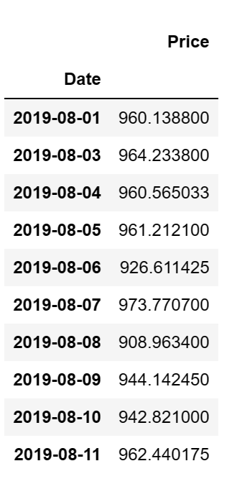

df.to_csv(r'stock.csv')

df

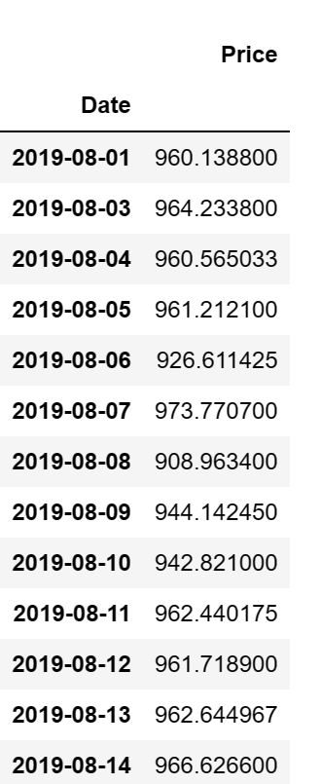

import matplotlib.pyplot as plt

plt.rcParams['figure.figsize'] = (14, 10)

plt.plot(df)

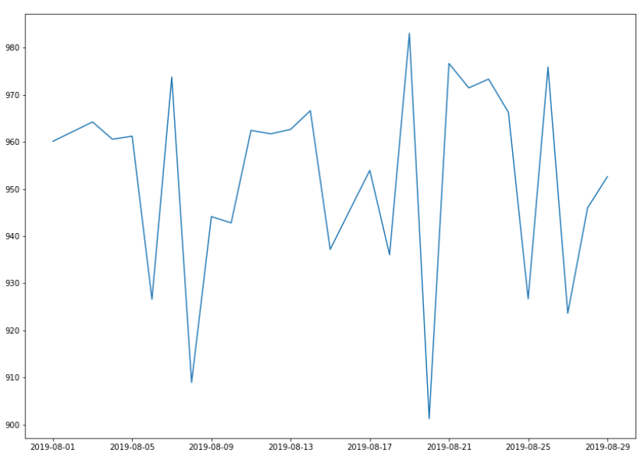

import datetime

import pandas as pd

import random

import radar

def generateData(n):

listdata = []

start = datetime.datetime(2019, 8, 1)

end = datetime.datetime(2019, 8, 30)

delta = end - start

for _ in range(n):

date = radar.random_datetime(start='2019-08-1', stop='2019-08-30').strftime("%Y-%m-%d")

price = round(random.uniform(900, 1000), 4)

listdata.append([date, price])

df = pd.DataFrame(listdata, columns=['Date', 'Price'])

df['Date'] = pd.to_datetime(df['Date'], format='%Y-%m-%d')

df = df.groupby(by='Date').mean()

return df

df = generateData(50)

print(df.head(10))

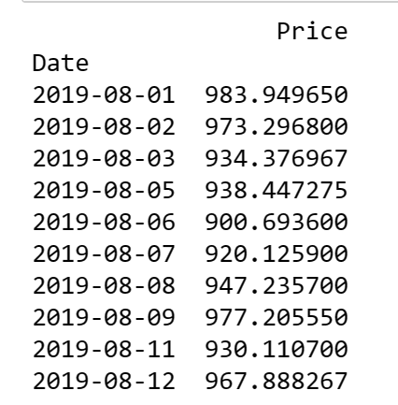

df.to_csv(r'stock.csv')

import matplotlib.pyplot as plt

plt.rcParams['figure.figsize'] = (14, 10)

plt.plot(df)

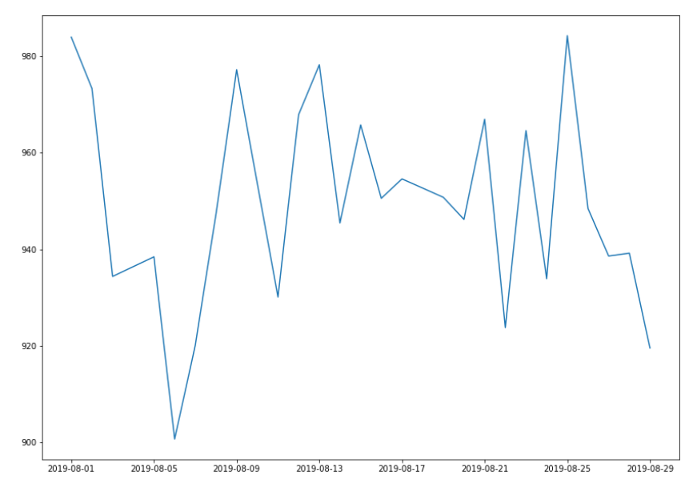

import numpy as np

import calendar

import matplotlib.pyplot as plt

import random

months = list(range(1, 13))

sold_quantity = [round(random.uniform(100, 200)) for x in range(1, 13)]

figure, axis = plt.subplots()

plt.xticks(months, calendar.month_name[1:13], rotation=20)

plot = axis.bar(months, sold_quantity)

for rectangle in plot:

height = rectangle.get_height()

axis.text(rectangle.get_x() + rectangle.get_width() / 2., 1.002 * height, '%d' % int(height))

plt.show()

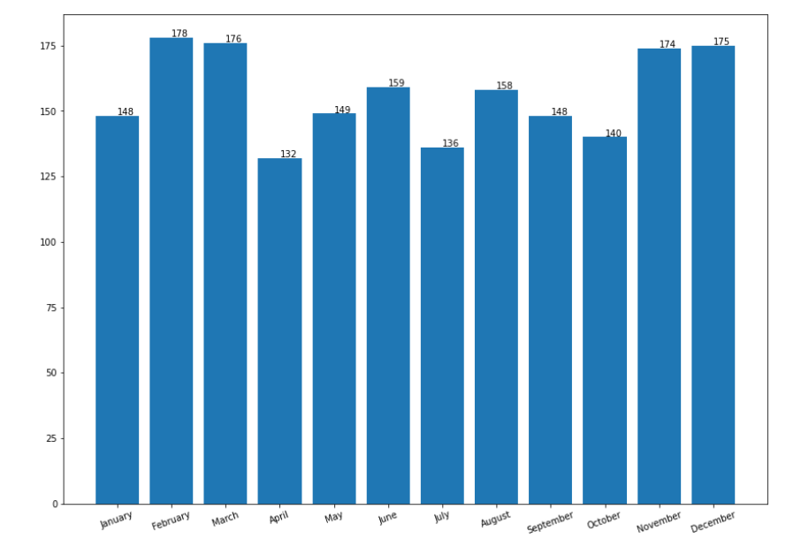

import random

import calendar

import matplotlib.pyplot as plt

months = list(range(1, 13))

sold_quantity = [round(random.uniform(100, 200)) for x in range(1, 13)]

figure, axis = plt.subplots()

plt.yticks(months, calendar.month_name[1:13], rotation=20)

plot = axis.barh(months, sold_quantity)

for rectangle in plot:

width = rectangle.get_width()

axis.text(width + 2.5, rectangle.get_y() + 0.38, '%d' % int(width), ha='center', va='center')

plt.show()

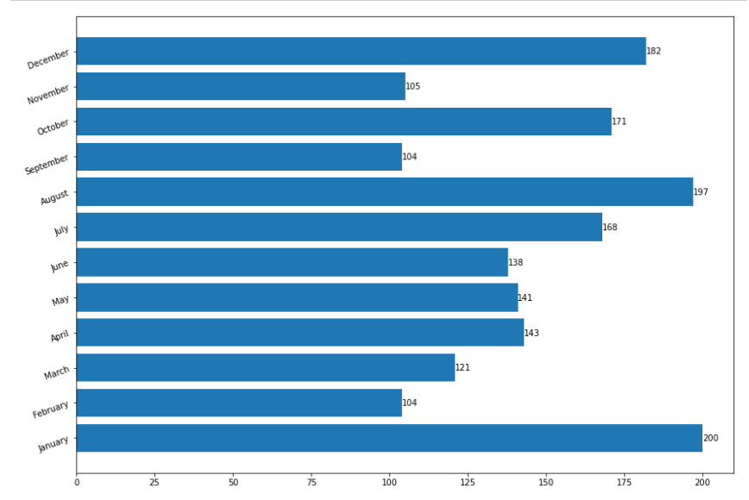

import pandas as pd

age = list(range(0, 65))

sleep = []

classBless = ['newborns(0-3)', 'infants(4-11)', 'toddlers(12-24)', 'preschoolers(36-60)', 'school-aged-children(72-156)', 'teenagers(168-204)', 'young-adults(216-300)', 'adults(312-768)', 'older-adults(>=780)']

headers_cols = ['age', 'min_recommended', 'max_recommended', 'may_be_appropriate_min', 'may_be_appropriate_max', 'min_not_recommended', 'max_not_recommended']

# Newborn (0-3)

for i in range(0, 4):

min_recommended = 14

max_recommended = 17

may_be_appropriate_min = 11

may_be_appropriate_max = 13

min_not_recommended = 11

max_not_recommended = 19

sleep.append([i, min_recommended, max_recommended, may_be_appropriate_min, may_be_appropriate_max, min_not_recommended, max_not_recommended])

# infants(4-11)

for i in range(4, 12):

min_recommended = 12

max_recommended = 15

may_be_appropriate_min = 10

may_be_appropriate_max = 11

min_not_recommended = 10

max_not_recommended = 18

sleep.append([i, min_recommended, max_recommended, may_be_appropriate_min, may_be_appropriate_max, min_not_recommended, max_not_recommended])

# toddlers(12-24)

for i in range(12, 25):

min_recommended = 11

max_recommended = 14

may_be_appropriate_min = 9

may_be_appropriate_max = 10

min_not_recommended = 9

max_not_recommended = 16

sleep.append([i, min_recommended, max_recommended, may_be_appropriate_min, may_be_appropriate_max, min_not_recommended, max_not_recommended])

# preschoolers(36-60)

for i in range(36, 61):

min_recommended = 10

max_recommended = 13

may_be_appropriate_min = 8

may_be_appropriate_max = 9

min_not_recommended = 8

max_not_recommended = 14

sleep.append([i, min_recommended, max_recommended, may_be_appropriate_min, may_be_appropriate_max, min_not_recommended, max_not_recommended])

# school-aged-children(72-156)

for i in range(72, 157):

min_recommended = 9

max_recommended = 11

may_be_appropriate_min = 7

may_be_appropriate_max = 8

min_not_recommended = 7

max_not_recommended = 12

sleep.append([i, min_recommended, max_recommended, may_be_appropriate_min, may_be_appropriate_max, min_not_recommended, max_not_recommended])

# teenagers(168-204)

for i in range(168, 204):

min_recommended = 8

max_recommended = 10

may_be_appropriate_min = 7

may_be_appropriate_max = 11

min_not_recommended = 7

max_not_recommended = 11

sleep.append([i, min_recommended, max_recommended, may_be_appropriate_min, may_be_appropriate_max, min_not_recommended, max_not_recommended])

# young-adults(216-300)

for i in range(216, 301):

min_recommended = 7

max_recommended = 9

may_be_appropriate_min = 6

may_be_appropriate_max = 11

min_not_recommended = 6

max_not_recommended = 11

sleep.append([i, min_recommended, max_recommended, may_be_appropriate_min, may_be_appropriate_max, min_not_recommended, max_not_recommended])

# adults(312-768)

for i in range(312, 769):

min_recommended = 7

max_recommended = 9

may_be_appropriate_min = 6

may_be_appropriate_max = 10

min_not_recommended = 6

max_not_recommended = 10

sleep.append([i, min_recommended, max_recommended, may_be_appropriate_min, may_be_appropriate_max, min_not_recommended, max_not_recommended])

# older-adults(>=780)

for i in range(769, 780):

min_recommended = 7

max_recommended = 8

may_be_appropriate_min = 5

may_be_appropriate_max = 6

min_not_recommended = 5

max_not_recommended = 9

sleep.append([i, min_recommended, max_recommended, may_be_appropriate_min, may_be_appropriate_max, min_not_recommended, max_not_recommended])

sleepDf = pd.DataFrame(sleep, columns=headers_cols)

sleepDf.to_csv(r'sleep_vs_age.csv', index=False)

import seaborn as sns

import matplotlib.pyplot as plt

sns.set()

# Scatter plot

plt.scatter(x=sleepDf["age"]/12., y=sleepDf["min_recommended"], label='Min Recommended', color='blue')

plt.scatter(x=sleepDf["age"]/12., y=sleepDf['max_recommended'], label='Max Recommended', color='orange')

plt.xlabel('Age of person in Years')

plt.ylabel('Total hours of sleep required')

plt.legend()

plt.show()

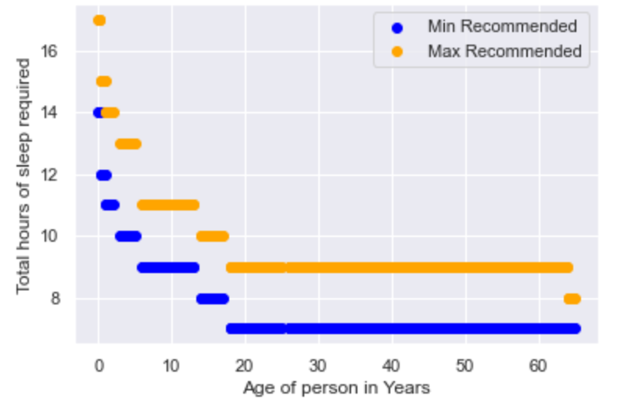

# Line plot

plt.plot(sleepDf['age']/12., sleepDf['min_recommended'], 'g--', label='Min Recommended')

plt.plot(sleepDf['age']/12., sleepDf['max_recommended'], 'r--', label='Max Recommended')

plt.xlabel('Age of person in Years')

plt.ylabel('Total hours of sleep required')

plt.legend()

plt.show()

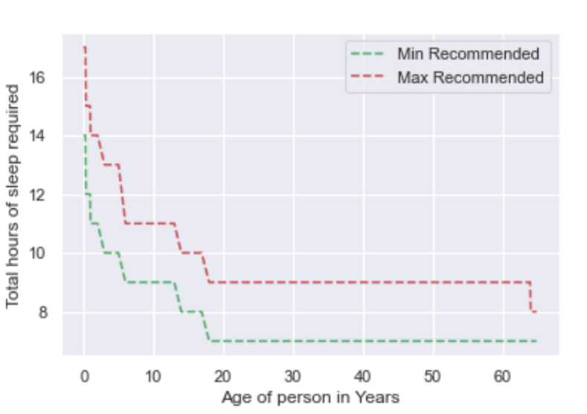

import seaborn as sns

import matplotlib.pyplot as plt

# Set some default parameters of matplotlib

plt.rcParams['figure.figsize'] = (8, 6)

plt.rcParams['figure.dpi'] = 150

# Use style from seaborn. Try to comment the next line and see the difference in graph

sns.set()

# Load the Iris dataset

df = sns.load_dataset('iris')

df['species'] = df['species'].map({'setosa': 0, "versicolor": 1, "virginica": 2})

# A regular scatter plot

plt.scatter(x=df["sepal_length"], y=df["sepal_width"], c=df.species)

# Create labels for axes

plt.xlabel('Sepal Length')

plt.ylabel('Sepal Width')

# Display the plot on the screen

plt.show()

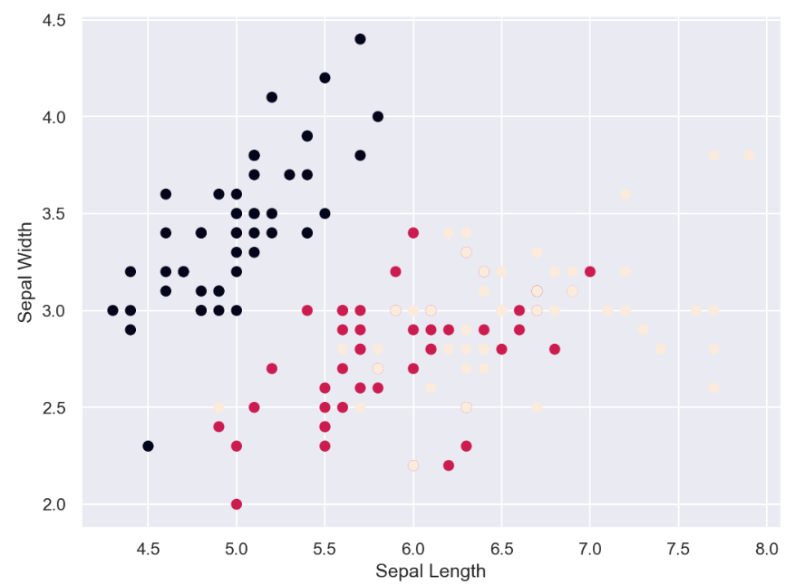

import seaborn as sns

import matplotlib.pyplot as plt

df = sns.load_dataset('iris')

df['species'] = df['species'].map({'setosa': 0, "versicolor": 1, "virginica": 2})

# Create bubble plot

plt.scatter(df.petal_length, df.petal_width, s=50 * df.petal_length * df.petal_width,

c=df.species,

alpha=0.3

)

# Create labels for axes

plt.xlabel('Petal Length')

plt.ylabel('Petal Width')

plt.show()

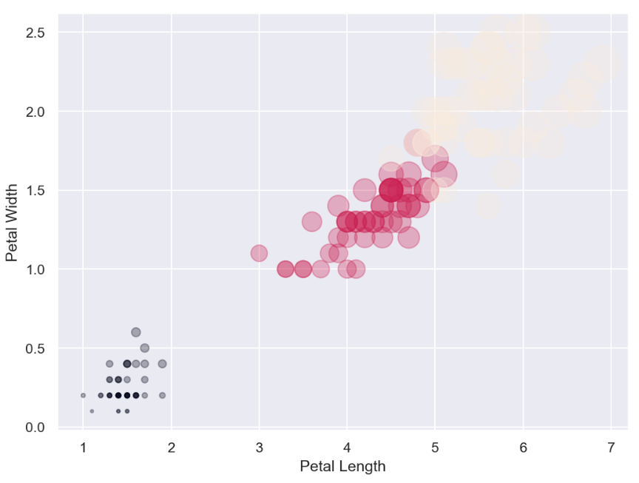

import seaborn as sns

df = sns.load_dataset('iris')

df['species'] = df['species'].map({'setosa': 0, "versicolor": 1, "virginica": 2})

sns.scatterplot(x=df["sepal_length"], y=df["sepal_width"], hue=df.species, data=df)

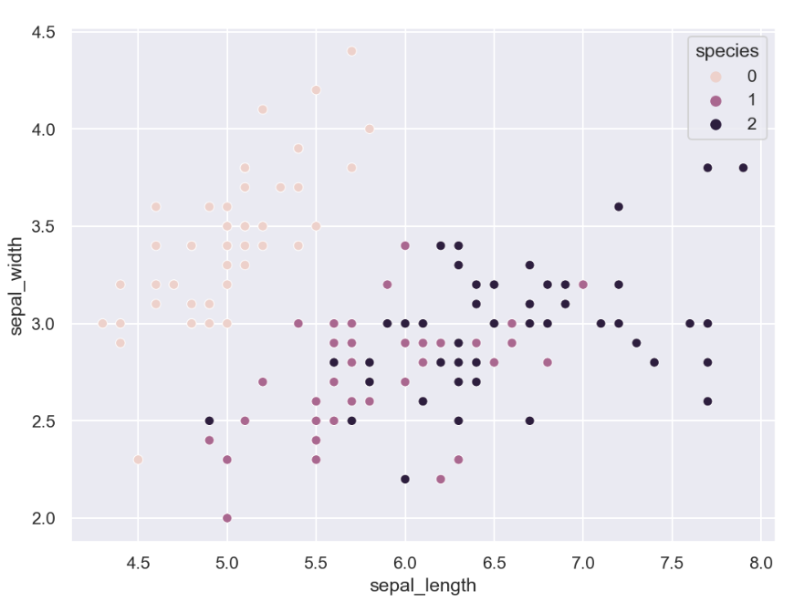

import matplotlib.pyplot as plt

import seaborn as sns

houseLoanMortgage = [9000, 9000, 8000, 9000, 8000, 9000, 9000, 9000, 9000, 8000, 9000, 9000]

utilitiesBills = [4218, 4218, 4218, 4218, 4218, 4218, 4219, 2218, 3218, 4233, 3000, 3000]

transportation = [782, 900, 732, 892, 334, 222, 300, 800, 900, 582, 596, 222]

carMortgage = [700, 701, 702, 703, 704, 705, 706, 707, 708, 709, 710, 711]

import matplotlib.pyplot as plt

import seaborn as sns

months = [x for x in range(1, 13)]

sns.set()

plt.plot([], [], color='sandybrown', label='houseLoanMortgage')

plt.plot([], [], color='tan', label='utilitiesBills')

plt.plot([], [], color='bisque', label='transportation')

plt.plot([], [], color='darkcyan', label='carMortgage')

plt.stackplot(months, houseLoanMortgage, utilitiesBills, transportation, carMortgage, colors=['sandybrown', 'tan', 'bisque', 'darkcyan'])

plt.legend()

plt.title('Household Expenses')

plt.xlabel('Months of the year')

plt.ylabel('Cost')

plt.show()

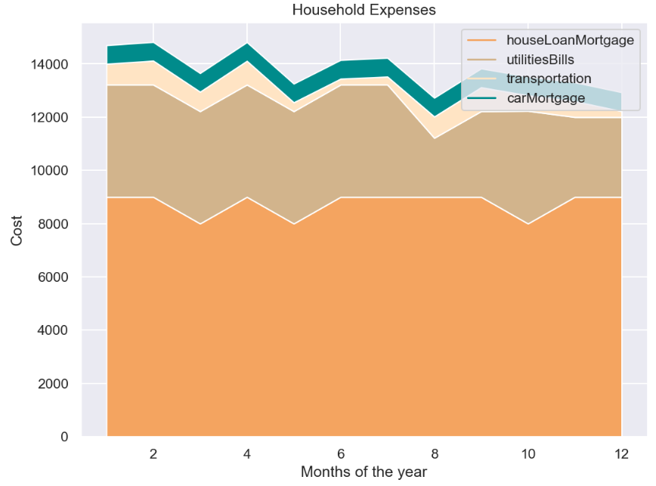

import pandas as pd

url = 'https://raw.githubusercontent.com/hmcuesta/PDA_Book/master/Chapter3/pokemonByType.csv'

# Load the CSV file into a data frame

pokemon = pd.read_csv(url, index_col='type')

# Display the data frame

print(pokemon)

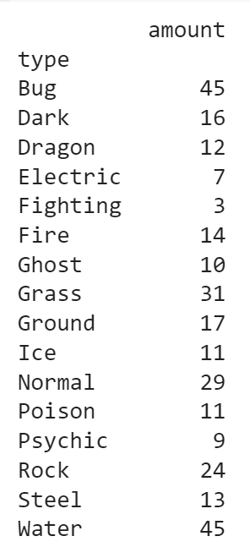

import matplotlib.pyplot as plt

# Assuming 'pokemon' DataFrame is already defined and contains the 'amount' column and has been loaded successfully

plt.pie(pokemon['amount'], labels=pokemon.index, shadow=False, startangle=90, autopct='%1.1f%%')

plt.axis('equal')

plt.show()

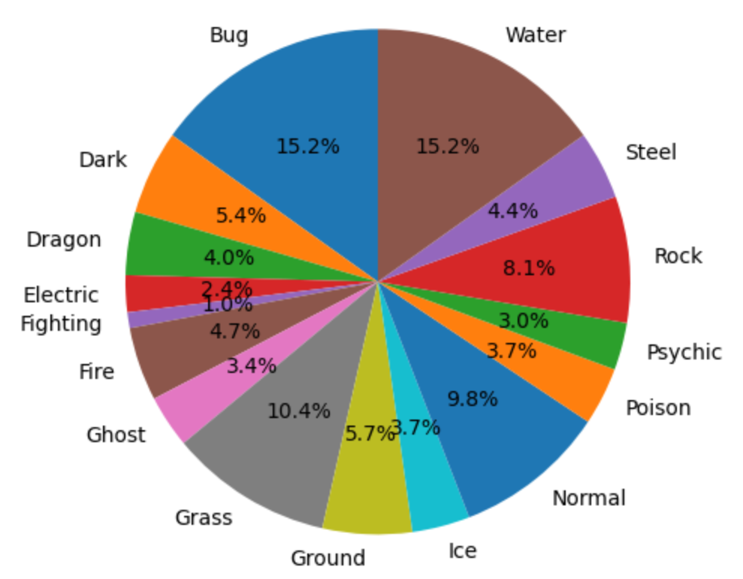

import pandas as pd

import matplotlib.pyplot as plt

# Assuming 'pokemon' DataFrame is already defined and contains the 'amount' column

pokemon.plot.pie(y="amount", figsize=(20, 10), autopct='%1.1f%%')

plt.axis('equal') # Ensures the pie chart is circular

plt.show()

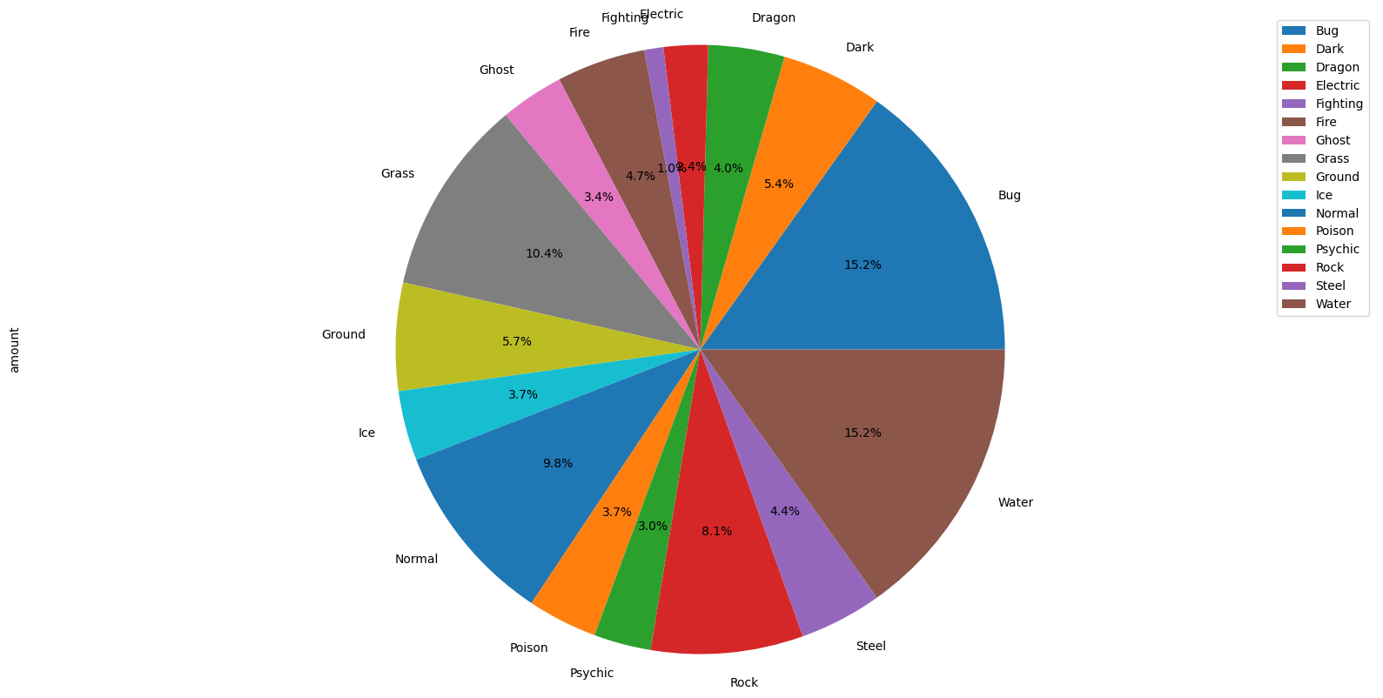

import numpy as np

import pandas as pd

import matplotlib.pyplot as plt

# Assuming 'pokemon' DataFrame is already defined and contains the 'amount' column

pokemon.plot.pie(y="amount", figsize=(20, 10), autopct='%1.1f%%')

plt.axis('equal') # Ensures the pie chart is circular

plt.show()

# Years under consideration

years = ["2010", "2011", "2012", "2013", "2014"]

# Available watt

columns = ['4.5W', '6.0W', '7.0W','8.5W','9.5W','13.5W','15W']

unitsSold = [

[65, 141, 88, 111, 104, 71, 99],

[85, 142, 89, 112, 103, 73, 98],

[75, 143, 90, 113, 89, 75, 93],

[65, 144, 91, 114, 90, 77, 92],

[55, 145, 92, 115, 88, 79, 93],

]

# Define the range and scale for the y-axis

values = np.arange(0, 600, 100)



import numpy as np

import matplotlib.pyplot as plt

# Assuming 'colors', 'index', 'bar_width', 'years', 'columns', and 'unitsSold' are defined

colors = plt.cm.OrRd(np.linspace(0, 0.7, len(years)))

index = np.arange(len(columns)) + 0.3

bar_width = 0.7

y_offset = np.zeros(len(index)) # Update to use len(index) instead of len(columns)

fig, ax = plt.subplots()

cell_text = []

n_rows = len(unitsSold)

for row in range(n_rows):

plot = plt.bar(index, unitsSold[row], bar_width, bottom=y_offset, color=colors[row])

y_offset = y_offset + unitsSold[row]

cell_text.append(['%1.1f' % (x) for x in y_offset])

# Each iteration of this for loop, labels each bar with the corresponding value

for i, rects in enumerate(ax.patches):

height = rects.get_height()

ax.text(rects.get_x() + rects.get_width() / 2, height,

'%d' % int(height),

ha='center', va='bottom')

# Add a table to the bottom of the axes

the_table = plt.table(cellText=cell_text, rowLabels=years,

rowColours=colors, colLabels=columns, loc='bottom')

plt.ylabel("Units Sold")

plt.xticks([])

plt.title('Number of LED Bulbs Sold/Year')

plt.show()

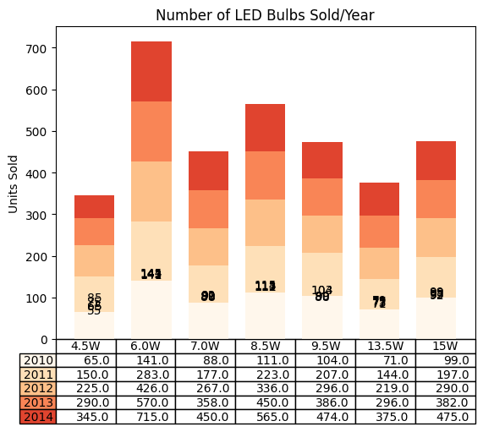

import matplotlib.pyplot as plt

import numpy as np

# Define the variables

subjects = ["C programming", "Numerical methods", "Operating system", "DBMS", "Computer Networks"]

plannedGrade = [90, 95, 92, 68, 68]

actualGrade = [75, 89, 89, 80, 80]

bar_width = 0.35

index = np.arange(len(subjects))

plt.bar(index, plannedGrade, bar_width, label='Planned Grade')

plt.bar(index + bar_width, actualGrade, bar_width, label='Actual Grade')

plt.xlabel('Subjects')

plt.ylabel('Grades')

plt.title('Planned vs. Actual Grades in Courses')

plt.xticks(index + bar_width / 2, subjects)

plt.legend()

plt.show()

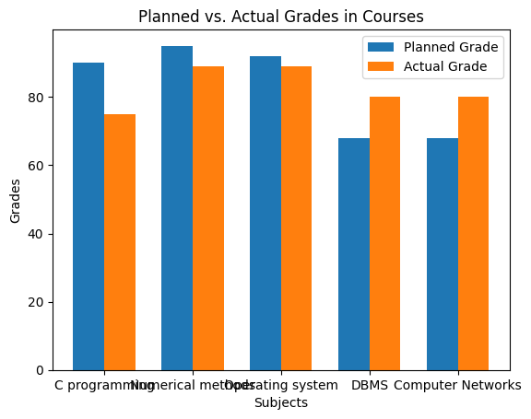

# 1. Import required libraries

import numpy as np

import matplotlib.pyplot as plt

# 2. Prepare the data set.

# Assuming 'subjects', 'plannedGrade', and 'actualGrade' are defined

# 3. Set up theta

theta = np.linspace(0, 2 * np.pi, len(subjects), endpoint=False)

# 4. Initialize the plot by figure size and polar projection

plt.figure(figsize=(10, 6))

plt.subplot(polar=True)

# 5. Get the grid lines to align with each of the subject names.

(lines, labels) = plt.thetagrids(range(0, 360, int(360 / len(subjects))), subjects)

# 6. We use plot method to plot the graph. And fill the area under it.

plt.plot(theta, plannedGrade, label='Planned Grades')

plt.fill(theta, plannedGrade, 'b', alpha=0.2)

# 7. Now, we plot the actual grade obtained

plt.plot(theta, actualGrade, label='Actual Grades')

# 8. Finally, we add a legend and a nice comprehensible title to the plot.

plt.legend(loc='upper right')

plt.title("Planned vs Actual grades by Subject")

# 9. Lastly, we show the plot on the screen.

plt.show()

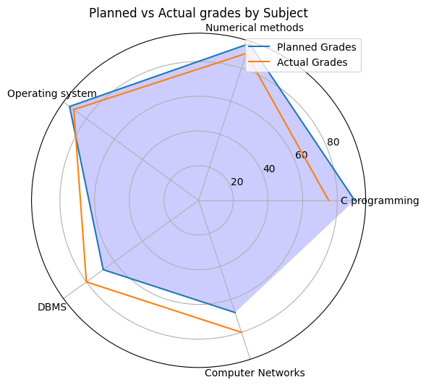

import numpy as np

import matplotlib.pyplot as plt

# 1. Create data set

yearsOfExperience = np.array([10, 16, 14, 5, 10, 11, 16, 14, 3, 14, 13, 19, 2, 5,

11, 11, 14, 2, 20, 15, 11, 1, 15, 15, 15, 2, 9, 18, 1, 17, 18,

13, 9, 20, 13, 17, 13, 15, 17, 10, 2, 11, 8, 5, 19, 2, 4, 9,

17, 16, 13, 18, 5, 7, 18, 15, 20, 2, 7, 0, 4, 14, 1, 14, 18,

8, 11, 12, 2, 9, 7, 11, 2, 6, 15, 2, 14, 13, 4, 6, 15, 3,

6, 10, 2, 11, 0, 18, 0, 13, 16, 18, 5, 14, 7, 14, 18])

yearsOfExperience

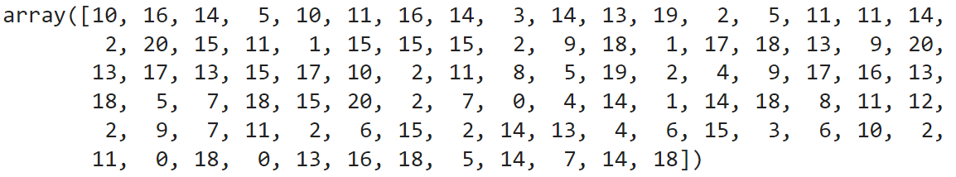

import matplotlib.pyplot as plt

plt.figure(figsize=(10, 6))

# 2. Plot the distribution of group experience

nbins = 20

n, bins, patches = plt.hist(yearsOfExperience, bins=nbins)

# 3. Add labels to the axis and title

plt.xlabel("Years of experience with Python Programming")

plt.ylabel("Frequency")

plt.title("Distribution of Python programming experience in the vocational training set")

# 4. Draw a green vertical line in the graph at the average experience

plt.axvline(x=yearsOfExperience.mean(), linewidth=3, color='g')

# 5. Display the plot

plt.show()

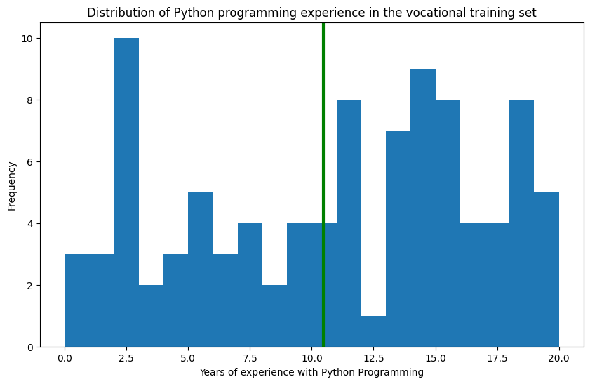

plt.figure(figsize=(10, 6))

# 2. Plot the distribution of group experience

nbins = 20

n, bins, patches = plt.hist(yearsOfExperience, bins=nbins, density=1)

# 3. Add labels to the axis and title

plt.xlabel("Years of experience with Python Programming")

plt.ylabel("Frequency")

plt.title("Distribution of Python programming experience in the vocational training set")

# 4. Draw a green vertical line in the graph at the average experience:

plt.axvline(x=yearsOfExperience.mean(), linewidth=3, color='g')

# 5. Compute mean and standard deviation of the dataset.

mu = yearsOfExperience.mean()

sigma = yearsOfExperience.std()

# 6. Adding a best-fit line for normal distribution.

y = ((1 / (np.sqrt(2 * np.pi) * sigma)) * np.exp(-0.5 * (1 / sigma * (bins - mu))**2))

# 7. Plot the normal distribution

plt.plot(bins, y, '--')

# 8. Display the plot

plt.show()

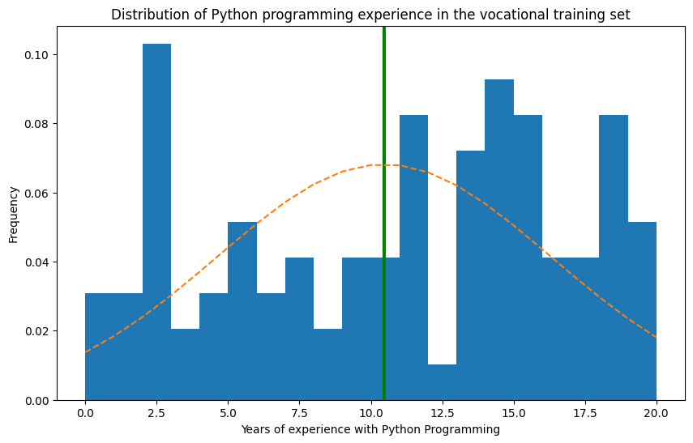

import pandas as pd

import matplotlib.pyplot as plt

# Correct the URL string and complete it

url = 'https://raw.githubusercontent.com/PacktPublishing/Hands-on-Exploratory-Data-Analysis-with-Python/master/Chapter%202/cardata.csv'

carDF = pd.read_csv(url)

# 2. Group by manufacturer and take average mileage

processedDF = carDF[['cty', 'manufacturer']].groupby('manufacturer').apply(lambda x: x.mean())

# 3. Sort the values by cty and reset index

processedDF.sort_values('cty', inplace=True)

processedDF.reset_index(inplace=True)

# 4. Plot the graph

fig, ax = plt.subplots(figsize=(16, 10), dpi=80)

ax.vlines(x=processedDF.index, ymin=0, ymax=processedDF.cty, color='firebrick', alpha=0.7, linewidth=2)

ax.scatter(x=processedDF.index, y=processedDF.cty, s=75, color='firebrick', alpha=0.7)

# 5. Annotate Title

ax.set_title('Lollipop Chart for Highway Mileage using car dataset', fontdict={'size': 22})

# 6. Annotate labels and xticks, ylim

ax.set_ylabel('Miles Per Gallon')

ax.set_xticks(processedDF.index)

ax.set_xticklabels(processedDF.manufacturer.str.upper(), rotation=65, fontdict={'horizontalalignment': 'right'})

ax.set_ylim(0, 30)

# 7. Write the values in the plot

for row in processedDF.itertuples():

ax.text(row.Index, row.cty + 0.5, s=round(row.cty, 2), horizontalalignment='center', verticalalignment='bottom')

# 8. Display the plot on the screen

plt.show()

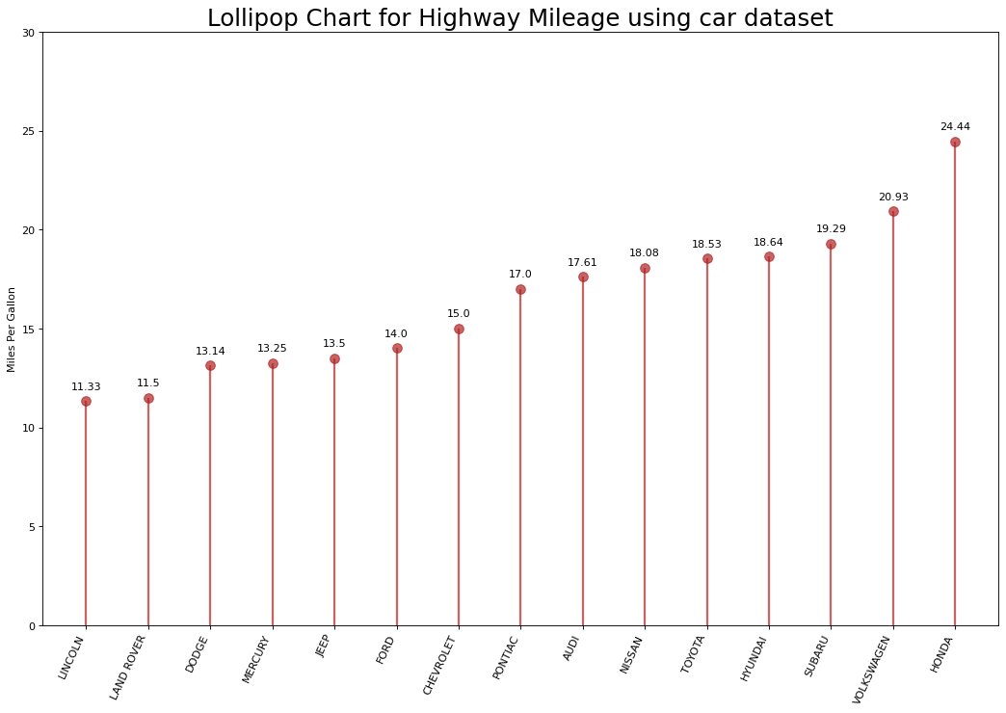

import numpy as np

# Defining 1D array

my1DArray = np.array([1, 8, 27, 64])

print(my1DArray)

# Defining and printing 2D array

my2DArray = np.array([[1, 2, 3, 4], [2, 4, 9, 16], [4, 8, 18, 32]])

print(my2DArray)

# Defining and printing 3D array

my3Darray = np.array([[[1, 2, 3, 4], [5, 6, 7, 8]], [[1, 2, 3, 4], [9, 10, 11, 12]]])

print(my3Darray)

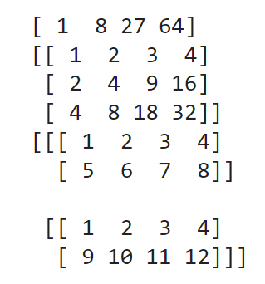

# Print out memory address

print(my2DArray.data)

# Print the shape of array

print(my2DArray.shape)

# Print out the data type of the array

print(my2DArray.dtype)

# Print the stride of the array

print(my2DArray.strides)

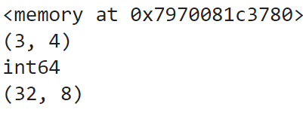

import pandas as pd

columns = ['age', 'workclass', 'fnlwgt', 'education', 'education_num',

'marital_status', 'occupation', 'relationship', 'ethnicity', 'gender','capital_gain']

df = pd.read_csv('http://archive.ics.uci.edu/ml/machine-learning-databases/adult/adult.data', names=columns)

df.head(10)

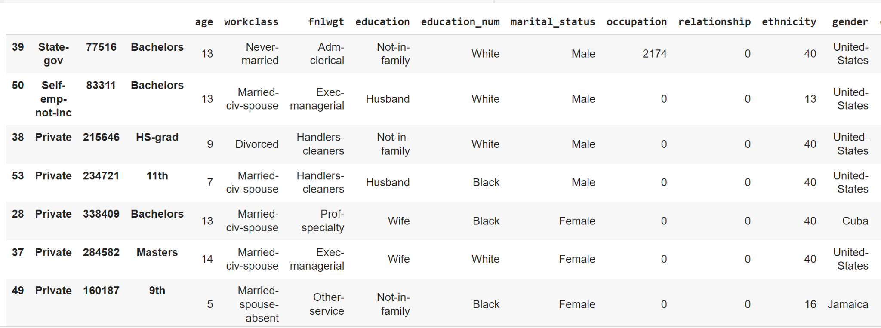

df.info()

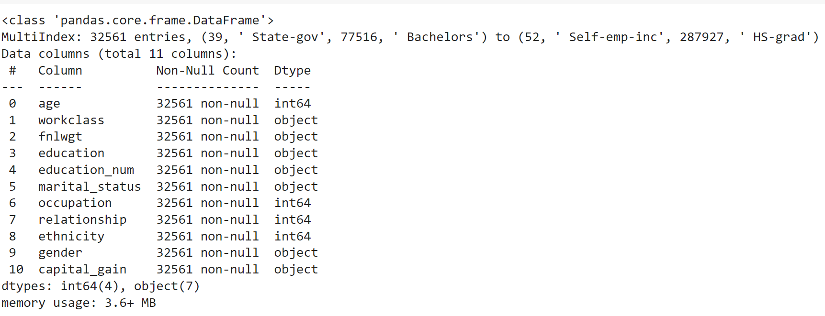

def colorNegativeValueToRed(value):

if value < 0:

color = 'red'

elif value > 0:

color = 'black'

else:

color = 'green'

return f'color: {color}'

# Example usage:

value = -5

styled_text = colorNegativeValueToRed(value)

print(styled_text)

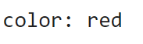

import pandas as pd

import numpy as np

np.random.seed(24)

df = pd.DataFrame({'F': np.linspace(1, 10, 10)})

df = pd.concat([df, pd.DataFrame(np.random.randn(10, 5), columns=list('EDCBA'))],

axis=1)

df.iloc[0, 2] = np.nan

df

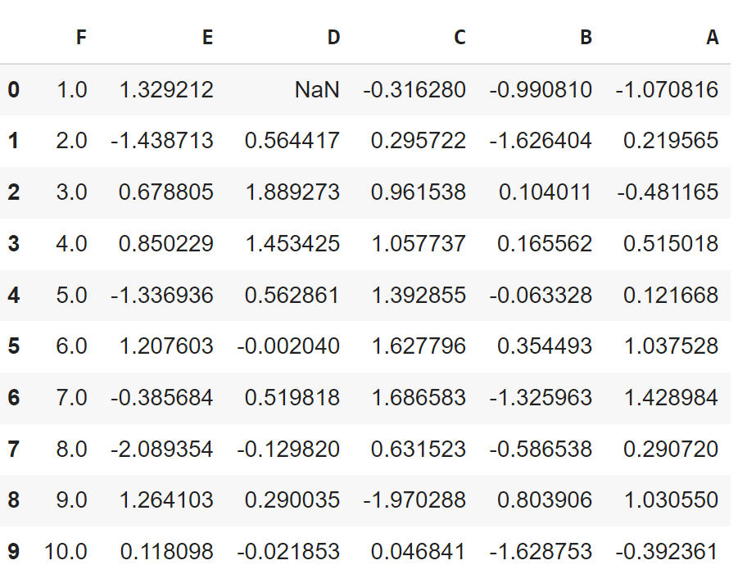

def colorNegativeValueToRed(value):

if value < 0:

color = 'red'

elif value > 0:

color = 'black'

else:

color = 'green'

return 'color: %s' % color

s = df.style.applymap(colorNegativeValueToRed)

s

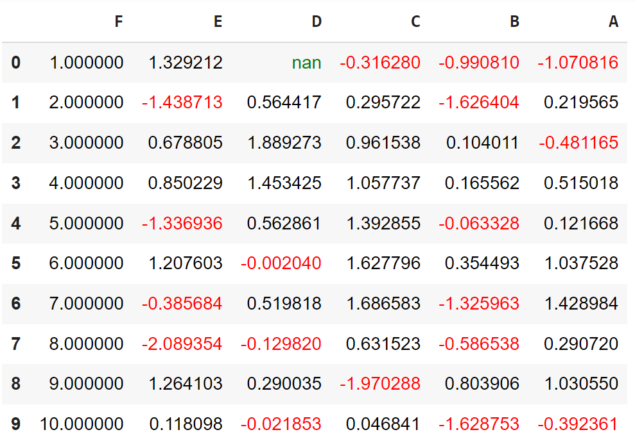

# Let us highlight max value in the column with green background and min value with oran

def highlightMax(s):

isMax = s == s.max()

return ['background-color: orange' if v else '' for v in isMax]

def highlightMin(s):

isMin = s == s.min()

return ['background-color: green' if v else '' for v in isMin]

df.style.apply(highlightMax).apply(highlightMin).highlight_null(null_color='red')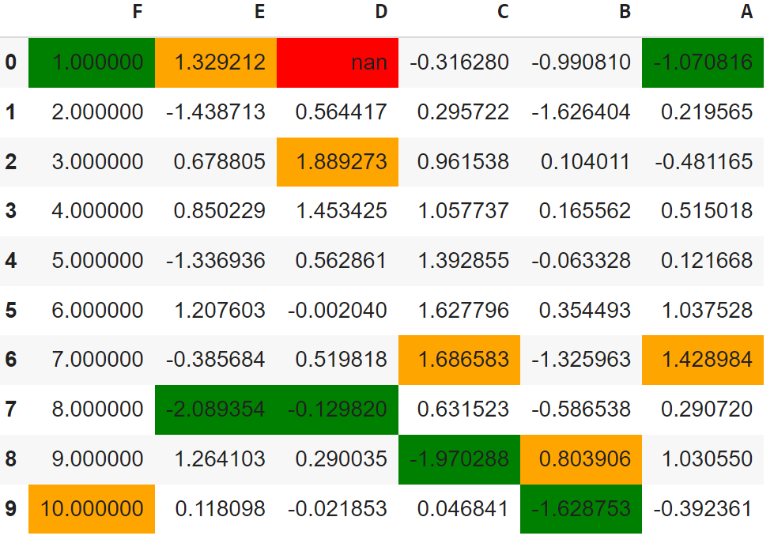

import seaborn as sns

cm = sns.light_palette("pink", as_cmap=True)

s = df.style.background_gradient(cmap=cm)

s

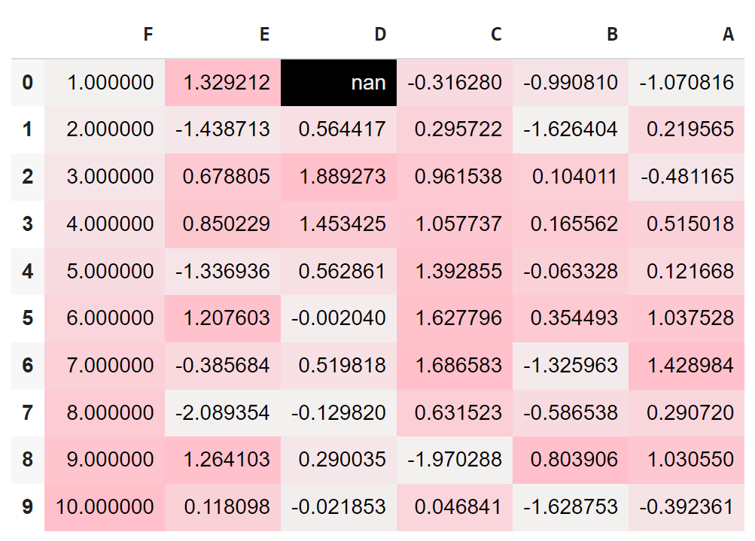

**RESULT**

Thus, working with Numpy Arrays, Pandas DataFrames, Basic Plotting using matplotlib has been executed successfully.

**DATE: EXERCISE : 04**

**EXPLORE VARIOUS VARIABLE AND ROW FILTERS IN R FOR CLEANING DATA. APPLY VARIOUS PLOT FEATURES IN R ON SAMPLE DATA SETS AND VISUALIZE.**

**AIM**

To explore various variable and row filters in R for cleaning data and apply various plot features in R on sample data sets and visualize them.

**PROCEDURE**

**Install R:**  Install R from the official website or using a package manager.

**Install RStudio (Optional):**

1. RStudio provides a user-friendly interface for working with R.
2. Use functions like read.csv() or read.table() to load your dataset into R.
3. Utilize functions like head(), summary(), and str() to get an overview of the dataset.
4. Identify and handle missing values using functions like is.na() and complete.cases().
5. Apply filters using functions like subset() or logical indexing to select specific rows based on conditions.
6. Choose relevant variables using indexing or the select() function from the dplyr package.
7. Use duplicated() and distinct() to identify and remove duplicate rows.

**Applying Various Plot Features in R:**

**Install Required Packages:** Install necessary packages like ggplot2 for advanced plotting.

**Create Basic Plots:**

1. Use functions like plot() for basic plots.
2. Create more sophisticated plots using the ggplot() function from the ggplot2 package.
3. Adjust plot aesthetics, titles, labels, and themes to enhance visualization.
4. Explore different types of plots such as scatter plots, bar plots, box plots, and histograms.
5. Explore packages like plotly for interactive and dynamic plots.
6. Save plots using ggsave() or display them in the R environment.
7. Use plots to visualize relationships between variables and gain insights into the dataset

**PROGRAM**

data <- read.csv("iris.csv")

print(data)

Id SepalLengthCm SepalWidthCm PetalLengthCm PetalWidthCm Species

1 1 5.1 3.5 1.4 0.2 Iris-setosa

2 2 4.9 3.0 1.4 0.2 Iris-setosa

3 3 4.7 3.2 1.3 0.2 Iris-setosa

4 4 4.6 3.1 1.5 0.2 Iris-setosa

5 5 5.0 3.6 1.4 0.2 Iris-setosa

6 6 5.4 3.9 1.7 0.4 Iris-setosa

7 7 4.6 3.4 1.4 0.3 Iris-setosa

8 8 5.0 3.4 1.5 0.2 Iris-setosa

9 9 4.4 2.9 1.4 0.2 Iris-setosa

10 10 4.9 3.1 1.5 0.1 Iris-setosa

11 11 5.4 3.7 1.5 0.2 Iris-setosa

PL <- iris$Petal.Length

PW <- iris$Petal.Width

plot(PL, PW)

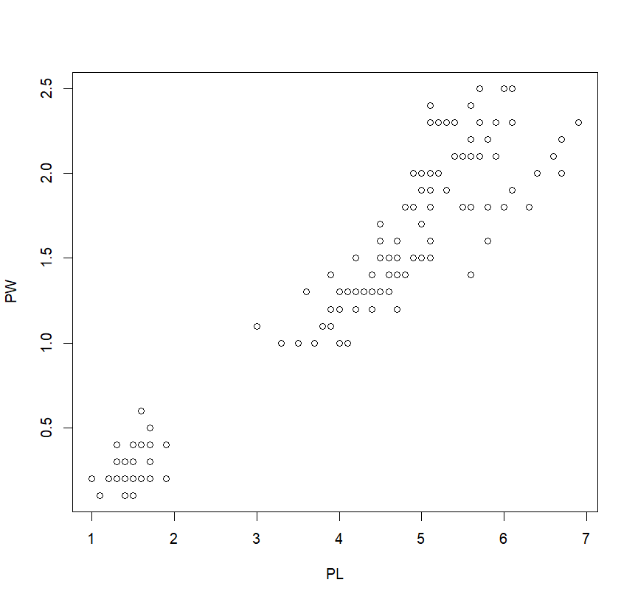

iris$Species

**[1] setosa setosa setosa setosa setosa setosa setosa setosa**

**[9] setosa setosa setosa setosa setosa setosa setosa setosa**

**[17] setosa setosa setosa setosa setosa setosa setosa setosa**

**[25] setosa setosa setosa setosa setosa setosa setosa setosa**

**[33] setosa setosa setosa setosa setosa setosa setosa setosa**

**[41] setosa setosa setosa setosa setosa setosa setosa setosa**

**[49] setosa setosa versicolor versicolor versicolor versicolor versicolor versicolor**

**[57] versicolor versicolor versicolor versicolor versicolor versicolor versicolor versicolor**

**[65] versicolor versicolor versicolor versicolor versicolor versicolor versicolor versicolor**

**[73] versicolor versicolor versicolor versicolor versicolor versicolor versicolor versicolor**

**[81] versicolor versicolor versicolor versicolor versicolor versicolor versicolor versicolor**

**[89] versicolor versicolor versicolor versicolor versicolor versicolor versicolor versicolor**

**[97] versicolor versicolor versicolor versicolor virginica virginica virginica virginica**

speciesID <- as.numeric(iris$Species)

speciesID

**[1] 1 1 1 1 1 1 1 1 1 1 1 1 1 1 1 1 1 1 1 1 1 1 1 1 1 1 1 1 1 1 1 1 1 1 1 1 1 1 1 1 1 1 1 1 1**

**[46] 1 1 1 1 1 2 2 2 2 2 2 2 2 2 2 2 2 2 2 2 2 2 2 2 2 2 2 2 2 2 2 2 2 2 2 2 2 2 2 2 2 2 2 2 2**

**[91] 2 2 2 2 2 2 2 2 2 2 3 3 3 3 3 3 3 3 3 3 3 3 3 3 3 3 3 3 3 3 3 3 3 3 3 3 3 3 3 3 3 3 3 3 3**

**[136] 3 3 3 3 3 3 3 3 3 3 3 3 3 3 3**

plot(PL, PW, pch = speciesID, col = "green")

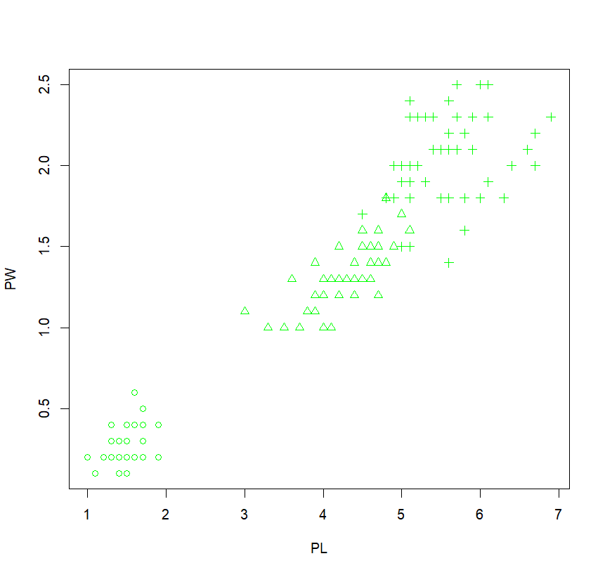

plot(PL, PW, pch = speciesID, col = speciesID)

plot(PL, PW,

pch = speciesID,

col = speciesID,

xlab = "Petal length (cm)",

ylab = "Petal width (cm)",

main = "Petal width vs. length"

)

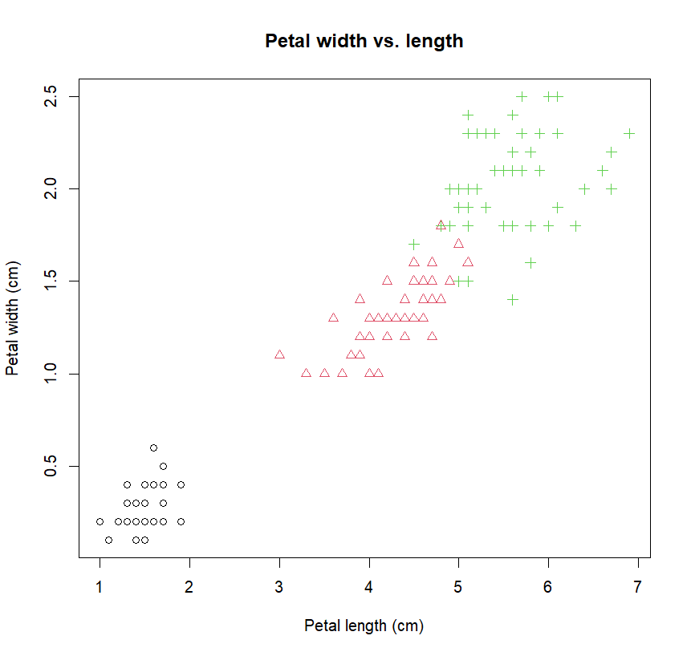

install.packages("ggplot2") library(ggplot2) ggplot(data = iris) + aes(x = Petal.Length, y = Petal.Width) + geom_point(aes(color = Species, shape = Species)) + geom_smooth(method = lm) + annotate("text", x = 5, y = 0.5, label = "R=0.96")

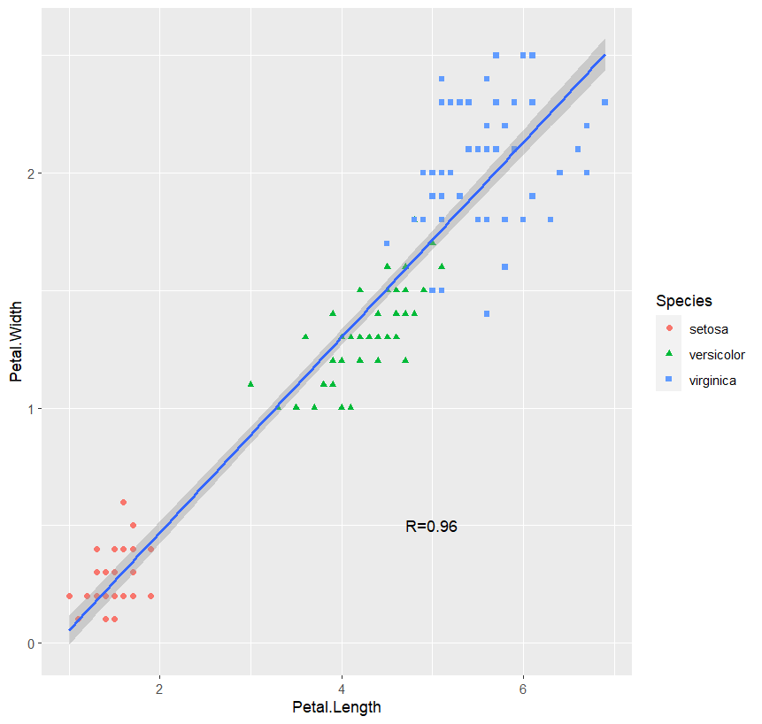

ggplot(iris) + aes(x = Petal.Length, y = Petal.Width) +

geom_point(aes(color = Species, shape = Species)) + geom_smooth(method = lm) + line annotate("text", x = 5, y = 0.5, label = "R=0.96") + xlab("Petal length (cm)") + ylab("Petal width (cm)") + ggtitle("Correlation between petal length and width") # title

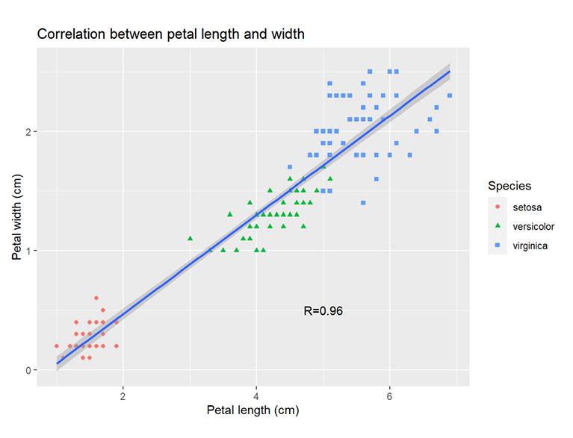

**RESULT**

Thus, the variable and row filters in R for data cleaning with the "iris" dataset, applying scatter plots and ggplot2 features to visually represent relationships and patterns have been explored successfully.

**DATE: EXERCISE : 05**

**PERFORM TIME SERIES ANALYSIS AND APPLY THE VARIOUS VISUALIZATION TECHNIQUES.**

**AIM**

To perform time Series Analysis and apply the various visualization techniques.

**PROCEDURE**

1.Start

2. Install Required Packages:Install necessary R or Python packages such as pandas, numpy, matplotlib, and statsmodels.

3. Load Time Series Data:Import time series data into a data frame or series.

4. Check Data Structure:Inspect the data types, indices, and general structure of the time series.

5. Handle Missing Values:Address missing values using methods like interpolation or filling with relevant values.

6. Convert to Time Series Object:Convert the data to a time series object for easier manipulation and analysis.

7. Explore Basic Statistics:Calculate basic statistics such as mean, median, and standard deviation.

8. Visualize Time Series:Plot the time series data to understand patterns and trends using line plots.

9. Decompose Time Series:Decompose the time series into components (trend, seasonality, and residuals) using methods like additive or multiplicative decomposition.

10. Stationarity Check:Ensure stationarity of the time series by checking mean, variance, and autocorrelation.

11. Apply Time Series Models:Utilize time series models such as ARIMA (AutoRegressive Integrated Moving Average) or SARIMA for forecasting.

12. Evaluate Model Performance:Assess model performance using metrics like Mean Squared Error (MSE) or Root Mean Squared Error (RMSE).

13. Forecast Future Values:Forecast future values using the trained time series model.

14. Stop.

**PROGRAM**

import numpy as np

import pandas as pd

df=pd.read_csv("Electric_Production.csv")

df

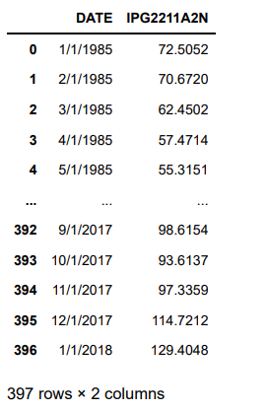

df.rename(columns={'DATE':'date','IPG2211A2N':'production'},inplace=True) df.tail()

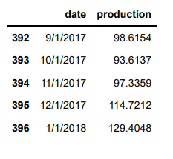

df.describe()

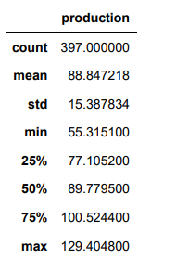

df.info()

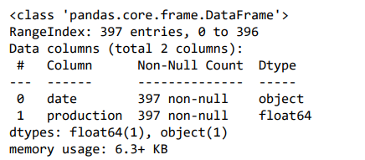

df.isnull().sum()

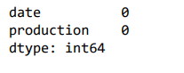

df['date'] = pd.to_datetime(df.date)

df.set_index('date' ,inplace=True)

df[['production']].plot()

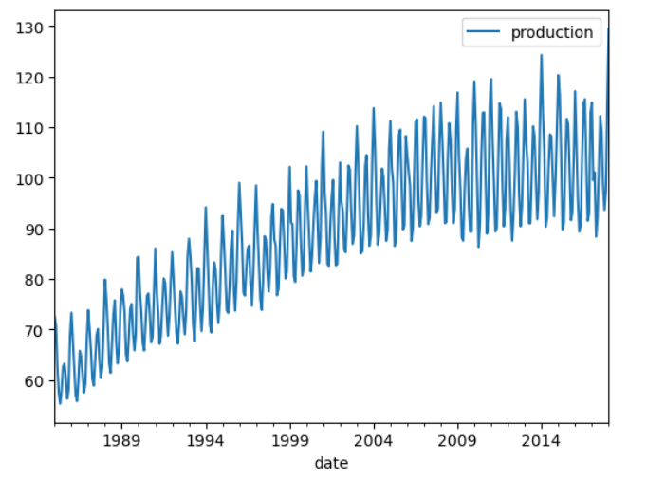

data_roll_production =df[['production']].rolling(12).mean().plot()

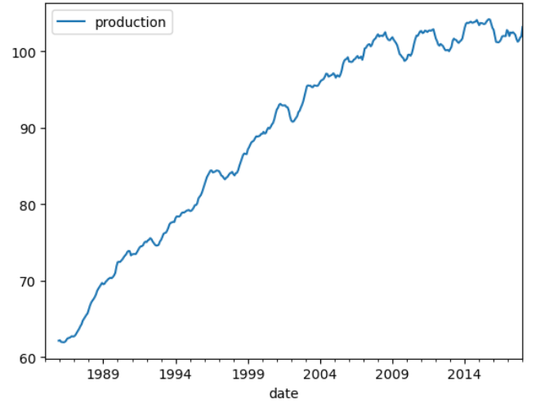

import matplotlib.pyplot as plt

from statsmodels.tsa.seasonal import seasonal_decompose

decomposition = seasonal_decompose(x=df['production'],model='additive',period decomposition.plot()

plt.show()

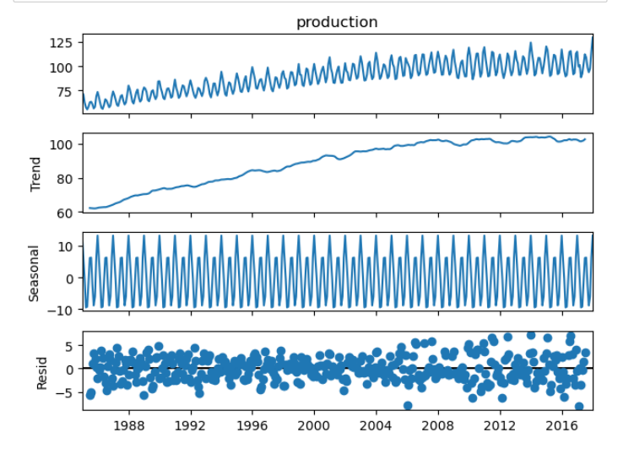

df.shape



df_test = df[['production']].iloc[300:]

df_train = df[[ 'production']].iloc[:299]

df_train.shape



df_test.shape



from statsmodels.tsa.arima.model import ARIMA

arima_model = ARIMA(df_train['production'],order=(2,1,3)).fit()

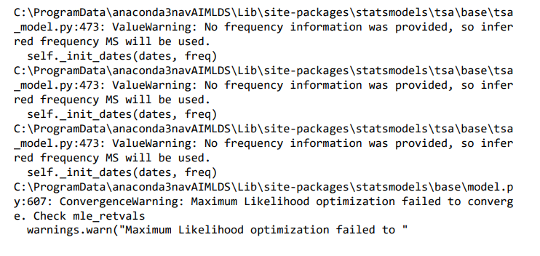

df_pred = arima_model.predict(start= 300 , end= 396)

# plot actual vs. predicted

fig = plt.figure(figsize=(20, 10))

plt.title('ARMA Predictions', fontsize=30)

plt.plot(df_test['production'], label='actual', color='#ABD1DC')

plt.plot(df_pred, label='predicted', color='#C6A477')

plt.legend(fontsize =20, loc='upper left')

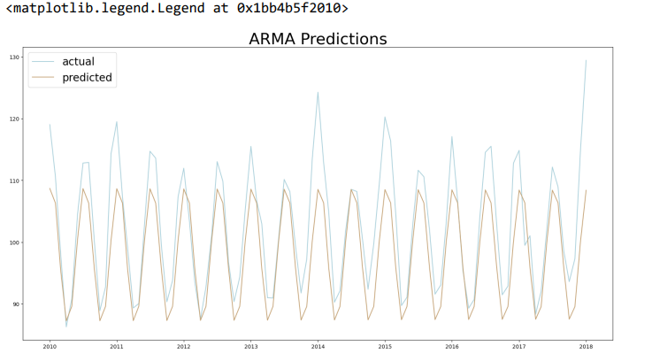

df_pred_upper_dataset = arima_model.predict(start= 380 , end= 450)

# plot actual vs. predicted

fig = plt.figure(figsize=(20, 10))

plt.title('ARMA Predictions', fontsize=30)

plt.plot(df_test['production'], label='actual', color='#ABD1DC') plt.plot(df_pred_upper_dataset, label='predicted', color='#C6A477') plt.legend(fontsize =20, loc='upper left')

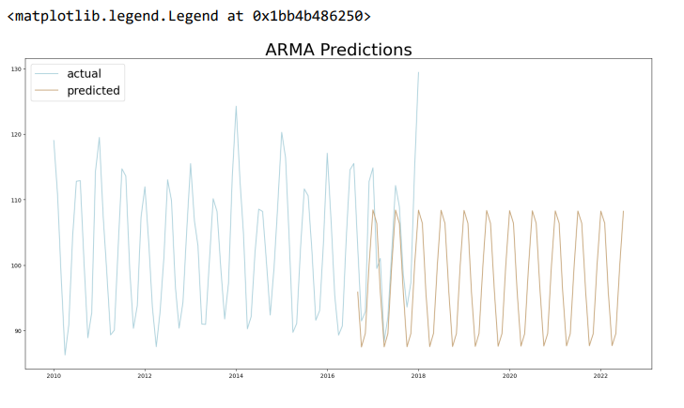

from sklearn.metrics import mean_squared_error

from math import sqrt

rmse = sqrt(mean_squared_error(df_test['production'], df_pred))

print("RMSE:", round(rmse,2))

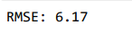

arima_model.summary()

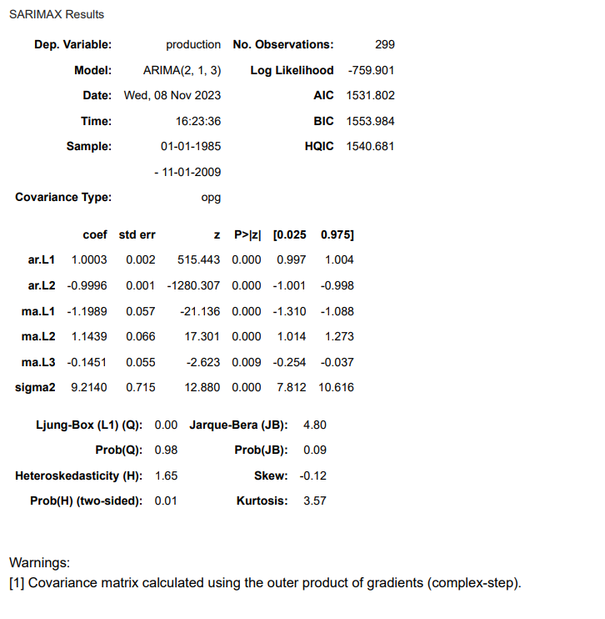

**RESULT**

Thus, the performance of Time Series Analysis and application of the various visualization techniques have been executed successfully.

**DATE: EXERCISE : 06**

**PERFORM DATA ANALYSIS AND REPRESENTATION ON A MAP USING VARIOUS MAP DATA SETS WITH MOUSE ROLLOVER EFFECT, USER INTERACTION, ETC..**

**AIM**

To perform Data Analysis and representation on a Map using various Map data sets with Mouse Rollover effect, user interaction, etc.

**PROCEDURE**

1. Install the required libraries by executing the command: `!pip install folium plotly pandas`

2. Import the necessary libraries in your Python script or Jupyter Notebook:

`import pandas as pd`

`import folium`

`import plotly.express as px`

3. Create or load the data for visualization. Ensure the data includes relevant columns such as 'Country', 'Value', 'Lat', and 'Lon'.

4. Create an interactive scatter plot on a geographical map using Plotly Express. Use latitude and longitude for positioning markers.

5. For an animated map with marker size changes over time, create a DataFrame with timestamps. Utilize the `animation_frame` parameter for time-based animation.

6. Create an interactive scatter plot with a hover effect using Plotly Express. The hover effect should display additional information when hovering over markers.

7. Develop an animated map with a time-related column and a hover effect. The animation should show changes over time with additional details on hover.

8. Create a choropleth map showing the world's GDP per capita. Include India state boundaries for a comprehensive visualization.

9. Upload GeoJSON files for Indian states and districts. Load GeoJSON files for Indian states and districts for further visualization.

10. Use Plotly Express to create choropleth maps for Indian states and districts. Customize the maps with relevant data and styles for clarity.

11. Display the created maps for interactive exploration and analysis. Ensure the maps provide clear insights into the geographical and statistical information being visualized.

**PROGRAM**

pip install folium plotly pandas

import pandas as pd

import folium

import plotly.express as px

import plotly.express as px

# Simulated data for illustration purposes

data = {

'Country': ['USA', 'Canada', 'India', 'China', 'Brazil'],

'Value': [30, 15, 25, 50, 10],

'Lat': [37.7749, 56.1304, 20.5937, 35.8617, -14.2350],

'Lon': [-122.4194, -106.3468, 78.9629, 104.1954, -51.9253]

}

df = pd.DataFrame(data)

# Plotting the interactive map

fig = px.scatter_geo(

df,

lat='Lat',

lon='Lon',

color='Value',

size='Value',

hover_name='Country',

projection='natural earth',

)

# Adding simulated data to the map

fig.update_geos(

showcoastlines=True,

coastlinecolor="Black",

showland=True,

landcolor="LightGreen",

showocean=True,

oceancolor="LightBlue",

)

# Add title and show the map

fig.update_layout(title_text='Sample Interactive Geomap', geo=dict(showframe=False))

fig.show()

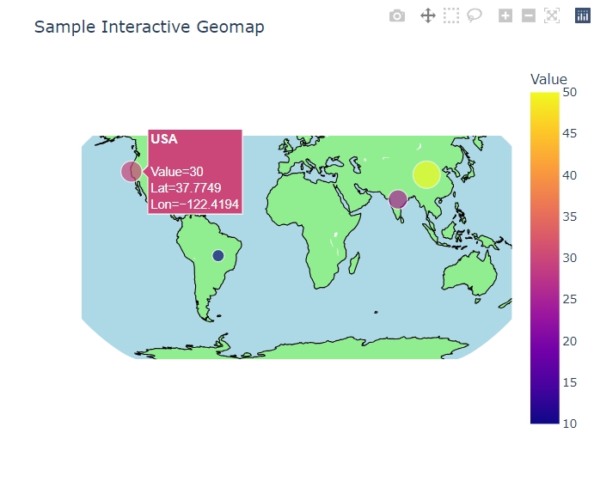

import plotly.express as px

import numpy as np

# Simulated data with a temporal dimension

np.random.seed(42)

num_frames = 5

timestamps = pd.date_range('2023-01-01', periods=num_frames, freq='M')

data = {

'Country': np.repeat(['USA', 'Canada', 'India', 'China', 'Brazil'], num_frames),

'Value': np.random.randint(10, 50, size=num_frames * 5),

'Lat': np.repeat([37.7749, 56.1304, 20.5937, 35.8617, -14.2350], num_frames),

'Lon': np.repeat([-122.4194, -106.3468, 78.9629, 104.1954, -51.9253], num_frames),

'Timestamp': np.tile(timestamps.strftime('%Y-%m-%d'), 5)

}

df = pd.DataFrame(data)

# Plotting the animated map with size changing over time

fig = px.scatter_geo(

df,

lat='Lat',

lon='Lon',

color='Value',

size='Value',

hover_name='Country',

animation_frame='Timestamp',

projection='natural earth',

title='Animated Geomap with Marker Size Changes Over Time',

range_color=[min(df['Value']), max(df['Value'])],

size_max=50 # Set the maximum size for better visualization

)

# Adding simulated data to the map

fig.update_geos( showcoastlines=True, coastlinecolor="Black", showland=True,

landcolor="LightGreen",

showocean=True,

oceancolor="LightBlue",

)

# Add title and show the map

fig.update_layout(geo=dict(showframe=False))

fig.show()

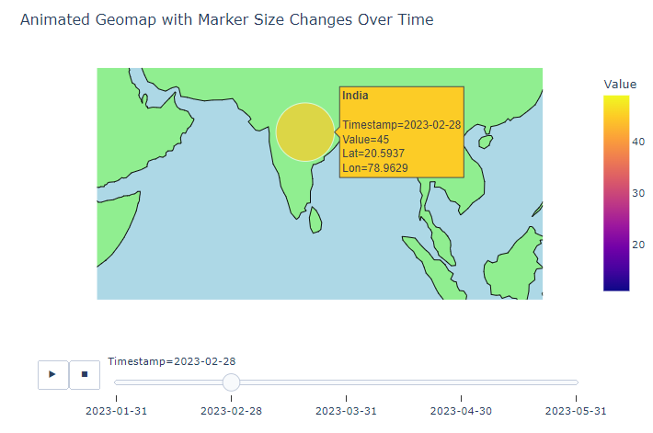

import plotly.express as px

# Simulated data for illustration purposes

data = {

'Country': ['USA', 'Canada', 'India', 'China', 'Brazil'],

'Value': [30, 15, 25, 50, 10],

'Lat': [37.7749, 56.1304, 20.5937, 35.8617, -14.2350],

'Lon': [-122.4194, -106.3468, 78.9629, 104.1954, -51.9253]

}

df = pd.DataFrame(data)

# Plotting the interactive map with hover effect

fig = px.scatter_geo(

df,

lat='Lat', lon='Lon', color='Value',

size='Value',

hover_name='Country',

text='Value', # Text to display on hover

projection='natural earth',

)

# Adding simulated data to the map

fig.update_geos( showcoastlines=True, coastlinecolor="Black", showland=True, landcolor="LightGreen", showocean=True, oceancolor="LightBlue",

)

# Add title and show the map

fig.update_layout(title_text='Sample Interactive Geomap with Hover Effect', geo=dict(showframe=False))

fig.show()

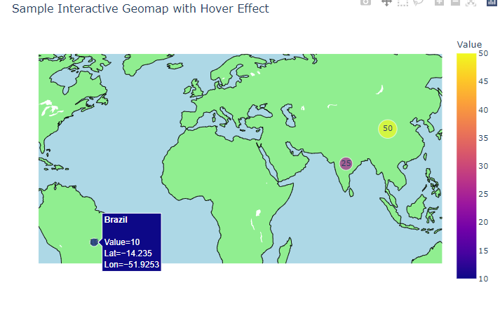

import plotly.express as px

# Simulated data with a time-related column

data = {

'Country': ['USA', 'Canada', 'India', 'China', 'Brazil'],

'Value': [30, 15, 25, 50, 10],

'Lat': [37.7749, 56.1304, 20.5937, 35.8617, -14.2350],

'Lon': [-122.4194, -106.3468, 78.9629, 104.1954, -51.9253],

'Year': [2010, 2011, 2012, 2013, 2014]

}

df = pd.DataFrame(data)

# Plotting the animated map

fig = px.scatter_geo(

df,

lat='Lat', lon='Lon', color='Value', size='Value', hover_name='Country', animation_frame='Year', # Animation based on the 'Year' column

projection='natural earth',

)

# Adding simulated data to the map

fig.update_geos( showcoastlines=True, coastlinecolor="Black", showland=True,

landcolor="LightGreen", showocean=True, oceancolor="LightBlue",

)

# Add title and show the animated map

fig.update_layout(title_text='Animated Geomap with Hover Effect', geo=dict(showframe=False))

fig.show()

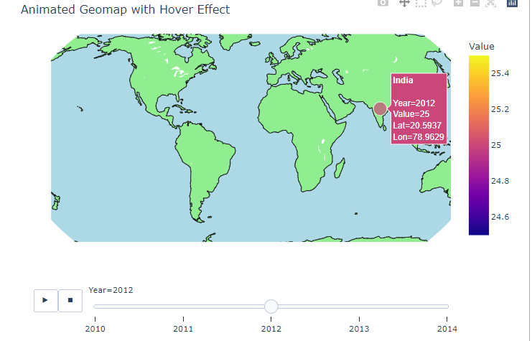

import plotly.express as px

# Sample data for illustration purposes

countries_data = px.data.gapminder().query("year == 2007")

india_states_data = px.data.gapminder().query("country == 'India'")

# You would need actual district-level data for India

# Plotting the cartographic visualization

fig = px.choropleth(

countries_data,

locations="iso_alpha",

color="gdpPercap",

hover_name="country",

title="World Map with GDP per Capita",

projection="natural earth",

)

# Add India state boundaries

fig.update_geos( showcountries=True, countrycolor="grey", showsubunits=True, subunitcolor="blue", subunitwidth=1,

)

# Add India state-level data

fig.add_trace(

px.choropleth_mapbox(

india_states_data, locations="iso_alpha", color="gdpPercap", hover_name="country", mapbox_style="carto-positron", zoom=3, opacity=0.5,

).data[0]

)

# Show the map

fig.show()

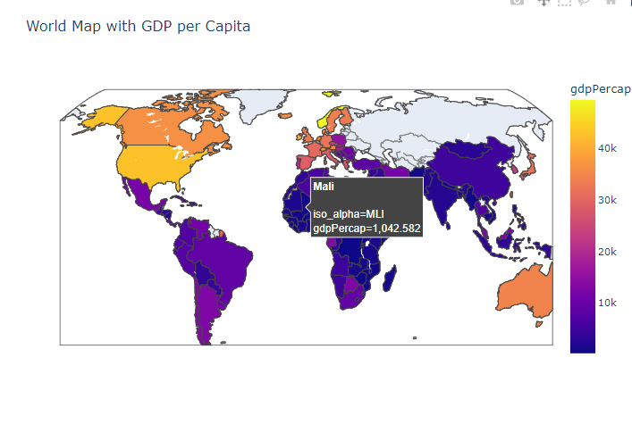

import json

import plotly.express as px

from google.colab import files

# Upload GeoJSON files

uploaded_states = files.upload()

uploaded_districts = files.upload()

# Print the keys to see the filenames

print("Uploaded States Keys:", uploaded_states.keys())

print("Uploaded Districts Keys:", uploaded_districts.keys())

# Choose the correct filenames based on the keys

states_filename = next(iter(uploaded_states.keys()))

districts_filename = next(iter(uploaded_districts.keys()))

# Save uploaded files

with open('states_india.geojson', 'wb') as f:

f.write(uploaded_states[states_filename])

with open('india_district.geojson', 'wb') as f:

f.write(uploaded_districts[districts_filename])

# Load GeoJSON files for Indian states and districts

with open('states_india.geojson', 'r') as f:

india_states_geojson = json.load(f)

with open('india_district.geojson', 'r') as f:

india_districts_geojson = json.load(f)

# Sample data for illustration purposes

states_data = {

'State': ['Maharashtra', 'Uttar Pradesh', 'Karnataka', 'Gujarat', 'Tamil Nadu'],

'Value': [30, 15, 25, 50, 10],

}

districts_data = {

'District': ['Mumbai', 'Lucknow', 'Bangalore', 'Ahmedabad', 'Chennai'],

'Value': [10, 5, 8, 15, 3],

}

# Plotting the cartographic visualization for states

fig_states = px.choropleth_mapbox(

states_data,

geojson=india_states_geojson,

featureidkey='properties.ST_NM',

locations='State',

color='Value',

mapbox_style="carto-positron",

center={"lat": 20.5937, "lon": 78.9629},

zoom=4,

opacity=0.7,

title="Indian States Visualization",

)

# Plotting the cartographic visualization for districts

fig_districts = px.choropleth_mapbox(

districts_data,

geojson=india_districts_geojson,

featureidkey='properties.DISTRICT',

locations='District',

color='Value',

mapbox_style="carto-positron",

center={"lat": 20.5937, "lon": 78.9629},

zoom=4,

opacity=0.7,

title="Indian Districts Visualization",

)

# Show the maps

fig_states.show()

fig_districts.show()

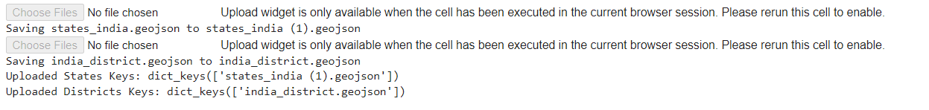

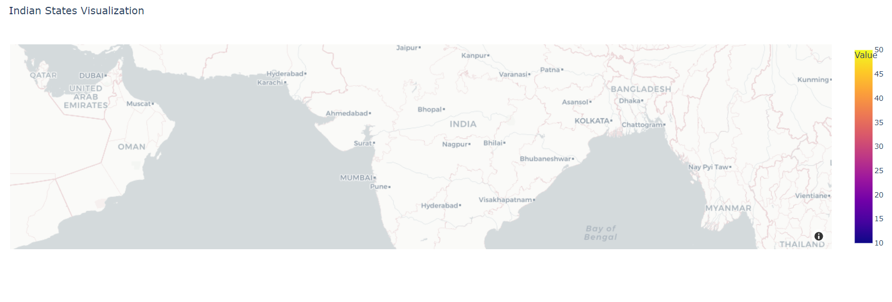

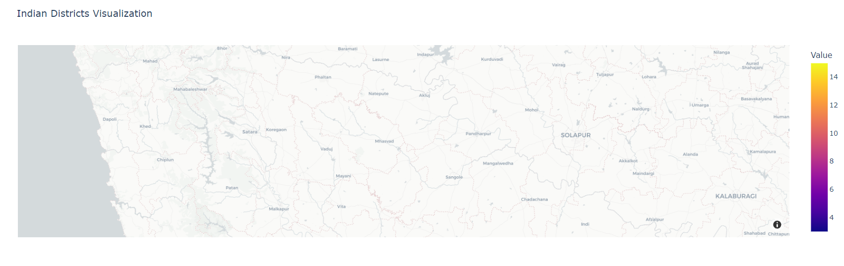

**RESULT**

Thus, Data Analysis and representation on a Map using various Map data sets with Mouse Rollover effect, user interaction, etc. has been executed successfully.

**DATE: EXERCISE : 07**

**BUILD CARTOGRAPHIC VISUALIZATION FOR MULTIPLE DATASETS INVOLVING VARIOUS COUNTRIES OF THE WORLD; STATES AND DISTRICTS IN INDIA ETC.**

**AIM**

To build cartographic visualization for multiple datasets involving various countries of the world; states and districts in India etc.

**PROCEDURE**

1. Start
2. Install Required Packages:
   1. Install necessary packages such as geopandas and geodatasets.
3. Import Libraries:
   1. Import required libraries, including geopandas and matplotlib.pyplot.
4. Read Data:
   1. Read the shapefile into a GeoDataFrame.
5. Extract Relevant Columns:
   1. Create a new GeoDataFrame with only the relevant columns (e.g., "NAME" and "geometry").
6. Plot GeoDataFrame:
   1. Plot the GeoDataFrame using matplotlib.pyplot with specified parameters.
7. Calculate and Display Area:
   1. Calculate the area of each geometry and add it as a new column in the GeoDataFrame.
   2. Optionally, filter out specific regions (e.g., Antarctica) if needed.
8. Display Final Plot:
   1. Show the final plot with the updated GeoDataFrame.
9. Stop

**PROGRAM**

pip install geopandas

pip install geodatasets

import geopandas as gpd

import matplotlib.pyplot as plt

world=gpd.read_file("Visualizing Geographicalset.shp”) world

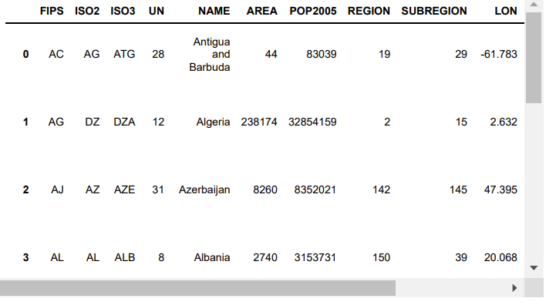

world_data=world[["NAME","geometry"]]

fig, ax = plt.subplots(1, figsize=(50, 50))

world_data.plot(cmap='viridis', linewidth=0.8, ax=ax, edgecolor='0.8')

plt.axis('off')

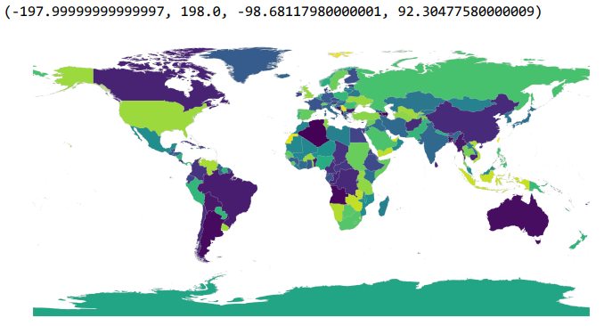

world_data['area']=world.area

world_data

world_data['area']=world.area

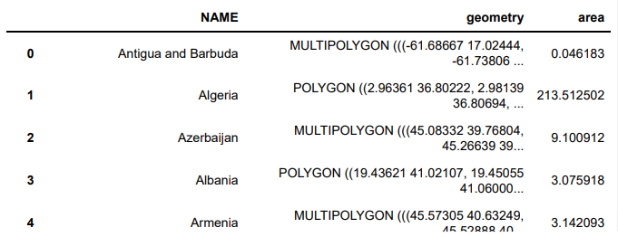

fig, ax = plt.subplots(1, figsize=(50, 50))

world_data = world_data[world_data['NAME'] != 'Antarctica']

world_data.plot(cmap='viridis', linewidth=0.8, ax=ax, edgecolor='0.8')

plt.axis('off')

plt.show()

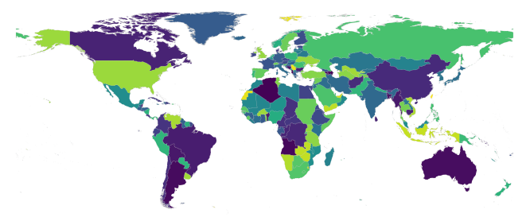

fig, ax = plt.subplots(1, figsize=(50, 50))

current_crs = world_data.crs

world_data.to_crs(epsg = 3857, inplace = True)

world_data.plot(column = 'NAME',cmap='nipy_spectral', linewidth=0.8, ax=ax)

plt.axis('off')

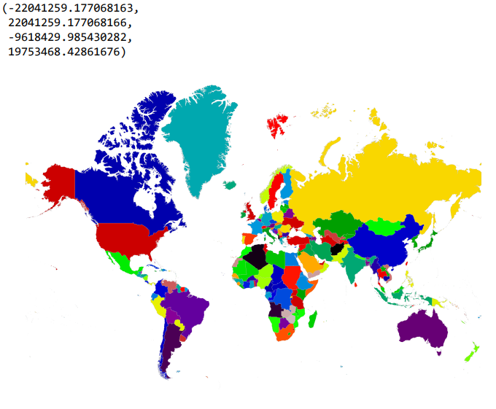

world_data['area'] = world_data.area/1000000

world_data.plot(column = 'area' , cmap = 'viridis' , legend = True, legend_kwds = {'label': "Area of the country (Sq. Km.)"}, figsize=(4,4))

fig plt.axis('off')

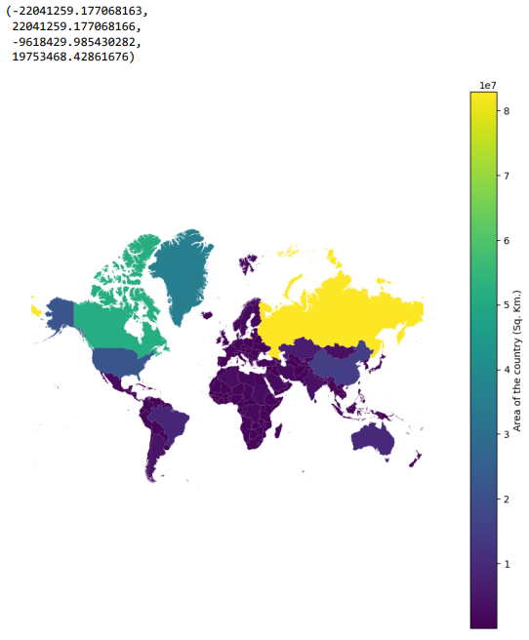

fig, ax = plt.subplots(figsize = (30,30)) world_data.plot(column = 'NAME' , cmap = 'hsv' , legend = None, legend_kwds = {'label': "Area of the country (Sq. Km.)"}, ax = ax)

plt.axis('off')

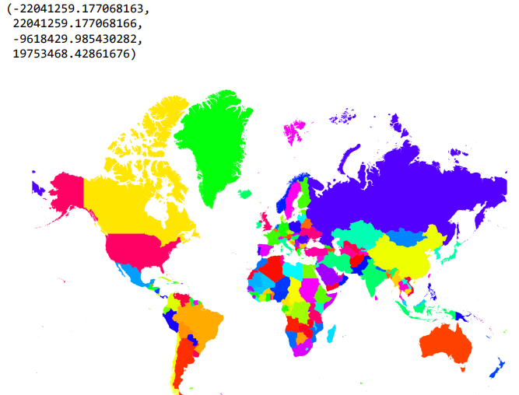

import geodatasets

usa = gpd.read_file(geodatasets.get_path('geoda.natregimes'))

usa

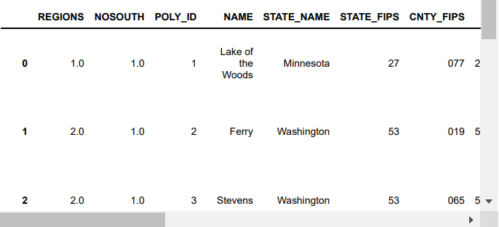

fig, ax = plt.subplots(1, figsize=(20, 20))

usa.plot(cmap='viridis', linewidth=0.8, ax=ax)

plt.axis('off')

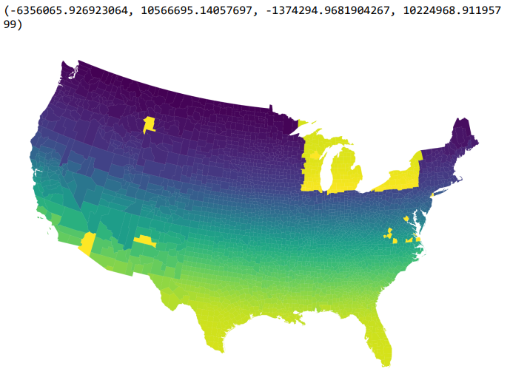

usa.boundary.plot()

plt.axis('off')

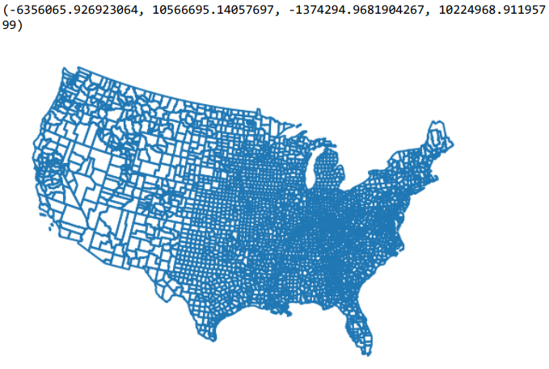

usa = usa.to_crs(epsg = 3547)

fig, ax = plt.subplots(1, figsize=(20, 20))

usa.plot(cmap='winter', linewidth=0.8, ax=ax)

plt.axis('off')

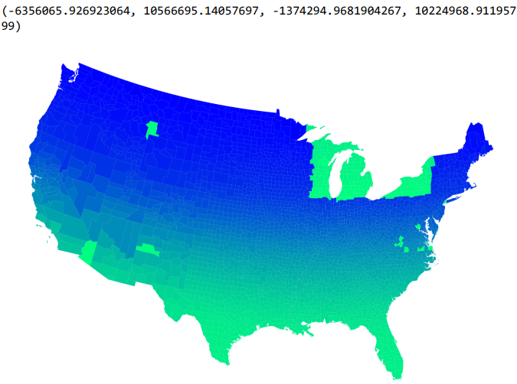

#Indonesia

Indo=gpd.read_file("Indonesia.shp”)

Indo

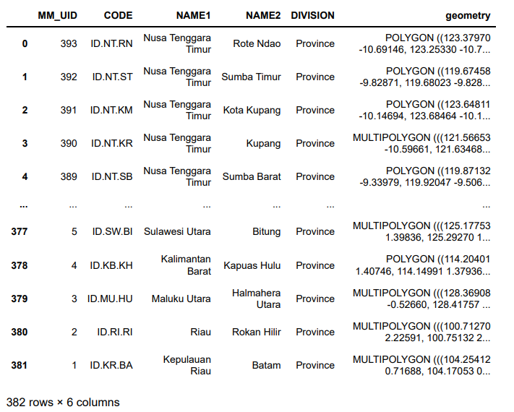

Indo.plot()

plt.axis('off')

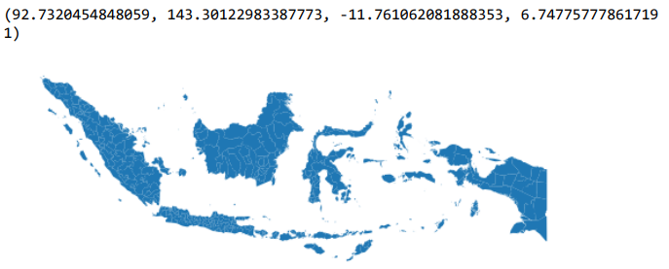

#Germany

Ger=gpd.read_file("DEU_a Germany.shp”)

Ger

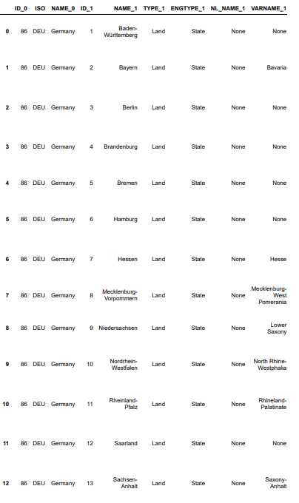

fig, ax = plt.subplots(1, figsize=(20,15))

ax = Ger.plot(cmap='RdYlBu', linewidth=0.8, ax=ax)

Ger.apply(lambda x: ax.annotate(text=x['NAME_1'], xy=x.geometry.centroid.coords[0], ha='center'), axis=1)

plt.axis('off')

plt.show()

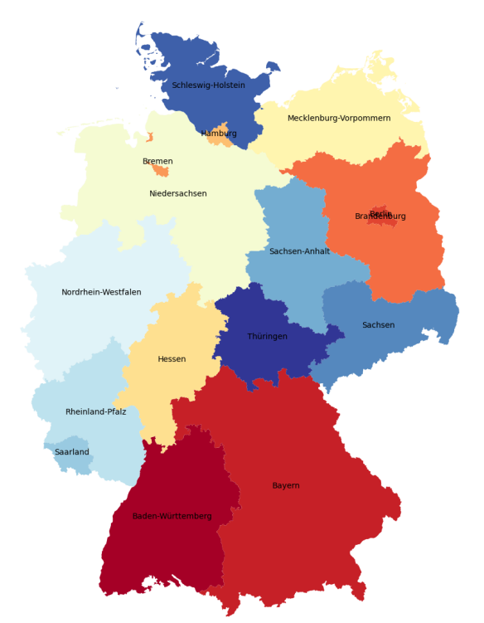

Ger.plot(cmap="viridis", edgecolor="k", categorical=True, legend=True)

plt.axis('off')

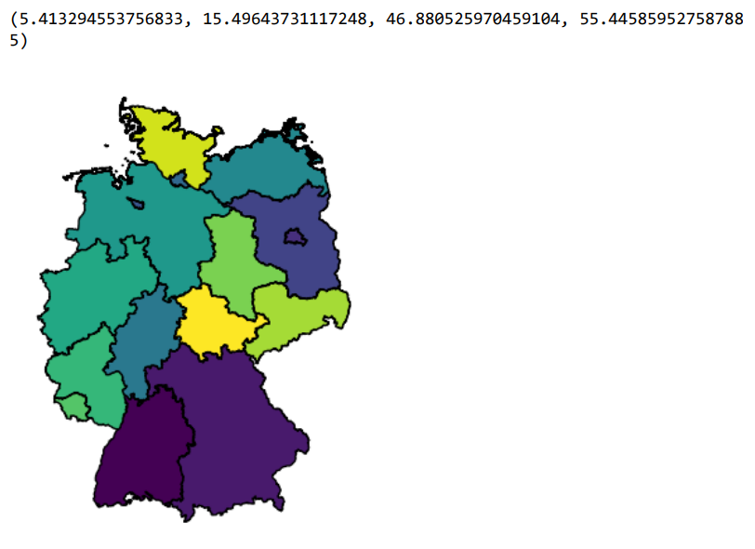

Ger.plot(cmap='plasma', legend=True, scheme='quantiles')

plt.axis('off')

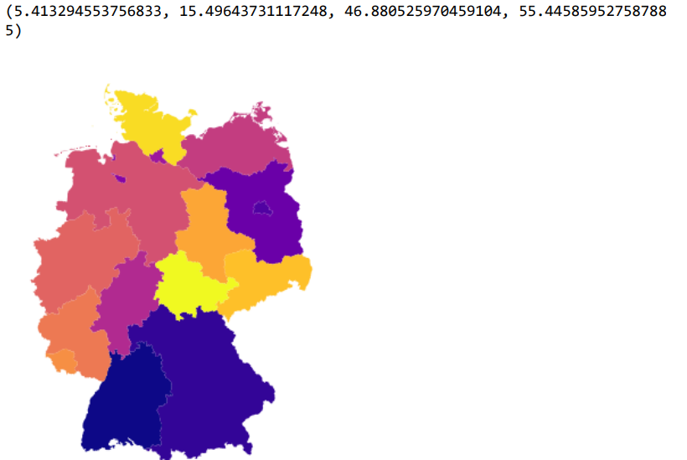

#China

Chn=gpd.read_file("StatPlanet_China\China.shp”)

Chn

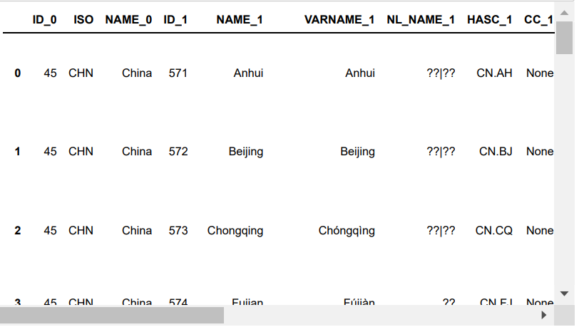

fig, ax = plt.subplots(1, figsize=(20,15))

ax = Chn.plot(cmap='RdYlBu', linewidth=0.8, ax=ax)

Chn.apply(lambda x: ax.annotate(text=x['NAME_1'], xy=x.geometry.centroid.coords[0], ha='center'), axis=1)

plt.axis('off')

plt.show()

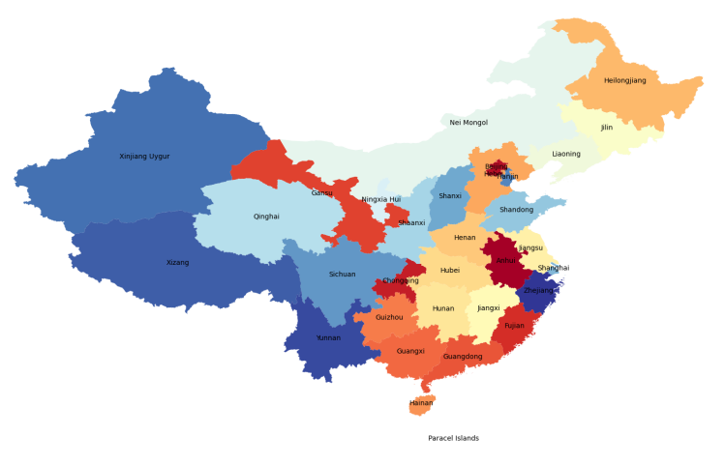

fig, ax = plt.subplots(1, figsize=(20, 20))

Chn.plot(cmap='viridis', linewidth=0.8, ax=ax,scheme='quantiles')

plt.axis('off')

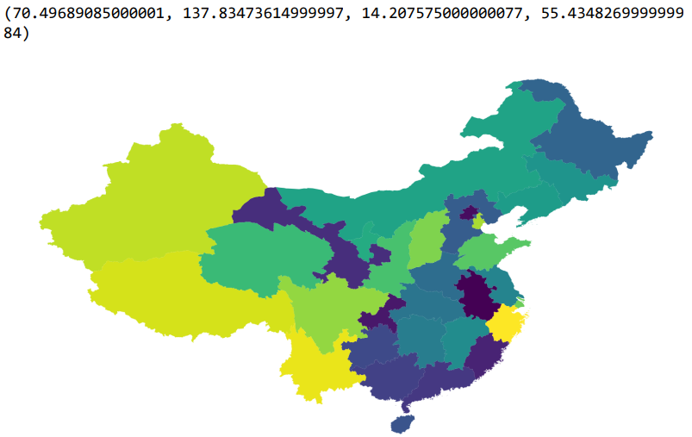

#UK

Uk=gpd.read_file("StatPlanet_UK\\UK.shp”)

Uk

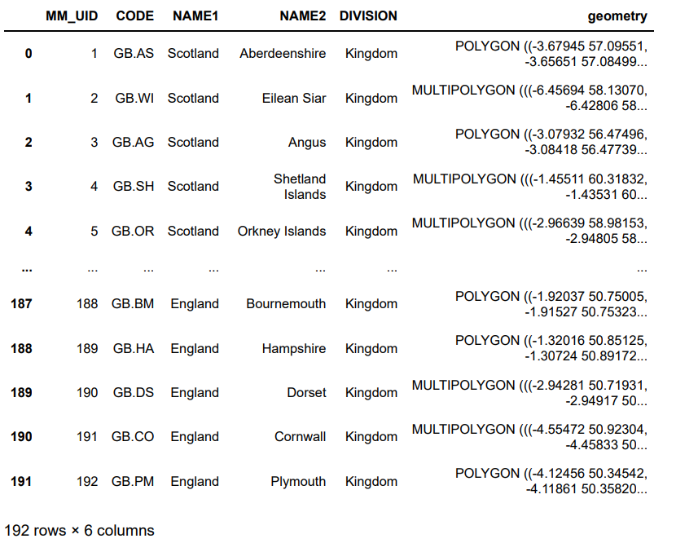

fig, ax = plt.subplots(1, figsize=(20,15))

ax = Uk.plot(cmap='RdYlBu', linewidth=0.8, ax=ax)

plt.axis('off')

plt.show()

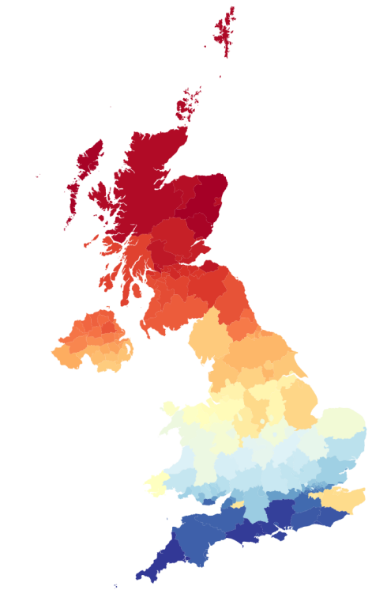

Uk.crs = "epsg:3547"

fig, ax = plt.subplots(1, figsize=(20,20))

ax = Uk.plot(cmap='coolwarm', linewidth=0.8, ax=ax)

plt.axis('off')

plt.show()

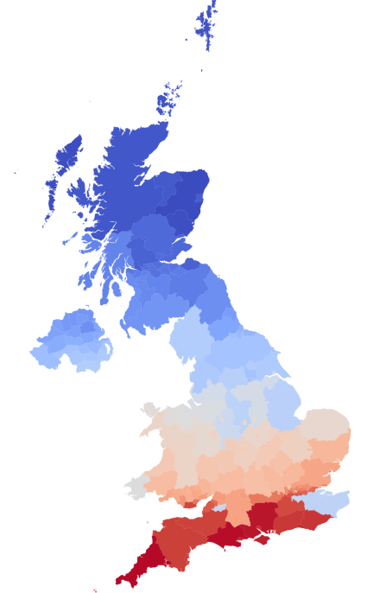

fig, ax = plt.subplots(1, figsize=(20, 20))

Uk.plot(cmap='viridis', linewidth=0.8, ax=ax,scheme='quantiles')

plt.axis('off')

(485489.3002651772, 1265297.1915127523, 5467579.373502172, 6834953.45866401 7)

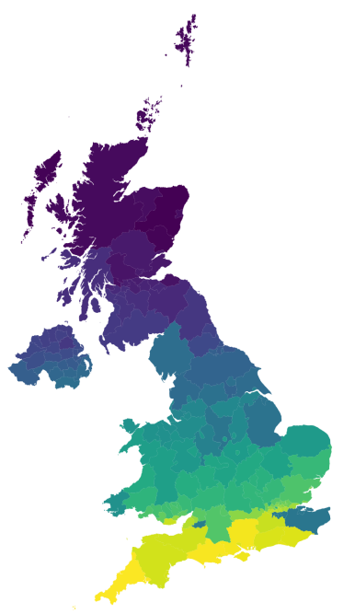

#India

India=gpd.read_file("India\\INDIA.shp”)

India

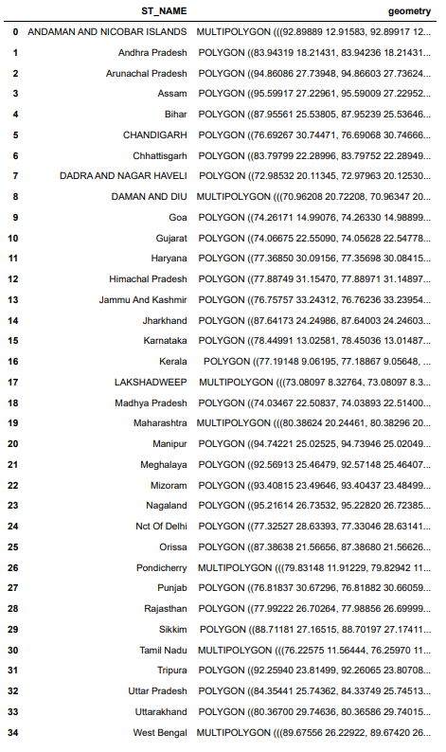

fig, ax = plt.subplots(1, figsize=(20, 20))

India.plot(cmap='terrain', linewidth=0.8, ax=ax,scheme='quantiles')

plt.axis('off')

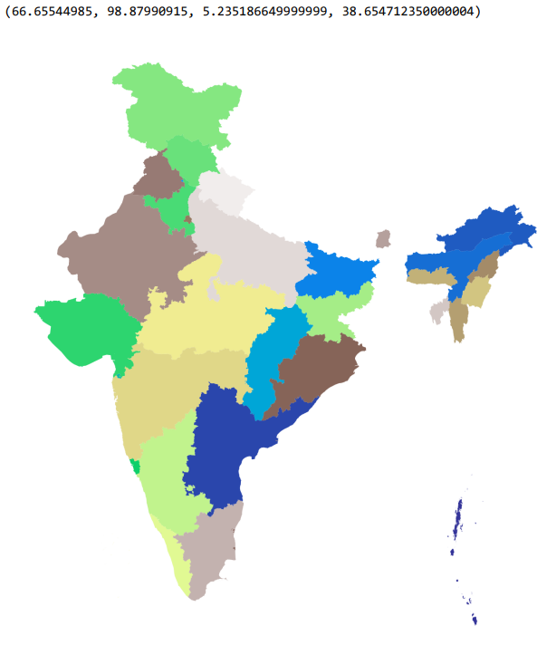

fig, ax = plt.subplots(1, figsize=(20, 20))

India.plot(cmap='viridis', linewidth=0.8, ax=ax)

plt.axis('off')

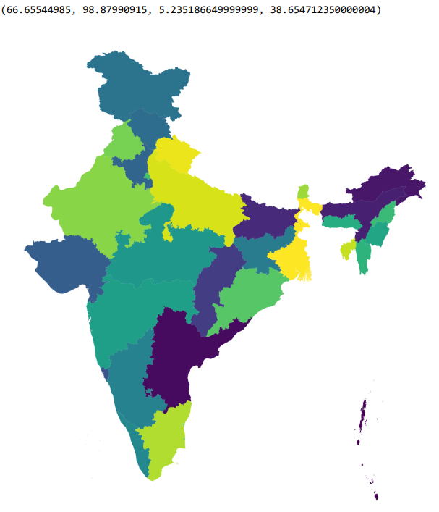

fig, ax = plt.subplots(1, figsize=(20,15))

ax = India.plot(cmap='tab20', linewidth=0.8, ax=ax)

India.apply(lambda x: ax.annotate(text=x['ST_NAME'], xy=x.geometry.centroid.coords[0], ha='center'), axis=1)

plt.axis('off')

plt.show()

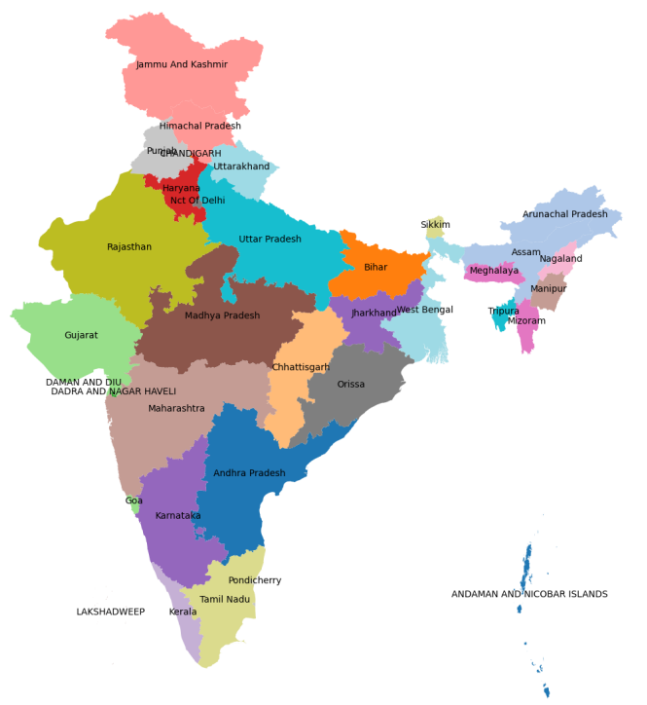

**RESULT**

Thus, building cartographic visualization for multiple datasets involving various countries of the world; states and districts in India etc has been done successfully.

**DATE: EXERCISE : 08**

**PERFORM EDA ON WINE QUALITY DATA SET.**

**AIM:**

To perform EDA on Wine Quality Data Set.

**PROCEDURE:**

1. Load the dataset.
2. Display basic information about the dataset.
3. Display summary statistics for numerical columns.
4. Check for null values.
5. Check for and handle duplicates.
6. Visualize the distribution of numerical features.
7. Visualize relationships between numerical features.
8. Explore categorical variables.
9. Visualize categorical variables.
10. Explore time-based trends if applicable.
11. Identify and handle outliers if necessary.
12. Draw preliminary conclusions and insights.
13. Document any data cleaning or preprocessing decisions.

**PROGRAM:**

df **=** pd**.**read_csv("WineQuality.csv")

df.info

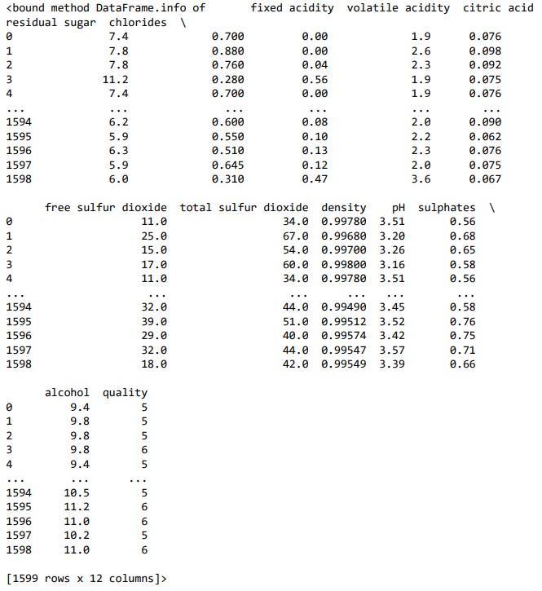

df.shape

(1599, 12)

df.columns

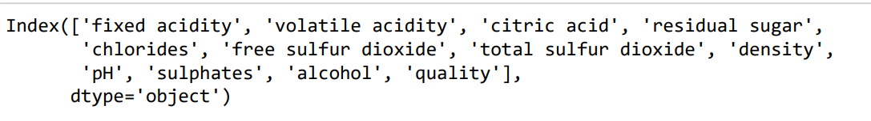

df.isnull().sum()

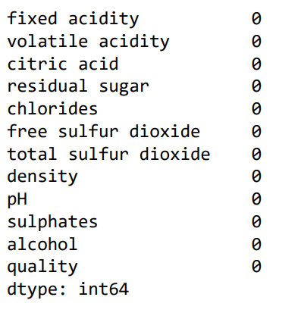

# Statistical Measures of the data set

df.describe()

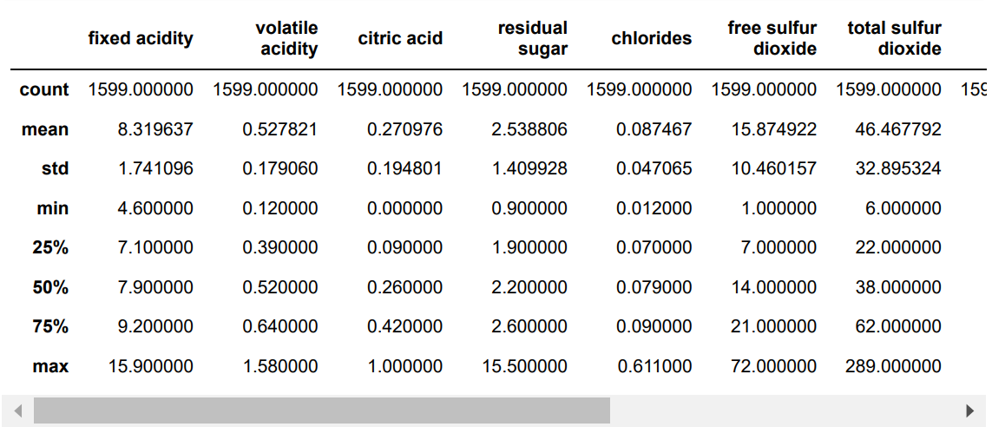

df.quality.unique()

array([5, 6, 7, 4, 8, 3], dtype=int64)

# No: of Quality values of the wines

df["quality"].value_counts()

sns.catplot(x="quality", data=df,kind="count")

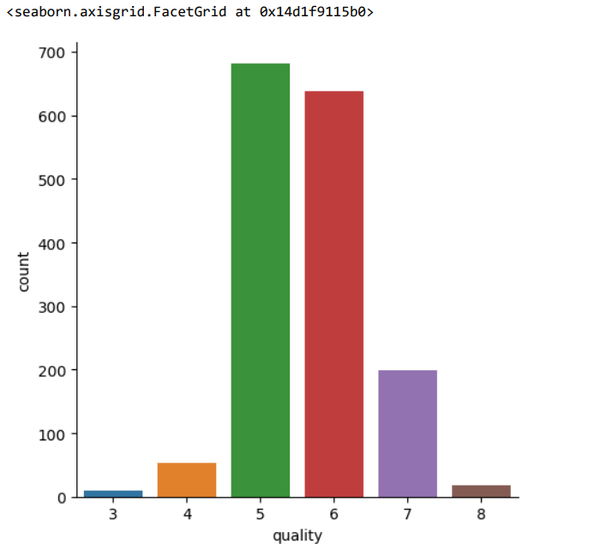

sns.boxplot(x="quality",y="alcohol",data=df)

plt.legend()

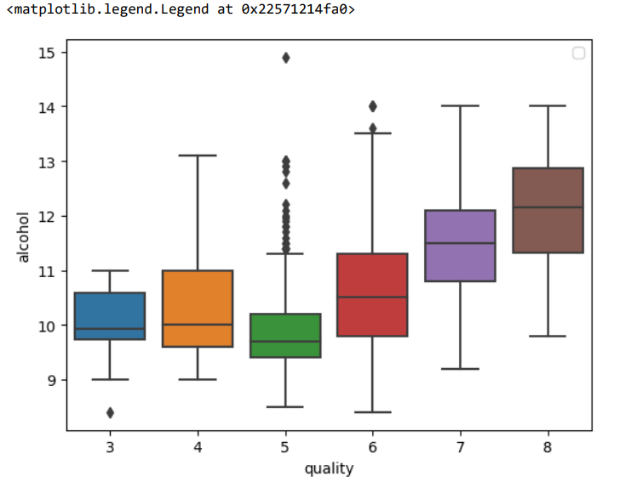

for i in df .columns :

sns .boxplot (data = df [ i])

plt .title ( i )

plt .show()

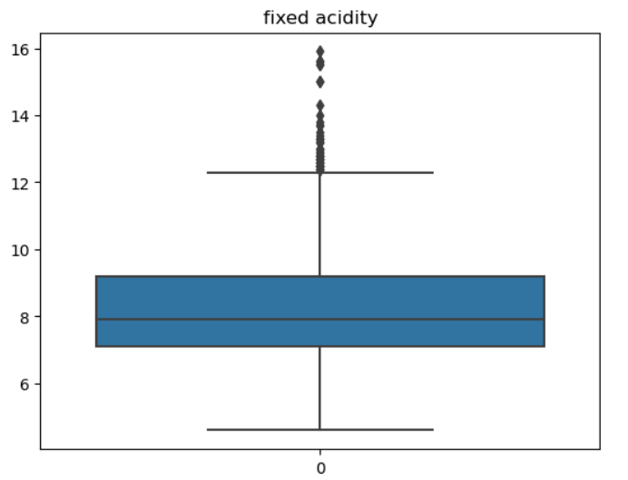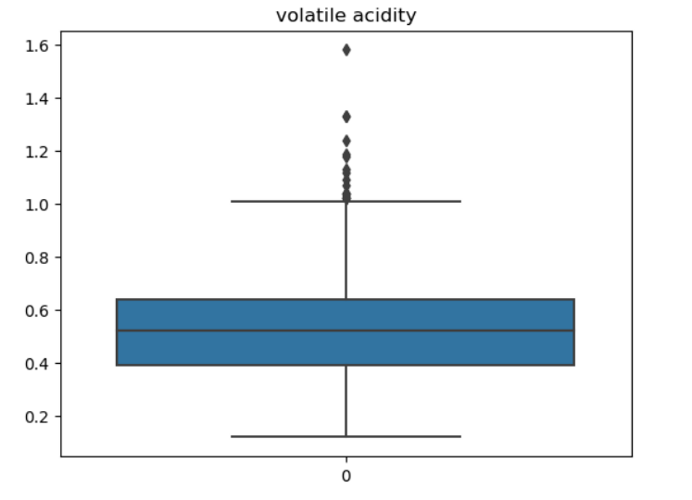

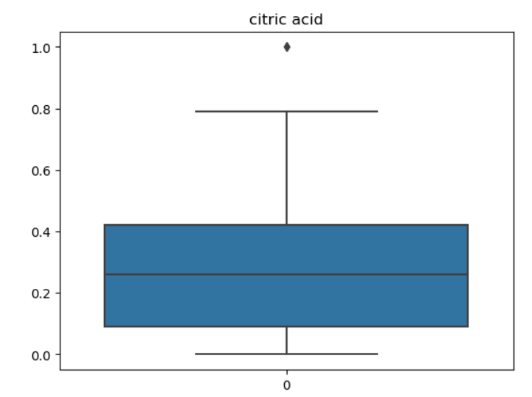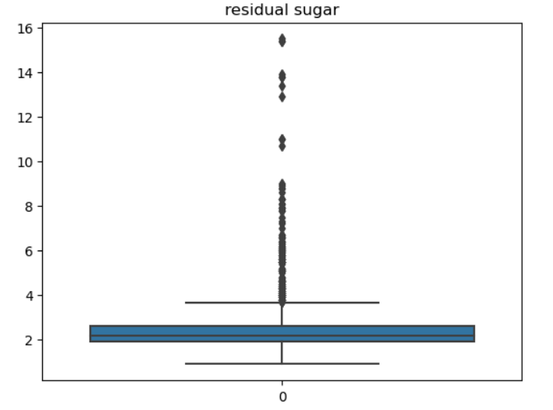

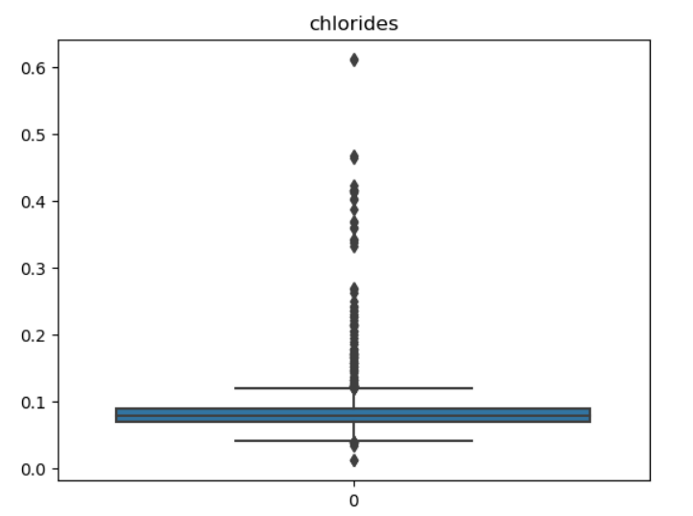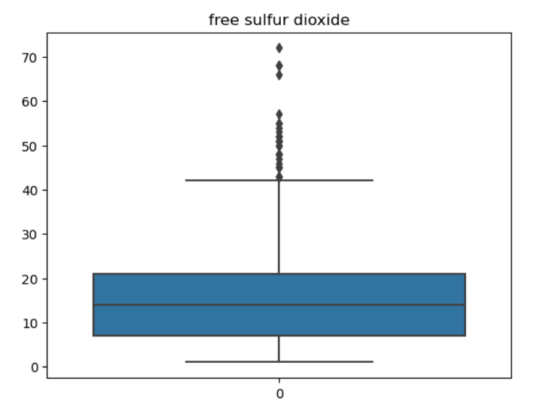

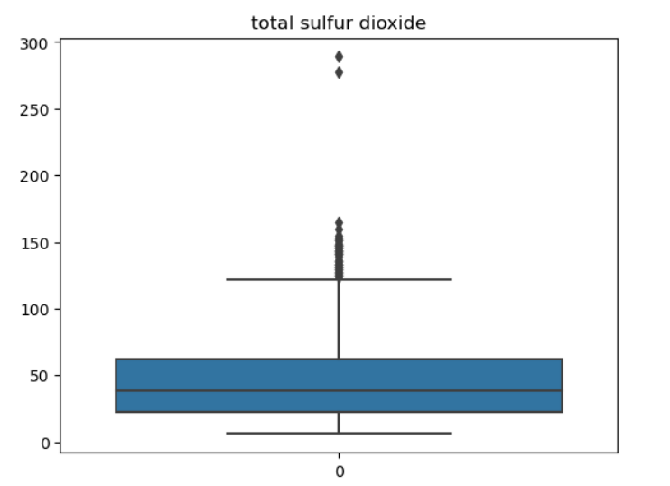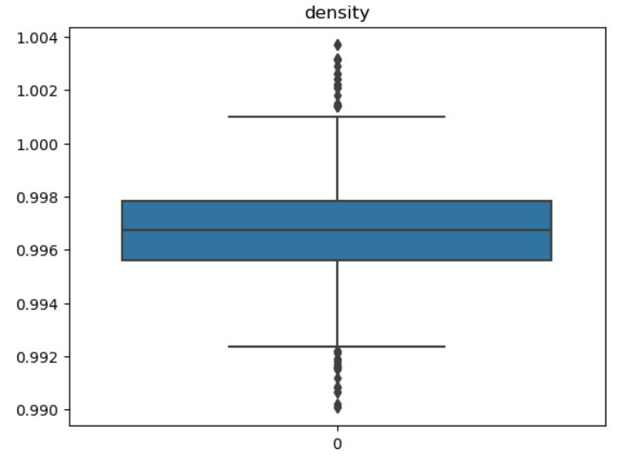

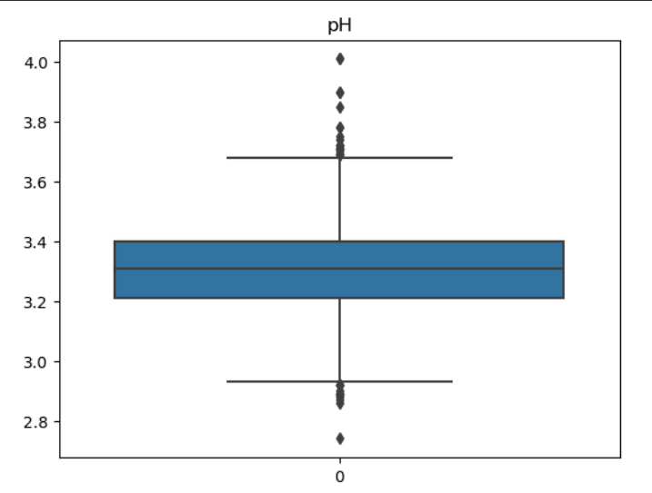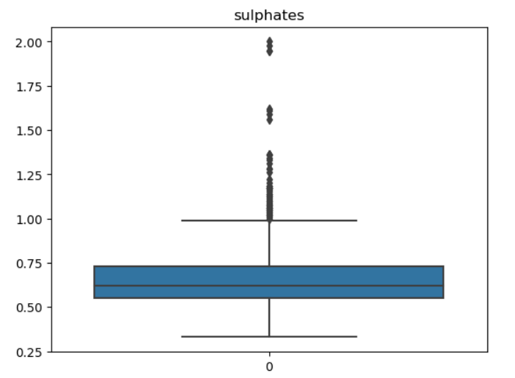

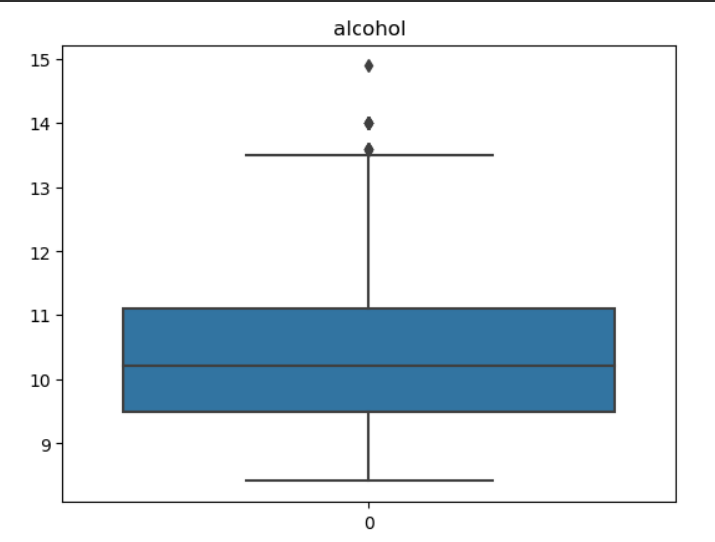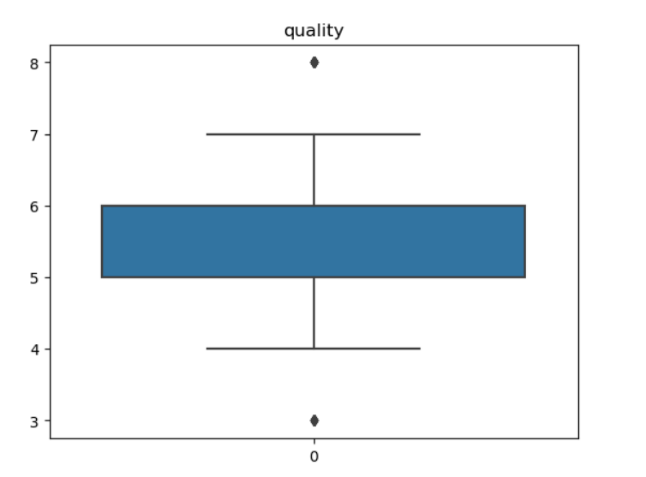

# Take any 2 columns and plot them

plot=plt.figure(figsize=(12,9))

sns.barplot(x="quality",y="chlorides",label=feature,data=df)

plt.legend()

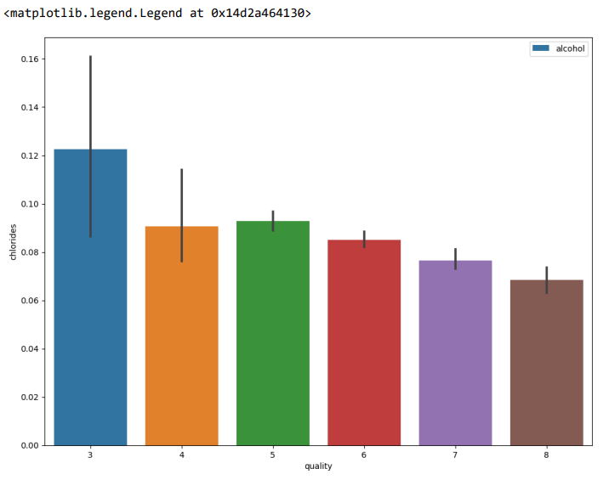

for i in df.columns:

sns.distplot(df[i])

plt.title(i)

plt.show()

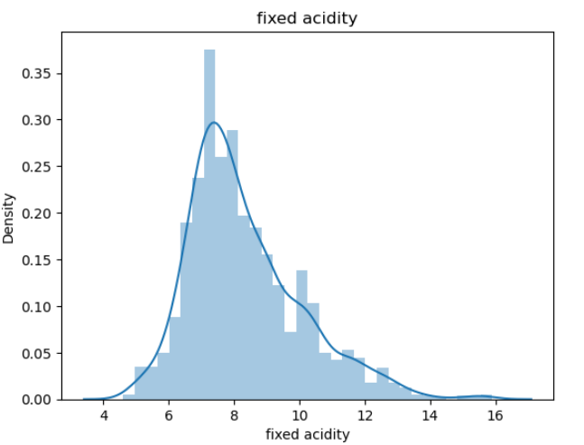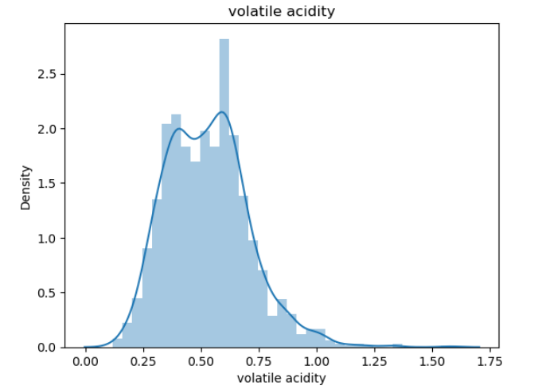

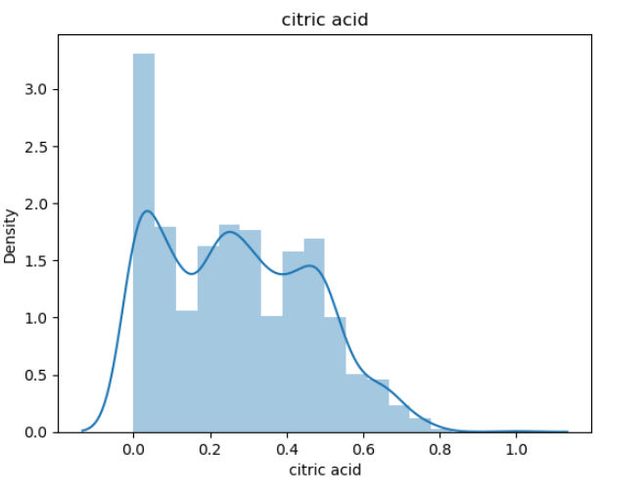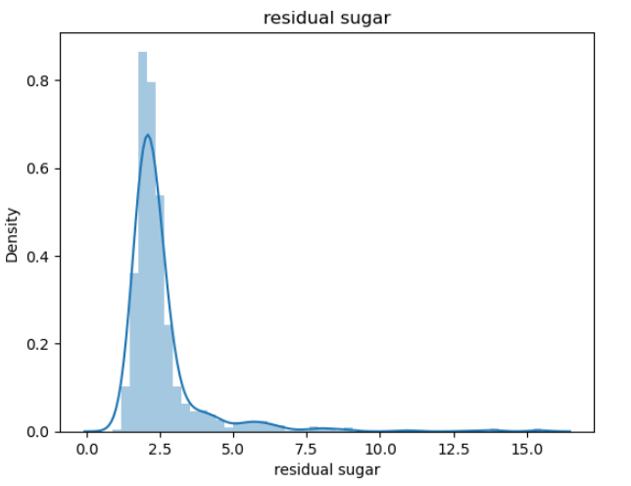

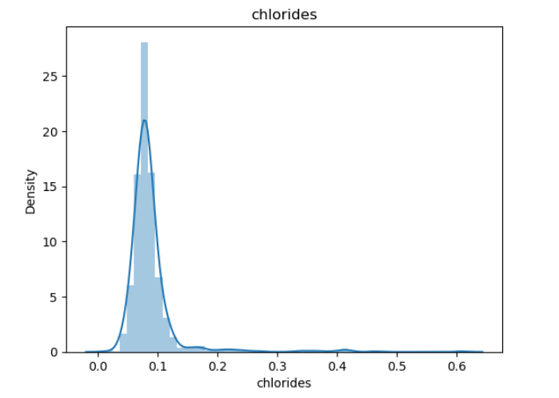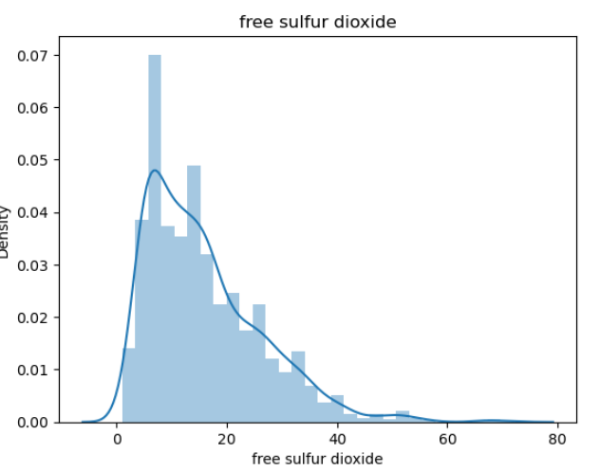

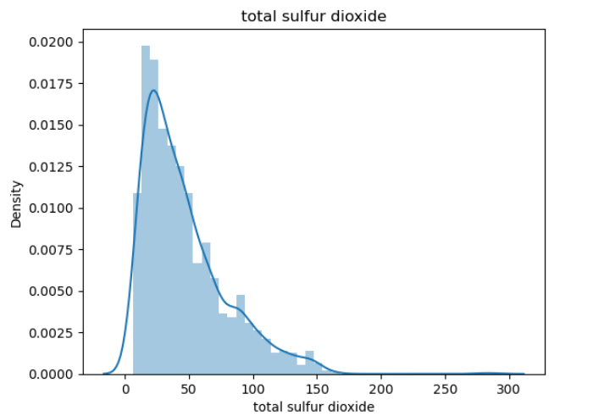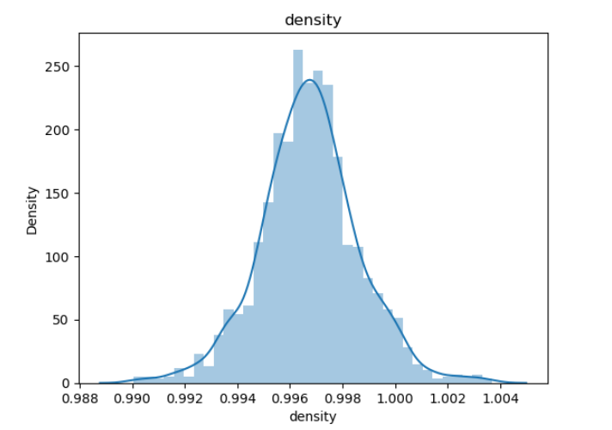

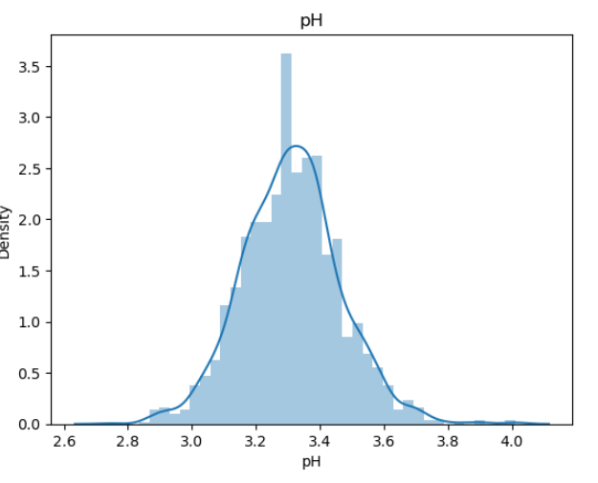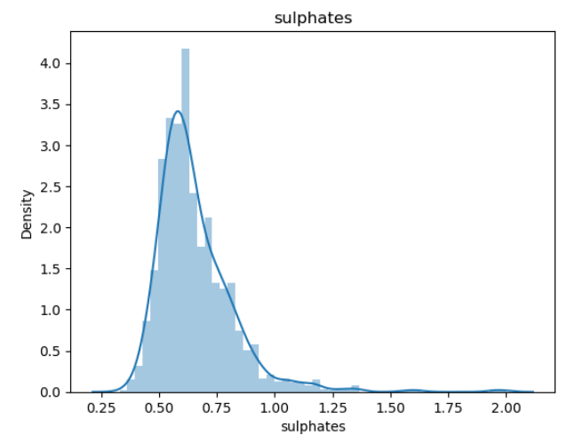

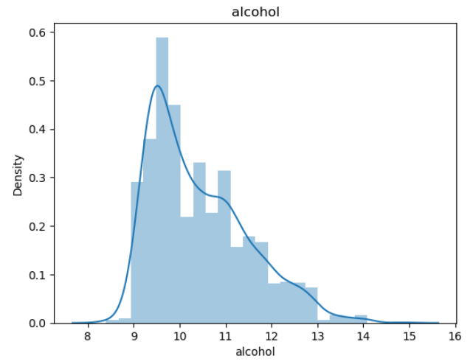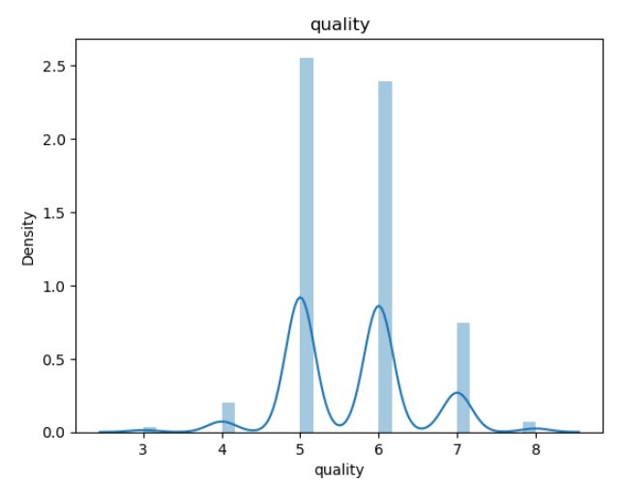

Co=df.corr()

Co

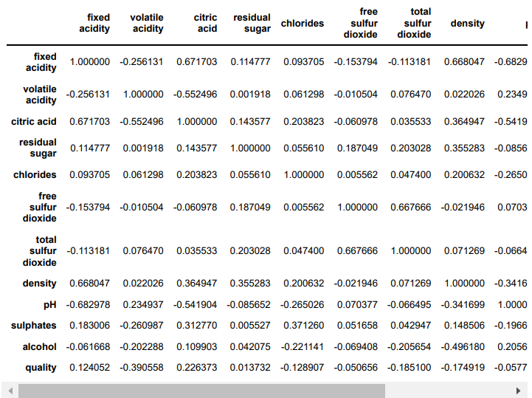

plt.figure(figsize=(12,12)) sns.heatmap(Co,annot=True,cbar=True,square=True,fmt=".3f",annot_kws={'size':8})

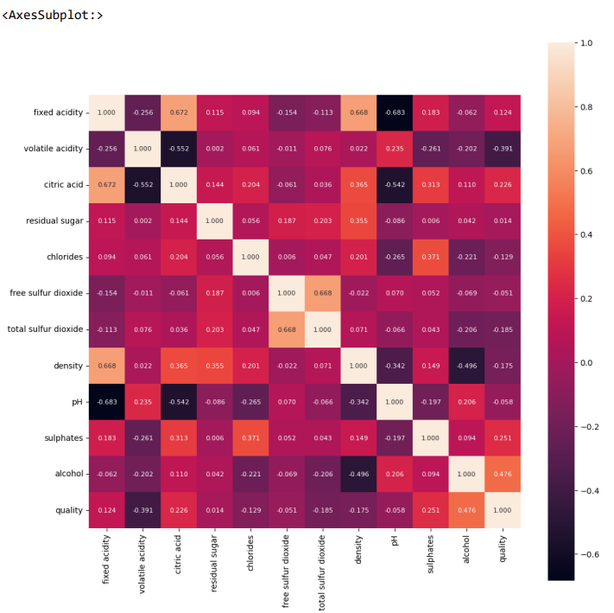

plt.scatter(df['density'],df['residual sugar'])

plt.xlabel('Density')

plt.ylabel('Residual Sugar')

plt.show()

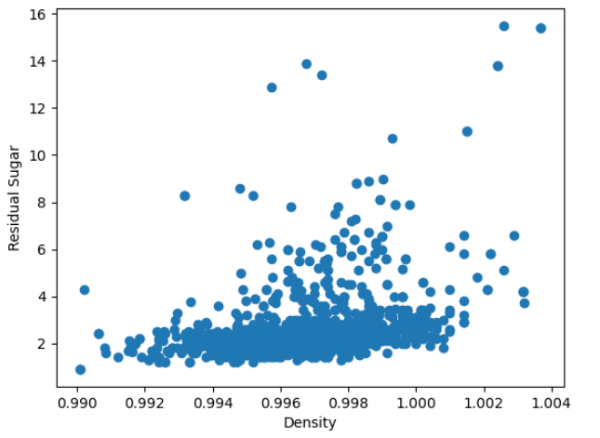

out=df.describe(percentiles=[0.05,0.95])

out.drop(['count', 'mean', 'std', 'min', '50%', 'max'], axis=0, inplace=True)

out

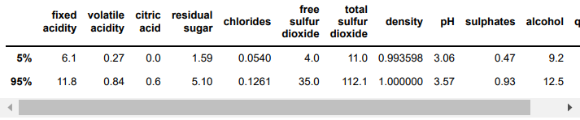

plt.scatter(df['density'],df['alcohol'])

plt.xlabel('Density')

plt.ylabel('alcohol')

plt.show()

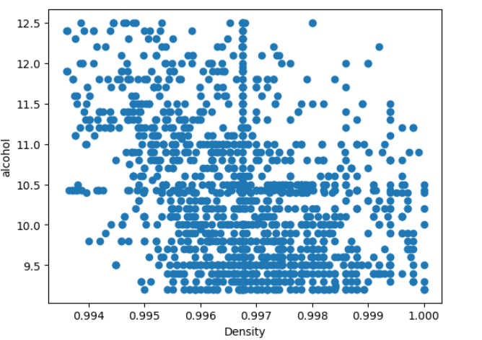

x=df[['fixed acidity', 'volatile acidity', 'citric acid', 'residual sugar', 'chlorides', 'free sulfur dioxide', 'total sulfur dioxide', 'density', 'pH', 'sulphates', 'alcohol',]]

x.head(10)

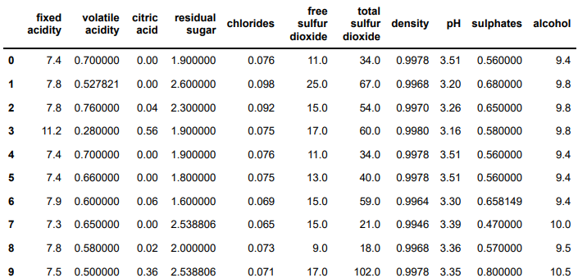

y=df["quality"].apply(lambda y_value: 1 if y_value>=7 else 0)

y

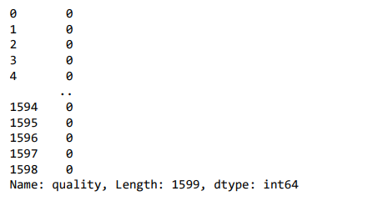

xtrain,xtest,ytrain,ytest=train_test_split(x,y,test_size=0.2,random_state=3)

xtrain.shape,ytrain.shape

((1279, 11), (1279,))

xtest.shape,ytest.shape

((320, 11), (320,))

#Random Forest Classifier

model=RandomForestClassifier()

model.fit(xtrain,ytrain)

x_test_pred=model.predict(xtest)

test_accu=accuracy_score(x_test_pred,ytest)

print("The accuracy of the test data is:",test_accu)

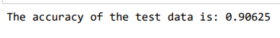

#Building a Predictive System

input_data=[[7.3,0.65,0.00,1.2,0.065,15.0,21.0,0.9946,3.39,0.47,10.0]] pred=model.predict(input_data)

if(pred[0]==1):

print("Good Quality Wine")

else:

print("Bad Quality Wine")

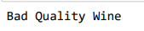

from sklearn.feature_selection import VarianceThreshold variance=VarianceThreshold(threshold=0)

variance.fit(df)

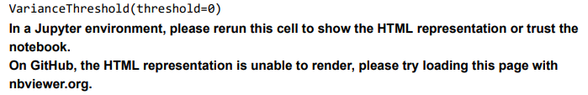

df.columns[variance.get_support()]

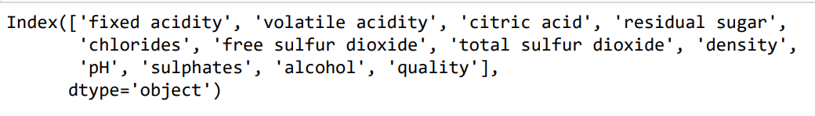

**RESULT:**

Thus, performing EDA on the Wine Quality Data Set has been executed successfully.

**DATE: EXERCISE : 09**

**USE A CASE STUDY ON A DATA SET AND APPLY THE VARIOUS EDA AND VISUALIZATION TECHNIQUES AND PRESENT AN ANALYSIS REPORT.**

**AIM:**

To perform EDA on HDFC Bank Stock market dataset and to present an analysis report based on it.

**PROCEDURE:**

1. Load the dataset.
2. Display basic information about the dataset.
3. Display summary statistics for numerical columns.
4. Check for null values.
5. Check for and handle duplicates.
6. Visualize the distribution of numerical features.
7. Visualize relationships between numerical features.
8. Explore categorical variables.
9. Visualize categorical variables.
10. Explore time-based trends if applicable.
11. Identify and handle outliers if necessary.
12. Draw preliminary conclusions and insights.
13. Document any data cleaning or preprocessing decisions.

**PROGRAM:**

import numpy as np

import pandas as pd

import matplotlib.pyplot as plt

df = pd.read_csv("StockDataHDFCBANK.csv")

df

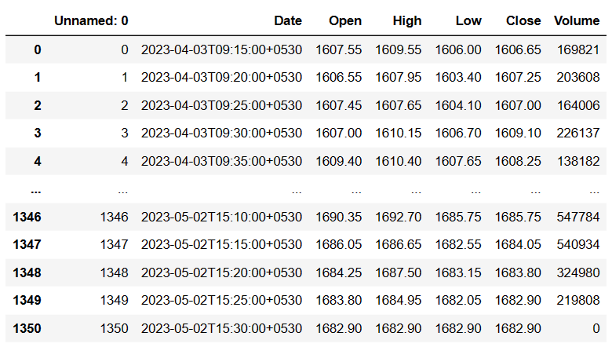

# Convert the 'Date' column to datetime data type

df['Date'] = pd.to_datetime(df['Date'])

# Set the 'Date' column as the index of the DataFrame

df.set_index('Date', inplace=True)

# Display the updated DataFrame

print(df.head())

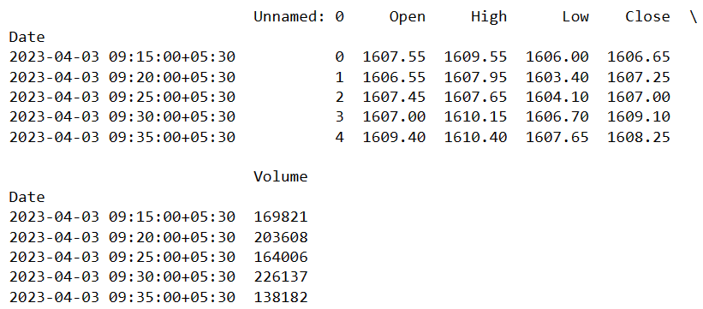

# Display basic information about the dataset

print("Dataset Information:")

print(df.info())

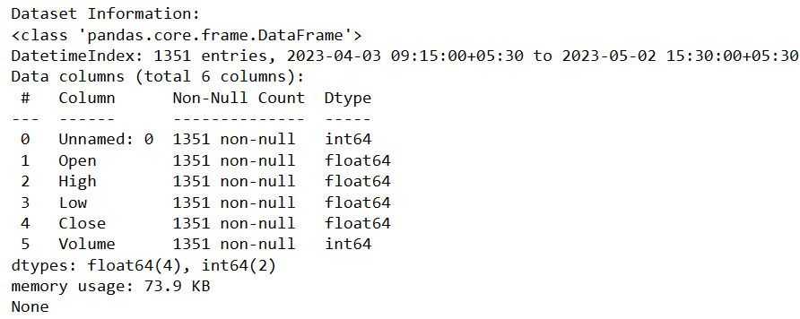

# Display summary statistics of numerical columns

print("\nSummary Statistics:")

print(df.describe())

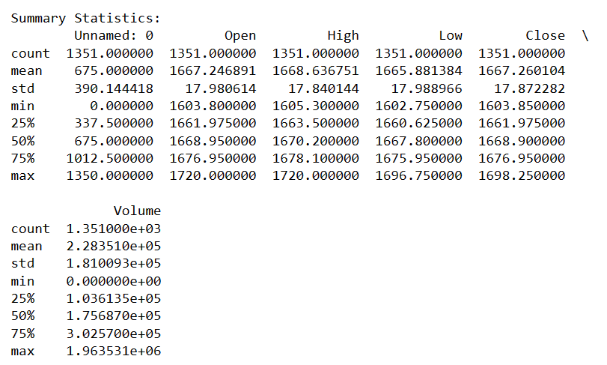

# Check for null values in the dataset

null_values = df.isnull().sum()

print("Null Values:")

print(null_values)

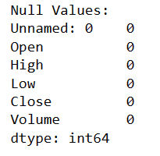

# Check for duplicates in the dataset

duplicates = df.duplicated().sum()

print("\nNumber of Duplicates:", duplicates)

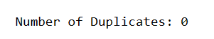

# Plot the closing prices over time

plt.figure(figsize=(12, 6))

plt.plot(df.index, df['Close'], label='Close Price', color='blue')

plt.title('HDFCBank Stock Price - Closing Prices Over Time')

plt.xlabel('Date')

plt.ylabel('Close Price')

plt.legend()

plt.show()

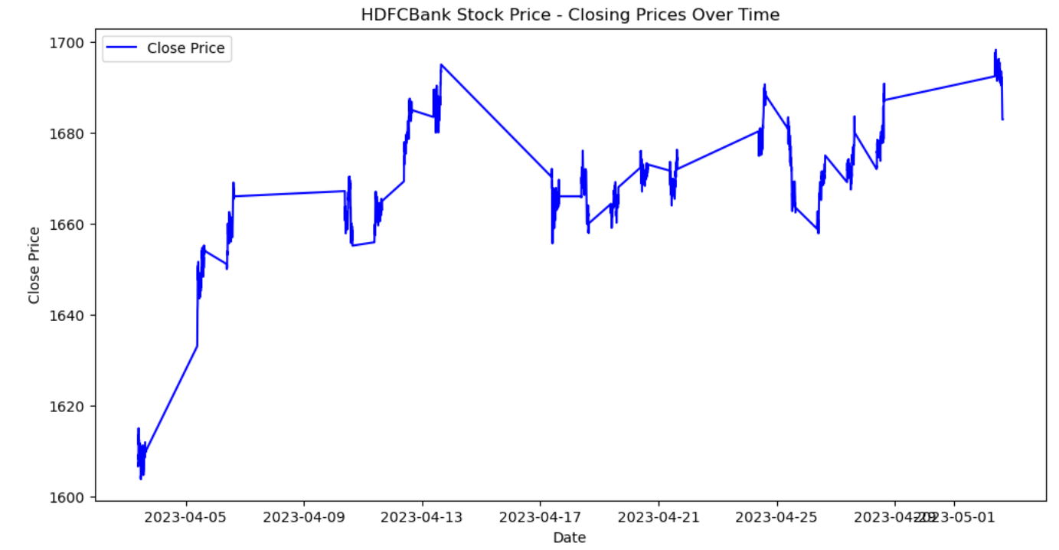

# Plot a histogram of the closing prices

plt.figure(figsize=(12, 6))

plt.hist(df['Close'], bins=30, color='skyblue', edgecolor='black')

plt.title('Histogram of HDFCBank Closing Prices')

plt.xlabel('Close Price')

plt.ylabel('Frequency')

plt.show()

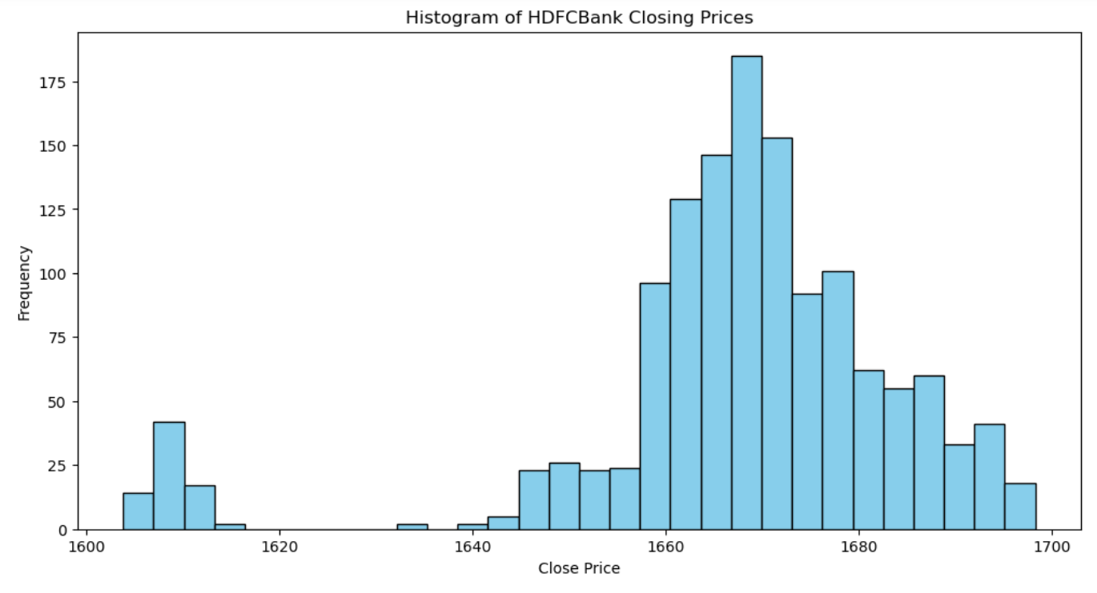

# Plotting the HDFCBank stock prices

plt.figure(figsize=(12, 6))

plt.plot(df.index, df['Close'], label='HDFCBank Close Price', color='blue')

# Marking significant support levels (you can customize these levels based on your analysis)

support_levels = [1700, 1650, 1600]

for level in support_levels:

plt.axhline(y=level, color='green', linestyle='--', label=f'Support Level {level}')

# Adding labels and title

plt.title('HDFCBank Stock Price with Support Levels')

plt.xlabel('Date')

plt.ylabel('Close Price')

plt.legend()

plt.grid(True)

plt.show()

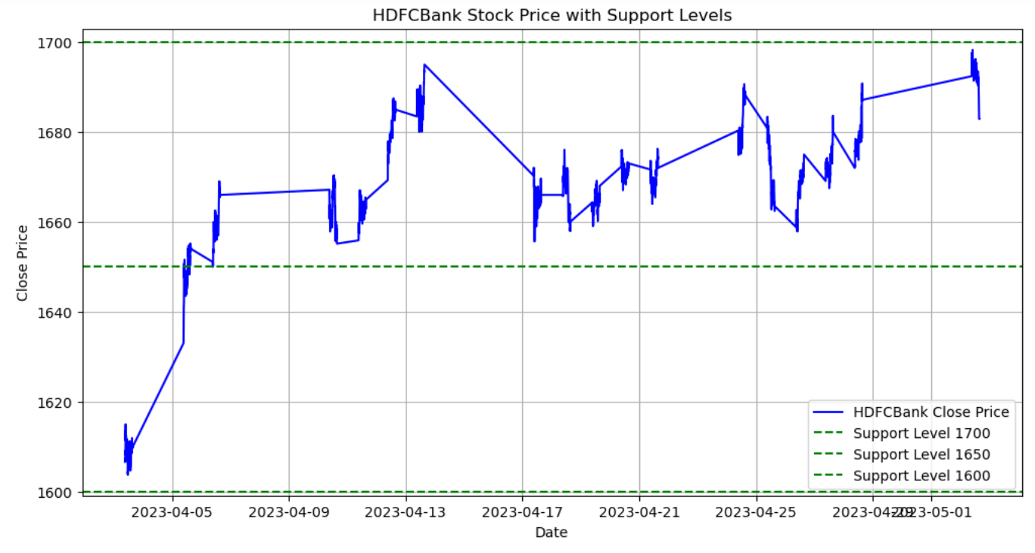

import plotly.graph_objects as go

fig = go.Figure(data=[go.Candlestick(x=df.index,

open=df['Open'],

high=df['High'],

low=df['Low'],

close=df['Close'])])

fig.update_layout(title='Candlestick Chart',

xaxis_title='Date',

yaxis_title='Price',

xaxis_rangeslider_visible=True) # Add a range slider for zooming

# Step 5: Save the plot as an interactive HTML file

fig.write_html("candlestick_plot.html")

# Step 6: Display the plot (optional)

fig.show()

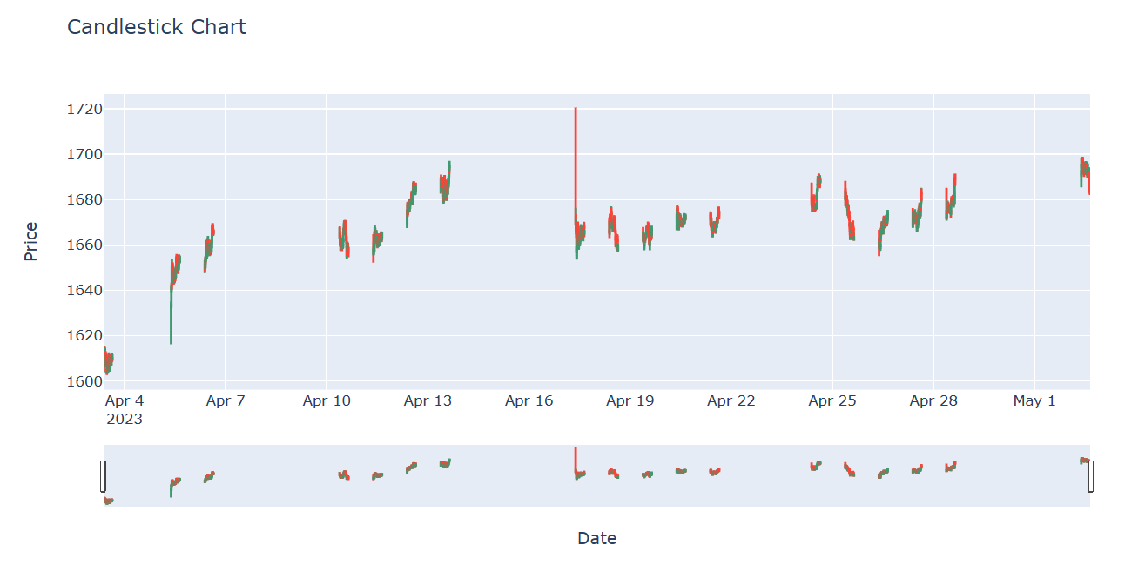

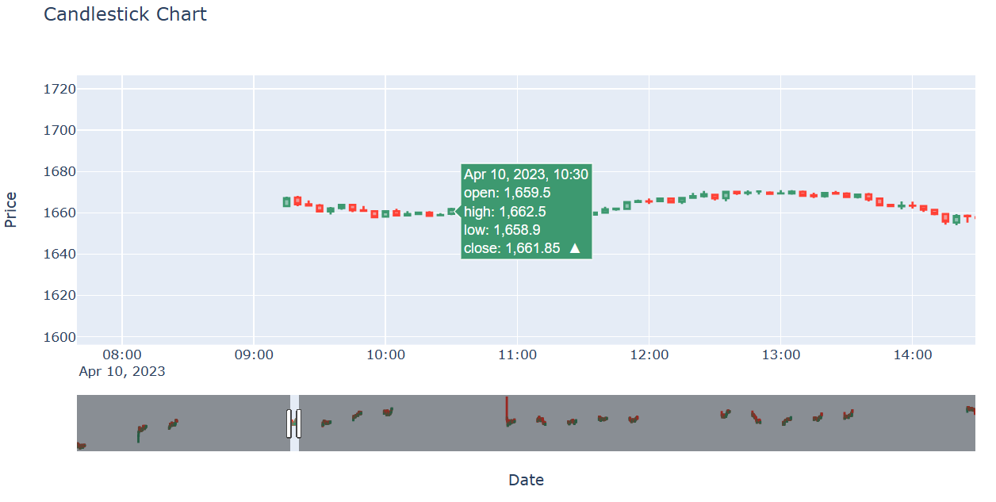

**ANALYSIS REPORT ON EXPLORATORY DATA ANALYSIS ON HDFC BANK STOCK MARKET DATASET**

**1. Dataset Overview:**

* The dataset contains stock data for HDFCBank, including columns such as 'Date', 'Open', 'High', 'Low', 'Close', and 'Volume'.
* The 'Date' column has been converted to the datetime data type, and it is set as the index of the DataFrame.

**2. Support Levels Visualization:**

* A line chart of HDFCBank stock prices was plotted, emphasizing the closing prices over time.
* Significant support levels were marked on the chart using horizontal lines, with levels set at 1700, 1650, and 1600.

**3. Summary Statistics:**

* Summary statistics of numerical columns ('Open', 'High', 'Low', 'Close', 'Volume') were computed and displayed.
* These statistics provide insights into the central tendency, spread, and distribution of the stock prices and trading volume.

**4. Null Values and Duplicates Check:**

* No null values were found in the dataset, indicating completeness.
* No duplicate rows were identified, suggesting a lack of redundancy in the data.

**5. Visualization of Closing price values:**

* A line chart was created to visualize the closing prices of HDFCBank stock over time.
* This chart provides an overview of the general trend and fluctuations in closing prices.
* A histogram of closing prices was plotted to visualize the distribution of closing prices.
* The histogram helps identify the frequency of different price ranges and potential patterns.

**6. Line Chart Visualization:**

* A simple line chart of HDFCBank closing prices was created, providing a clear representation of price movements over time.

**7. Bar Chart Visualization:**

* A bar chart was plotted, illustrating the high and low prices of HDFCBank stock.
* This chart adds granularity to understanding price movements within each time period.

**8. Candlestick Chart:**

* A candlestick chart was generated using the Plotly library, providing a detailed view of open, high, low, and close prices.
* Candlestick charts offer insights into price patterns and volatility.

**9. Chart Patterns Visualization:**

* The closing prices were plotted with markers indicating potential chart patterns.
* In this example, double tops were identified and marked on the chart.

**10. Conclusion:**

The HDFCBank stock dataset appears to be well-structured, with no missing values or duplicates. Visualizations such as trendlines, support levels, and candlestick charts provide valuable insights into price movements and potential patterns. Therefore, this report summarizes the key findings from the EDA process, highlighting important aspects of the HDFCBank stock dataset.

**RESULT:**

Thus, performing EDA on HDFC Bank stock market data set has been completed and the report was done successfully.